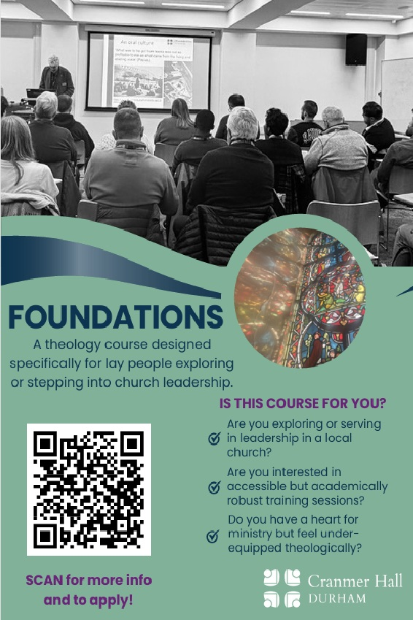

Foundations is an introductory theology course designed for anyone who wants to increase their theological confidence: whether you're a new leader or just curious and want to grow in your faith. The sessions take place once a week in the evening in local hubs, for those who can’t commit to a full-time or even part time programme. Over two terms, you’ll build confidence in reading the Bible, grasping core Christian doctrine, understanding church history, and thinking clearly about mission, always with local church leadership in view. Sessions are accessible (no prior study required), but the course is academically robust and designed to help you grow in clarity, humility, and wisdom. We've filming our brilliant Cranmer Hall lecturers and other leader academics from further afield to bring deep and accessible Theology to your doorstep.
This coming academic year our hubs will be in Sunderland, Durham, and Darlington.

Learning outcomes:
This course will help you:
- Read the Bible with greater confidence, using sound interpretive tools and encourage good theological instincts.
- Summarise the core claims of Christian doctrine (e.g., Trinity, Creation, Spirit) and explain why they matter for discipleship and leadership.
- Trace key moments in church history and identify how the past continues to shape the Church today.
- Think more clearly about mission and evangelism in contemporary culture, with a focus on faithful local practice.

Entry Requirements:
Foundations is open to anyone exploring or serving in lay leadership in a local church (including those involved in new worshipping communities). You do not need prior theological study or experience. What you do need is a willingness to learn, to participate in discussion, and to apply what you’re learning to the life of your church community. If you’re unsure whether Foundations is right for you, we’re happy to help you think it through.

For next academic year only, this course is fully funded for all Church of England students in the Dioceses of Durham and Newcastle. For everyone else it's £400 for the whole course, and you can pay in instalments if that helps.

Start date: Sunderland/Darlington – 7th Oct or Durham 8th Oct.
All sessions 7.30pm – 9pm

Term 1

Week 1 |  | Intro, Welcome, and What is Theology and Why Study It?
Week 2 | Bible Cluster | Becoming a Community of Readers: Contexts and Movements and Reading the Bible
Week 3 |  | Reading the Old Testament, parts 1 & 2
Week 4 |  | Reading the New Testament, parts 1 & 2
Week 5 | Doctrine Cluster | How (Not) to be a Heretic: An Intro to Doctrine, parts 1 & 2
Week 6 |  | Who is Our God? His Attributes and The Trinity
Week 7 |  | Creation
Week 8 |  | Jesus Christ and How are We Saved?
Week 9 |  | The Holy Spirit and Where is This Going?

Term 2

Week 10 | Ecclesiology and Missiology Cluster | What is the Church?
Week 11 |  | The Mission of God
Week 12 |  | Mission and the Global Church
Week 13 |  | Theology and Justice
Week 14 |  | Theology and the Public Square
Week 15 |  | Apologetics
Week 16 | Formation and Discipleship Cluster | Spirituality, Personal Formation, and Discipleship
Week 17 |  | Theology, Leadership and Ministry
Week 18 |  | Reflecting on Context

There is an Enquirer’s zoom meeting for questions and answers on Tuesday 8th September at 7pm. If you would like to join that please use the link here:

Time: Sep 8, 2026 19:00 Join Zoom Meeting
https://us06web.zoom.us/j/81499863387?pwd=lMatls8rMmG0FGkQcmhXhVsqmTdmtT.1
Meeting chat link
https://us06web.zoom.us/launch/jc/81499863387
Meeting ID: 814 9986 3387
Passcode: 708903
To book your place, please scan the QR code on the green flier first page, and complete the short application form.

For any further information within the diocese of Durham please contact: Sharon.pritchard@durham.anglican.org

