A Message from Rev’d Canon Eileen Harrop, Diocese of Durham UKME Adviser, on behalf of the Diocese
GIVING THANKS ON THE 75th ANNIVERSARY OF WINDRUSH
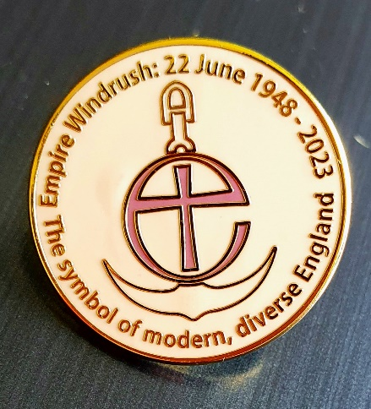
22nd June 2023 marks the 75th anniversary of the arrival of HMT Empire Windrush at Tilbury Docks in Essex. The ship brought to Britain over 800 passengers who had left the West Indies, and the majority settled into new lives in the UK. As a Diocese we want to acknowledge those who arrived on ‘the Windrush’ at the invitation of Great Britain, to learn from their stories, and to give thanks for them. Events and services across the country include the National Windrush 75th Anniversary Service (2pm, 22nd June 2023) at Southwark Cathedral.
Widely published readings can help us gain better understanding of the significance of ‘Windrush’. These include stories from among ‘Windrush’ passengers and their family members, some may be members of our congregations and our chapters of clergy and chaplains in Durham Diocese. Here are sources of stories: https://theconversation.com/how-the-windrush-generation-changed-stories-of-britain-forever-ten-recommended-reads-206729
https://www.blackhistorymonth.org.uk/article/section/windrush-75/windrush-75-nhs-75-a-celebration-of-staying-power/
On this anniversary year, the Royal British Legion (RBL) is celebrating the contribution of more than 100 serving and former armed forces personnel from the Caribbean who had been among ‘Windrush’ passengers.
This Sunday 25th June 2023, let us consider including A Prayer for the Windrush 75th Anniversary in our services.
Dear Lord,
We thank you for the gift of creation and the beauty you revealed in human diversity.
We repent of the sin of racism and discrimination, which we have allowed to dehumanise those you created in your own image and for your own purpose.
Help us to continually understand that the gift of salvation on the cross is for the whole of humanity.
Help us to know that serving you is to be welcoming and generous to all people.
Help us to know that preaching you is to act graciously and kindly to those who are different from us.
Help us to understand that doing your will is to love all people as we love ourselves.
Help us to always remember that we are your children by your grace and mercy,
And the need to be humble and kind for the numerous blessings and gifts you have bestowed on us as a nation and people.
Look mercifully on us as we do your will here on earth and
let your name be always glorified in our lives and our actions,
through Jesus Christ our Lord.
Amen.

