To Churchwardens, incumbents and priests-in-charge

Bishop’s Visitation
Sunday 26th June 2022 in Durham Cathedral at 2.45pm for 3.30pm

Dear Colleagues,
The role of Churchwarden is vital in the life of our parishes. It is also both a great privilege and responsibility. During the Covid pandemic there will have been times that it simply felt like hard work. I have both experienced as a parish priest, and seen and heard as a bishop, how good partnerships between incumbents and churchwardens really help the local church engage effectively in mission. I am pleased to be able to share with you in this ministry through this year’s Bishop’s Visitation.
All those who have been elected as Churchwardens for 2022-2023 are invited to my Visitation in the Cathedral on Sunday 26th June at 3.30pm to make the public declaration required of them before taking up office, and to be admitted to office as Churchwarden.
Churchwardens will need to register at their individual Archdeaconry desk at the back of the Cathedral from 2.45pm in time for the 3.30pm service.
It is a requirement that Churchwardens shall make both a verbal declaration at the service and a written one beforehand faithfully to discharge the duties of office. It is important therefore, to return the enclosed Declaration and Certificate of Election by 31st May 2022 to your Archdeacon’s Office.
It is also required that every elected Churchwarden shall be formally admitted before the end of August as they cannot take up office before admission. If an elected Churchwarden is unable to attend on 26th June please inform your Archdeacon’s Secretary so that special arrangements can be made.
Beneficed and licensed clergy and lay workers are invited to attend and support their Churchwardens but are not expected to robe. Please note the enclosed advice about parking arrangements.
I look forward to this important Diocesan occasion when there will be the opportunity to thank Churchwardens for all their time and dedication offered to the Church year by year, and especially those who have served so faithfully through the last couple of very difficult years. I also look forward to the opportunity to publicly pray for the work of all Churchwardens as we gather together in worship.
Yours in Christ
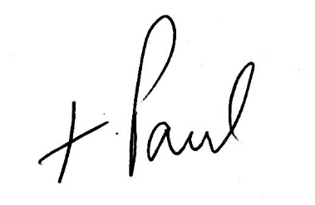
Rt Revd Paul Butler
Bishop of Durham

