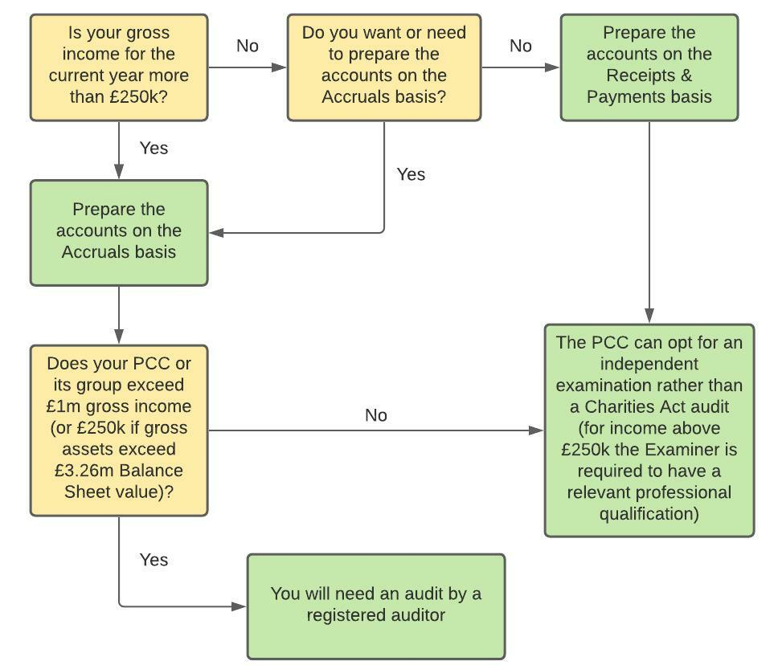

*NOTE: You would need to prepare accounts on the Accruals basis if this is a condition required by a donor, funder or grant maker*