**PARISH PROFILE**

St Columba’s Church,

Darlington

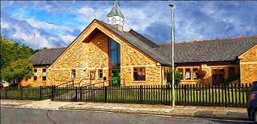

**Contents:**

**Our Diocesan Vision -** An Introduction from Bishop Sarah page 3

1. Welcome from the PCC page 4

2. Our Local Context page 5

3. Our Church and its Mission page 6

4. Our Building, serving our Mission page 10

5. Giving, Finance & Generosity page 12

6. Leadership and Governance page 13

7. Our New Minister page 14

**Our Diocesan Vision -** An introduction from Bishop Sarah

This is an exciting time to be exploring joining the Diocesan family in Durham Diocese. We are on the cusp of a fresh chapter in our mission and ministry together. We are currently discerning with the National Church who will be the next Bishop of Durham, called to lead as we seek to make real our vision for the transformation we so desire across our Diocese. We are deeply encouraged by the award this year of significant national funding, demonstrating real confidence in our vision.

Our strategy for transformation and missional growth (‘Called to Fruitfulness’) is an opportunity and invitation for each of our parishes to step out in faith together, responding practically to our priorities to ***Challenge Poverty, Energise Growth, Care for God’s Creation*** and ***Engage with Children, Youth and Young Adults***. Making this a reality it will look different in every community. In some places it will come about in collaboration with others. Nobody is expected to do everything immediately or alone, but we are all invited and expected to find ways to respond relevantly.

At St Columba’s this feels particularly relevant. We sense the importance of **Energising Growth** – in discipleship and in the number of people served by and engaging in the life of our churches. We also sense the importance of **Challenging Poverty**, **Engaging with Children and Young People** and **Caring for God’s Creation** in an area with lots of families, with some significant pockets of poverty, and with deeply rooted communities that still look to, and are open to, the local church.

In praying for a new Priest for St Columba we are looking for someone excited by and wanting to be part of this vision and new future. Together we pray hopefully:

***Loving God****, guiding the people of Durham Diocese faithfully through the years:*

*We thank you for saints who have marked our path,  
young and old, known and unknown, from all places and in all walks of life.  
Help us to find your way in our generation:*

*transformed by your truth, sharing your life, blessing our communities.*

*Through Jesus Christ our Lord,*

***Amen***

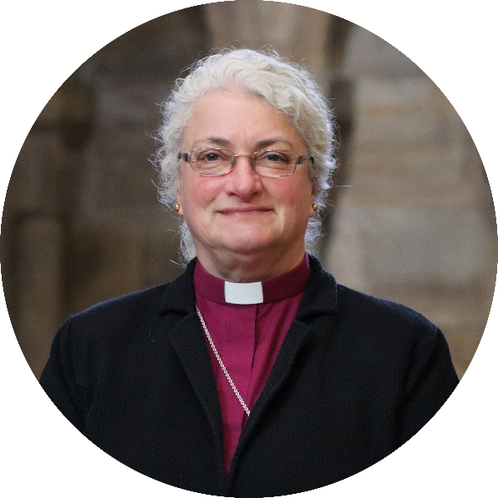

We look forward to meeting together  
and sharing in this with you.

In Christ,

**+Sarah**

**Bishop of Jarrow**

**Acting Bishop of Durham**

**1. Welcome from the PCC**

Thank you for taking the time to read our parish profile. We hope we will have anticipated your questions and awakened your interest!

We have been clear and honest with where we are as a parish and would not want to hide the challenges we face as we look to the future. We are hopeful that our new incumbent will give us the stability we need to build on what we have and help us to grow in faith, grow together and grow in mission.

Our mission statement is St Columba’s is:

“Here to worship and serve God

by sharing the good news of His love

with the people of the community

by witness, teaching and fellowship.”

We are open to change and want to put the needs of our community at the forefront of all we do. Hopefully we have piqued your interest and look forward to meeting with you and working and growing in faith together.

You will see from the section on our mission that we want to highlight with children and young people in particular. Post-covid we have seen a drastic reduction in the children and young people coming to church and would like the new incumbent to have a real commitment to developing our mission with this group.

If you have any questions or would like further clarification, please contact the Archdeacon for a conversation:

Archdeacon: The Ven Rick Simpson

Phone: 07384 511671

Email address: Archdeacon.of.Auckland@durham.anglican.org

**2. Our Local Context**

Darlington is on the border of North Yorkshire and Teesside. It is within easy reach of the Lake District, North York Moors, Yorkshire Dales and the Cleveland Hills, and only 25 minutes from the east coast. Public transport and connections are good with regular bus services, trains and the bypass road which links the A66 and Tees Valley. Our local airport, Teeside International, is also currently undergoing investment and expansion.

Although the Tees Valley area is well known historically for its industry, very little of that remains now. Darlington was the “home of the railway” boasting the first steam-powered passenger rail journey between Stockton and Darlington. Darlington Railway Station – with direct East Coast Main Line connections to London, York, Edinburgh and Glasgow – sits within the boundary of St Columba’s parish. At present a major redevelopment of is taking place, along with a major refurbishment of the Hopetown Darlington Railway Museum.

The population of Darlington is around 100,000, but is now growing with significant amount of new housing being built. Employment opportunities are also increasing.A remaining feature of the industrial past is Cummins, a large global engineering company. However, today there are new major employers in the town, including EE, The Student Loan Company, Amec, Argos, the Department for Education, The Treasury Department and Amazon.

In Darlington 93.23% identify as White/British, 1.79% are Asian, 0.9% as Mixed Race, 0.7% as Black and 0.5% as Chinese. 6% of the population are unemployed and 20.1% retired. In terms of housing: 65.3% of people line in owner/occupied housing, 18.2% rent privately rented, with 15.5% living in social housing.

There are areas of relative affluence, and areas of greater need – including our parish. St Columba’s serves an area of Darlington to the east and south of the centre. (If the town is thought of as a clock, St Columba’s covers an area just outside and around its centre from about 3 o’clock to 6 o’clock.) Approximately 6,500 live in the parish. It is an area where there are significant needs, and we seek to serve God and local people in our context.

**3. Our church and it mission**

We are a caring church community serving an area of urban housing where there are significant needs. Using the Index of Multiple Deprivation, which takes a wide range of factors into account, St Columba ranks 317 out of 12239. Details can be found at:

<https://cuf.org.uk/parish/130229>

**Church and Community Groups**

We are very blessed in having a community centre as part of our Church building, which means we can offer our building to the wider community and play an active role in community life. We have many groups using the building, including:

* Cafe JJ’s - a cafe operates by a group of people with learning disabilities
* A distribution hub for a local food bank
* Parish Councillors’ local surgeries
* GEM - Get Everyone Motivated, a gentle exercise class for those with learning disabilities

It is also well used by community members as a venue (e.g.) for children’s parties, and for events such as regular jumble sales.

The nature of our building and the uses it has mean that St Columba’s is widely known within the community and is a focal point for local people. It is a huge benefit having a building that is really fit for mission – not least in being able to host groups addressing the hopes and needs of people in our community.

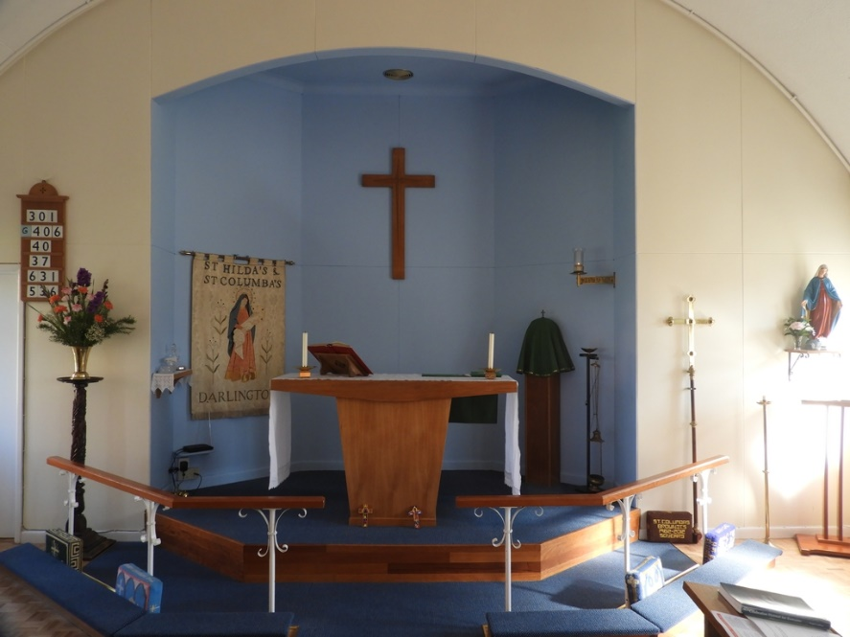

**Worship**

We have a faithful core of

committed church members

and attract many more from

the community to the main

festivals and special services.

The main Sunday service is a

Common Worship Eucharist.

There is a midweek service on

Wednesday mornings, and

monthly Wholeness and

Healing Service, as well as

seasonal services and baptisms, weddings and funerals.

We would like to continue to play our part in the life of the Church when the new incumbent joins us. At present the Churchwardens lead the first part of the service, and we have a group of people who are happy to read the first reading. Two members of the congregation presently lead the

Wholeness and Healing Service monthly and

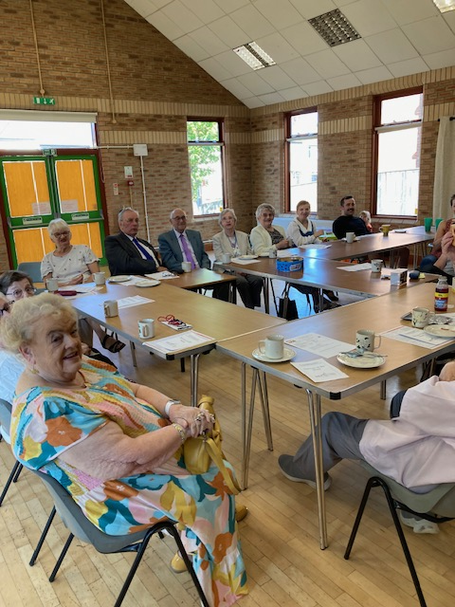would be happy to continue to do that, or hand

leadership over to a new minister. We have

run the Lent Course previously and are looking

into running the Blessing Course this year. In

worship and mission, we want to work alongside

the new incumbent not leave it all to them.

We see this as being part of our role as active,

practising Christians to support our Priest and

work as a team. We are most definitely a Church

who works together for the good of our Church

and each other. We will welcome the

opportunity to work alongside someone

who will challenge us, respect us and help us

to grow God’s work within our community.

*Bacon and Butties service*

**Outreach**

Like many churches, Covid had a major impact on us. Since that time we have in particular seen a drastic reduction particularly in the children and young people coming to church.

However, we are determined to reconnect with children and families. This is a time when new housing is being built around us, populated by unchurched residents. We are keen to build relationships with people who do not currently come to church and are open to new ways of worship to develop this. We appreciate that Church on a Sunday may not be the way to attract these people. We are happy, with a new incumbent, to explore ways that we can reach out in a meaningful way.

We recognise that we have to change. With the help of a new minister, we want to learn more about our faith, feel confident about welcoming new people into our Church and develop lay ministry.

One of the advantages of the vacancy has been the identification of gifts within our Church family and seeing individuals grow in confidence i.e., leading worship, preparing and reading intercessions, taking ownership of our Church and not being passive members. We hope with the aid of the new incumbent to continue to develop existing and new roles.

We want to work alongside the incumbent and not be passive partners as we are passionate about our Church and faith.

Our current congregation are aging and we are aware that we need to attract younger people from all walks of our community. Visiting clergy have all remarked how friendly we all are and how we are actively engaged in worship. The challenge for us is: how do we attract new members? We welcome the opportunity to develop new ideas and ways of working, so come and work with us to do that!

**Children and young people**

We want to highlight this aspect of mission. As noted, post-covid we have seen a huge reduction in the children and young people coming to church. The new incumbent needs to have a real commitment to developing our mission with this group.

We have a local amalgamated nursery, primary and junior school – Skerne Park Academy – within our parish. Before Covid we had good links with the school, and alongside our then curate, hosted events at the school and our Church. These included Christingle service at the school and a teddy bears wedding and introduction to Church and Communion at the Church. We are delighted that during the vacancy we have made contact with the academy again and been invited by them to conduct assemblies. We have taken their Harvest Festival Assembly and Christingle Assembly, and other times of collective worship. We have also been asked to assist in RE classes.

As a Church, we wanted to develop our mission with the young even while waiting for the next incumbent. We have undertaken Bacon Butties and Blessing services for young people and families when we have not had a Priest for Sunday service. We also restarted our Christian Halloween Party last year. These events have gone down well with the local community and we are keen to develop more family-friendly services.

We have three church members who are very keen to restart Junior Church as we get more children involved and, should the interest be there, restart a youth group. This was previously called Sunday at Five, and we had a group of between 6 and 12 individuals aged 10 to 16 who met to share food, listen to music and explore their faith. We seek the encouragement and leadership of the new incumbent, working with these volunteers, to resume church-based children’s and youth work.

We have a Rainbow and Brownie Group and are developing links with them in order to reinstate parade events at Church.

**Local charities and mission**

We try to support local charities and mission when we can. We have given to support the running of the Christmas Journey at St Matthew’s and St Luke’s church and to Kings Church Food Bank, which runs a weekly session from our church as a hub. We also have a designated Mission Fund which enables us to provide refreshments and provide other resources for mission activities. This is something we feel very strongly about as a Church.

Our previous incumbent always attended our jumble sales, in order to meet members of our community who would not normally attend Church, and we would like to continue this. Members of the public have commented how this made them feel part of the Church and we feel this is a great opportunity for mission. He also attended Cafe JJ’s on a regular basis and this again was a great way to meet people who would not come to Church and is a great potential for mission.

We open the Church up at public events so that individuals can enter the Church in a safe way and have found this is an opportunity for people to explore an unfamiliar environment and ask questions.

**4. Our Building, serving our mission**

Our building is brilliant!

St Columba's Church is set in an area of significant need, and is relatively new (built in approx. 1970) The thriving Community Centre was built/added in 2002 with a grant from The National Lottery Community Fund. At the same time, the PCC applied to various funders to build a Lady Chapel and refurbish the church.

The building is in use 7 days a week, with approximately 75% Community Centre usage.

The building is not listed and is very easy to maintain. We have a designated building fund which enables us to look after the building, and we keep it in a very good state of repair. With the Community Centre, we share the costs of a caretaker who goes above and beyond to keep both parts of the building – Community Centre and Church – well maintained and clean. All safety checks are carried out in a timely manner and records kept.

We have excellent kitchen and coffee bar facilities, and recently had the kitchen fully refurbished to catering standard.

Our heating system works well and we get lots of positive comments regarding how warm the building is. We have male, female and disabled access toilet facilities, and have recently had a defibrillator installed.

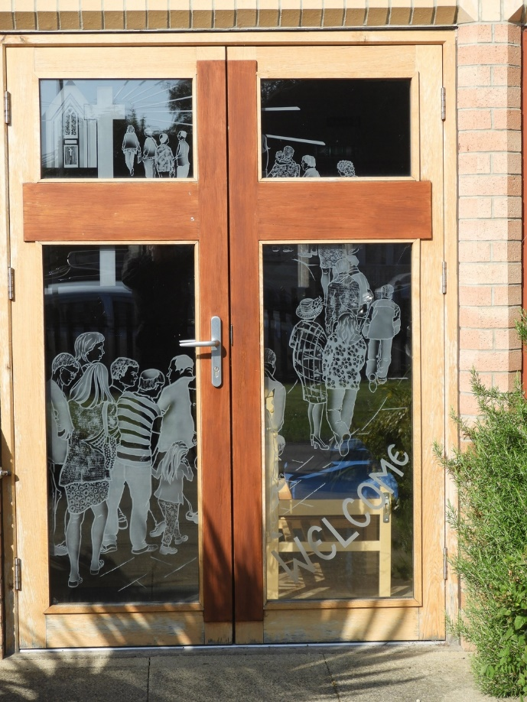We have had a new sound system installed in

2023 and are planning some maintenance

work on the etched doors to the Church

entrance. We previously fund-raised in order

to put in a stained glass window in the Lady

Chapel which has transformed this part of

the building.

There are things on the wish-list we would

like to do: we would like to look into creating

a foyer to the Church entrance in order to

protect the etched Church doors, but there

is no urgency for this.

We had a successful Quinquennial

inspection in 2023 year with no issues

of any note mentioned.

Our building is very sustainable, and our Treasurer negotiates the best options for our energy needs. We have registered as an eco Church and are looking forward to working with the Diocese in order to at least obtain a Bronze Award. This is obviously an ongoing, long term plan, though the majority of our lights are now LED. We are keen to explore the possibility of solar panels.

Our vision for the future is that our building it becomes even more embedded in the local community as a focal point, and we see the new incumbent as helping us to facilitate this by being a visible face of the Church. We would be open to sharing our resources with other churches and denominations, but again feel that we would look to the new incumbent to assist us with this.

**5. Giving, Finance and Generosity**

Despite the challenges experienced during lockdown and with decreased numbers post covid, we have been able to continue to pay our Parish Share – and we have always paid our full pledge.

We do need to fund raise in order to keep our finances in a healthy state and we do this cheerfully and willingly with the help of volunteers from the wider community. Although we are a small congregation with an aging population, people give as generously as they can. This is with their time as well as money. Our Treasurer lets us know in advance if he sees any problems so we can deal with them in a timely and organised manner. He produces statements for every PCC member prior to our meetings and is proactive in encouraging people to use Gift Aid. Finance is always an on the agenda at our PCC meeting and we are all aware of our responsibilities.

We do inform congregation if there are any difficulties coming up and do ask if giving can be increased. However as previously said, we are a small congregation, many of whom are on low incomes, so we tend to try fund raising as a way of raising money. This has worked well for us in the past.

We have a reserves policy in which funds not designated as specific use should be maintained at a level of between 3 and 6 months costs. This level has been maintained.

We have had legacies left to us in the past and our Treasurer is happy to discuss with individuals if they wish.

**6. Leadership, Governance and Safeguarding**

The PCC at St Columba’s meet every other month, or more if needed. We work and pray together as an effective team. We take responsibility for decision-making and ensure actions agreed are carried out. All make a conscious decision to be courteous, respectful of each other and we do not allow differences of opinion to escalate. Conflict is dealt with promptly and we have never left a meeting with bad feeling or upset. A compromise is always reached. We work very well together and involve the congregation where and when needed. Minutes are kept of all meetings.

We have two Deanery Synod representatives who feed back to the PCC. Safeguarding is always an agenda item. We have the Safeguarding Dashboard up and running and will soon be implementing level 3. We have two Parish Safeguarding Officers who keep the PCC and congregation updated. Training and DBS checks are kept up to date.

We have had young people on the PCC in the past (16 to 18) and would like to see this happen again. We are aware that we need to attract a greater diversity of people onto the PCC and would work with the incumbent to facilitate this. We have always managed to fill places on the PCC and have enjoyable, constructive meetings.

All posts are filled i.e., Churchwardens, Secretary, Treasurer, Deanery Synod representatives and Safeguarding Officers. We all are willing to take responsibility.

We look forward to continuing to share in the leadership and the governance of our church alongside a new incumbent as someone who will challenge us, respect us and help us to grow God’s work within our community.

**7. Our New Minister**

Prior to the present vacancy St Columba’s shared a minister with St John’s Church. Unfortunately, St John’s has now closed, and its parish has become part of St Herbert’s.

The diocese hopes to appoint a House-for-Duty minister to serve our parish. The expectation will be that the minister works the equivalent of three days a week – Sunday and two other days (either full days or worked as part days over the week).

Based on our needs and our hope, we are seeking a new Priest in Charge who will:

* **work with us and alongside us** in our mission in this parish;
* give us **leadership and confidence** in developing that mission;
* be committed to that mission, leading by example in helping us **engage with our community**;
* be able to support and be part of our **work with children and young people**, and help with further development in these areas;
* be an **encourager**;
* help us in **nurturing the faith and discipleship** of those who are involved in the life of the church;
* be committed to and skilled in the **development of lay ministry, lay leadership**, and helping church members to identify and grow in the use of their gifts;
* be a **prayerful person**, and able to encourage others in prayer;
* be a person who **models love and care** for the people of the congregation and the parish.