St Peter’s Church, Stockton on Tees
St John’s Church, Elton
Parishes Profile

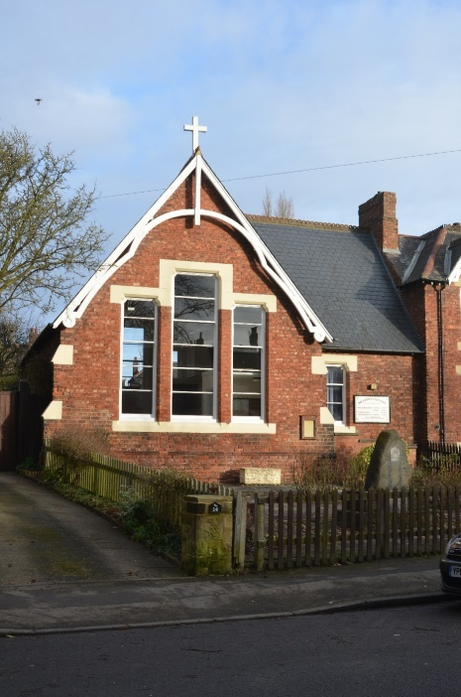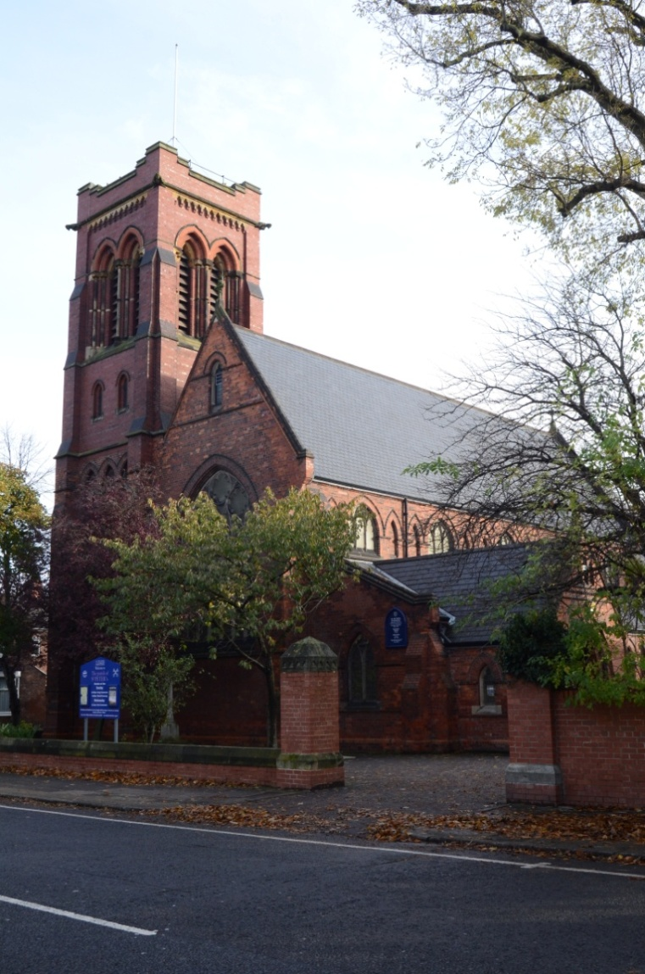

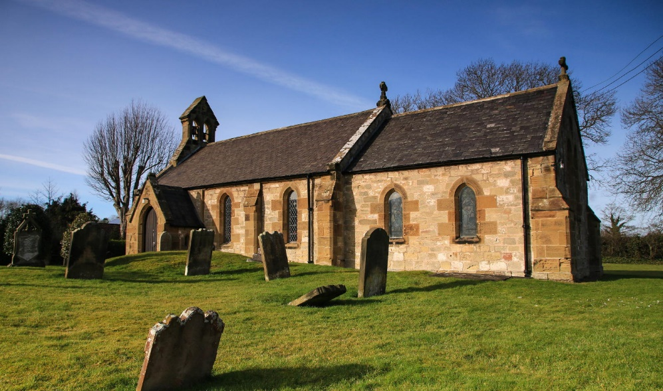

Vision and Mission in Stockton on Tees
At St Peter’s our commitment is to share God’s love with all, through worship and outreach.
At St John’s our mission is knowing God, and making God known. Our vision is directed to finding ways to make our mission a reality.
We share the Diocesan vision of ‘Blessing our communities in Jesus’ name for the transformation of us all’.
Person specification
We are looking for the new priest:
- To be a prayerful person who will offer vital spiritual leadership at St Peter’s, All Saints’ and St John’s.
- To work in partnership with a team of committed lay people in both parishes to nurture the faithful and reach out in Mission to the communities.
- To work with the Associate Priest and a small team of retired clergy, and to facilitate training placements for ordinands (which we have done recently).
- To work within the liberal Catholic tradition including the role of structured worship and the much valued musical heritage.
- To encourage, support and develop new initiatives and worship opportunities.
- To nurture discipleship through individual support, group study, parish weekends and retreats.
- To grow and develop our mission with all children and young adults. We have a committed lay team who are keen to expand this work.
- To support and engage with the Ecumenical links in the Yarm Road area and within the Deanery.

St Peter’s Church, Stockton on Tees
St Peter’s Church is located in the Parkfield and Oxbridge Ward of Stockton on Tees, close to the town centre. The parish was formed in 1875 and the church was dedicated in 1881. It is a fine red brick building with fixed pews, moveable chairs, panelling (including beautiful carved woodwork) and Victorian and modern stained-glass windows. The building is currently being reordered to create spaces for our missional activities, and when finished will have a new clergy vestry, entrance and kitchen. All Saints’ Church, the daughter church of St Peter’s, is situated in the suburb of Hartburn Village 1.5 miles southwest of St Peter’s. This former schoolhouse building was dedicated in 1912; it comprises a large open hall, with a small vestry, a kitchen and toilet facilities. There is a moveable altar and lectern for services.
St Peter’s parish has a strong and committed lay leadership team who assist with communion, read the lessons and intercessions, and also a small team of servers. There are 163 people on the Electoral Roll (as of May 2022). The average attendance at the Sunday 10am Eucharist is 60 – 80, and up to 20 at 6pm Evensong. We also hold a Wednesday morning Eucharist, plus extra services for Ash Wednesday, Holy Week etc. After the Sunday morning service, we serve parish breakfast (tea, coffee and biscuits). Baptisms usually take place at 12.00pm after the Eucharist has ended, unless the family request to have the baptism within the 10.00am service.
At All Saints’ there is a regular attendance of 15 – 20 at the Friday 9.45am Eucharist. Coffee and fellowship is shared afterwards.
We are defined by a liberal catholic tradition and an appreciation of choral music which contributes to the spiritual experience and attracts large number of non-church attendees at Advent, Christmas, Holy Week and Easter. We have an organist/choirmaster and a four-part choir that sings anthems and settings at both Sunday services. The choir is a founder and affiliated members of the RSCM; our Associate Priest (SSM) and retired clergy who take services wear vestments to reflect the traditional formality of our worship. We use the Common Worship Order One order of service at our main Eucharist, and the Book of Common Prayer for Choral Evensong. We regularly support local and national charities through our Christmas collections and at other times of the year. We employ a part time Parish Administrator who provides secretarial services to the clergy and the PCC. We have a good relationship with St John’s, supporting each other’s services and social events.
The parish is a mixture of town centre streets with multi occupied properties, businesses, new housing estates on brown field sites and suburban roads. Also within the parish is Hartburn Village, a popular and desirable residential conservation area, with a small parade of shops. The parish has links with two Primary schools: in addition, there are strong ecumenical links to the other churches in Yarm Road (Catholic, Methodist, United Reformed, Salvation Army and Church of the Nazarene).

Our Mission
Energising Growth
Some years ago we established Toddler Praise and Messy Church to attract new younger members and families. These initiatives were relatively successful, but we remain very aware that we need to energise growth. Our work with weekly Friday Praise (which replaced monthly Messy Church), a small Sunday School and Confirmation Classes are helping to deliver this strategy. We are particularly aware of our lack of work with secondary school children. A new post-confirmation group is designed to start work on this journey. Feedback we receive from new members tells us we are warm and welcoming. We do provide a real welcome for multicultural families and are delighted that people from other backgrounds have joined our PCC, bringing new ideas and ways of working from their different experiences. The building reordering programme, under the banner of ‘The Way Forward’ has already created a community facing accessible entrance, and in the near future will provide kitchen facilities for our Wednesday ESOL classes and workshops. The recent Advent Fair and New Year Turkish Celebration drew in many local residents including asylum seekers and refugees.
Children and Young People
We have good relationships with two local authority primary schools within the Parish, hosting Christingle and other services for them. Prior to the pandemic lay volunteers delivered ‘Open the Book’ events and provided individual reading support in both schools. We aim to restart these initiatives when capacity proves possible again. Since 2019 we have provided a weekly holiday club over the Summer for local children who are in receipt of free school meals. Children and family work is very important to us and takes place on a weekly basis in Sunday School, Toddler Praise, and an after-school club on Fridays. This provides regular contact with 30 families who are also supported via WhatsApp groups. This has led to 9 children being confirmed and a new junior choir started in Autumn 2022. Baptisms take place almost every week engaging with more families. In recent months a Junior Choir has been formed. Presently they sing at the Sunday Eucharist, and rehearse with the adult members on Friday evenings.
Challenging Poverty
We work with the Salvation Army Foodbank and we provide a Summer Holiday Club, both of which are designed to challenge poverty. In addition, we open the church as a Warm Space every Thursday morning for coffee and cake, which attracts between 15 and 20 older people. The ESOL Café takes place every Wednesday providing three levels of English Teaching to newly arrived asylum seekers. It also provides much appreciated advice, information, household goods, clothes, bedding, toiletries, and a hot meal, which is cooked by a rota of members from Syria, Afghanistan, El Salvador, Kurdistan, and Turkey. We usually feed 40 people each week. In partnership with A Way Out, a Christian Charity, a small group of volunteers from St Peter’s support our local street workers, meeting them where they are on the streets around the Church. We also support Recovery Connections who work with addicts many of whom live in the bedsits around the Church, they use our facilities for group work sessions each week.
Caring for God’s Creation
We are a Fairtrade Parish, selling and using Fairtrade products for all catering and cleaning activities. We are committed to recycling wherever possible. We are fitting LED lighting and closely monitor our energy use. We have also entered into early discussions with the Wildlife Trust about possible community use of our rear gardens.

Our vision for the future
We have a good foundation of missional work established in recent years, discerned through the Diocesan PMC process. We hope to work with the new priest to grow and develop existing and new missional opportunities. Ideas include:
- Maintaining and sustaining our current outreach with asylum seekers and refugees.
- Developing new outreach with adolescents and young adults.
- Establishing a partnership with a relevant charity to establish a Lunch Club based on our Warm Space work.
- Embedding the ethos of Generous Giving within the congregation.
- Improving the support in discipleship via individual and group study.
- Completing the reordering of the church building, including raising the balance of funding required
- Maintaining the quality of the music tradition, including concerts.

Leadership and Governance
St Peter’s PCC is a good reflection of the diversity of the congregation including members of Indian, Kurdish and Nigerian origin. We are fortunate to have a healthy mix of skills and experience who have a good grasp of their responsibilities. It is not difficult to fill places on the PCC nor for people to speak up and hear a range of opinions. Any disagreements are dealt with via dialogue and focused agenda items. St Peter’s has four places on Deanery Synod, provides the Deanery Secretary and has two members on Diocesan Synod. The Lay Chair is a member of Bishop’s Council.
During the Vacancy the five members of the Standing Committee meet before each PCC with our Associate Priest who has a full-time job as a Funeral Director. A small group of retired clergy helps with our worship and meets with the Administrator and Associate Priest regularly to manage the worship rota with the Church Wardens.
The Safeguarding Agenda is led by the PSO and Administrator. St Peter’s has joined the Diocesan Dashboard and has a well-developed action plan. Safeguarding is well embedded within parish life. Basic awareness and leadership training have been accessed either online or face to face basis across a wide range of volunteers and PCC members. The range and number of volunteers working across all activities is a God given gift.
Finance and generous giving
Our parish faced financial challenges during the pandemic; however, we have been able to pay our Parish Share in full.
St Peter’s endeavours to be a generous parish; we encourage regular giving through the Parish Giving Scheme. We have received financial support and donations from the congregation and from former members of the church towards the Way Forward Programme. We have recently undertaken a Generous Giving project following a visit by the Diocesan Generous Giving Officer. We also run a 100 Club Draw which raises funds for the church.
A copy of the Accounts for 2022 is attached.

Buildings For Mission
St Peter’s is an attractive red brick Victorian Church built in 1881. The church hall was sold many years ago. The church is well maintained and cared for. The interior of the church is partly wood panelled, with beautiful old and new stained-glass windows. There are fixed wooden pews at the front of the church, but they have been removed at the back to create a space for flexible worship and activities. Over the last 10 years we have been developing a Reordering Programme designed to deliver a fully accessible community facing multipurpose building. The Way Forward Programme is partially complete and has benefitted from significant grant funded charitable donations. The priority for the future in the plan includes a catering kitchen and additional toilets. St Peter’s worship and missional activity means the Church is used every day; however, there is still space for the occasional offices.
All Saints’ Church in Hartburn Village is in the more affluent area of the Parish. It provides a large hall suitable for family events, WI, Choir, Keep Fit and Brownies.
St Peter’s also owns a house which is let on a long-term basis. The house provides collateral for the Diocesan loan granted to support the reordering work.

Current service patterns
At St Peter’s there is a 10am Eucharist and 6pm Evensong every Sunday, and a midweek said Eucharist on Wednesdays. At All Saints’ there is a said Eucharist followed by coffee every Friday morning. These patterns have changed in response to clergy availability during the Vacancy and the pandemic. Extra services are held for Ash Wednesday, Holy Week, Easter, Ascension Day and other significant festal days. The Sunday services are enhanced by the choir who lead the hymns and sing anthems and psalms. We use Common Worship Order One liturgy and the Book of Common Prayer.

Occasional Offices
At St Peter’s and All Saints’ the statistics for the occasional offices is affected by the restrictions of lockdown during the pandemic.

The Vicarage and the local area
The original vicarage next to St Peter’s church was sold some years ago and has been replaced by a modern four bedroomed detached house on the Lower Hartburn estate, which is five minutes’ walk from St Peter’s and a five minute drive from St John’s. It has a lounge, dining room/kitchen, utility room, four bedrooms with one en-suite and a family bathroom. In addition, there is a large study with separate toilet facilities. Outside there is a small garden round three sides of the property and a double garage. It is well maintained and offers comfortable and practical accommodation for the incumbent. It has been recently redecorated.
In the centre of Stockton on Tees there are shops and a vibrant weekly market; the centre is currently undergoing a huge transformation to open up the riverside area with entertainment space and cafes etc. There is also a library, leisure facilities including a white-water canoeing centre, a local history museum and a beautiful Victorian park. Stockton is a short drive from the North Yorkshire Moors (30 mins), the coast (30 mins), Durham (30mins), Newcastle (40 mins) and York (60 mins). This gives the advantages of town living but you are never too far away from beautiful open countryside. There is a fireworks display on Bonfire Night, the Riverside Festival (four days of arts and street theatre) and the Arc arts centre which holds plays, musical events and a small cinema. Teesside Park leisure and shopping centre is a 10-minute drive away, offering a large out of town shopping experience.

St Peter’s Church

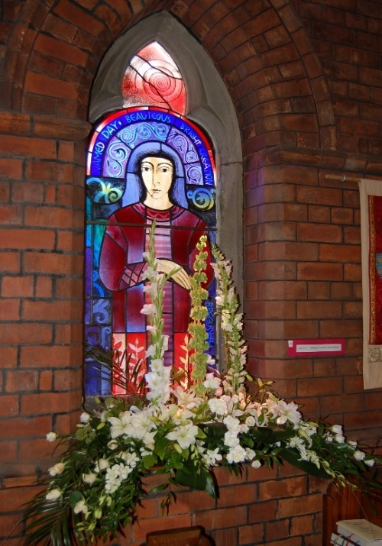
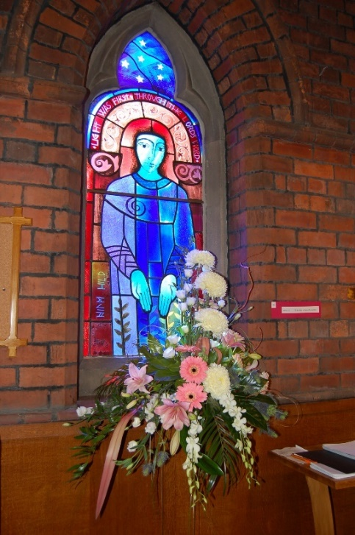

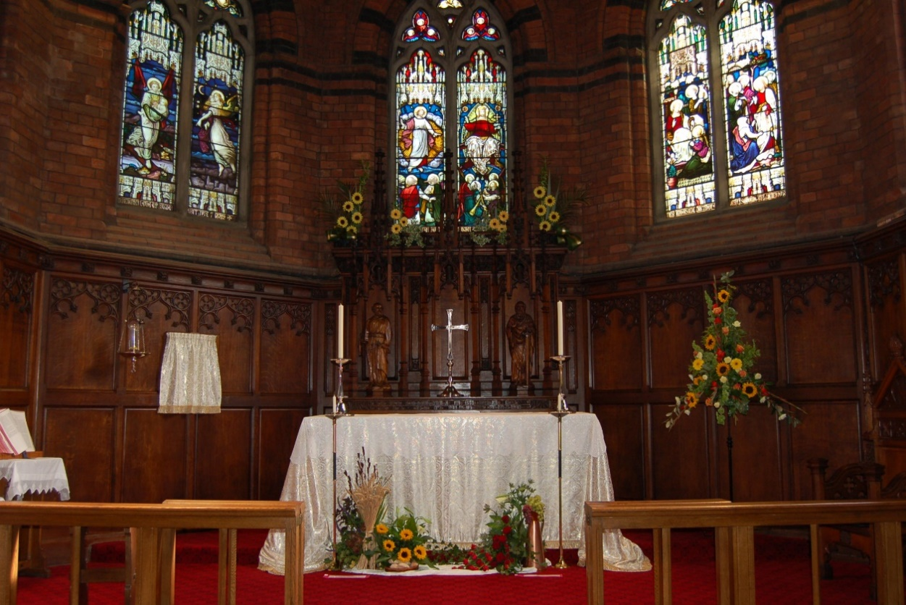

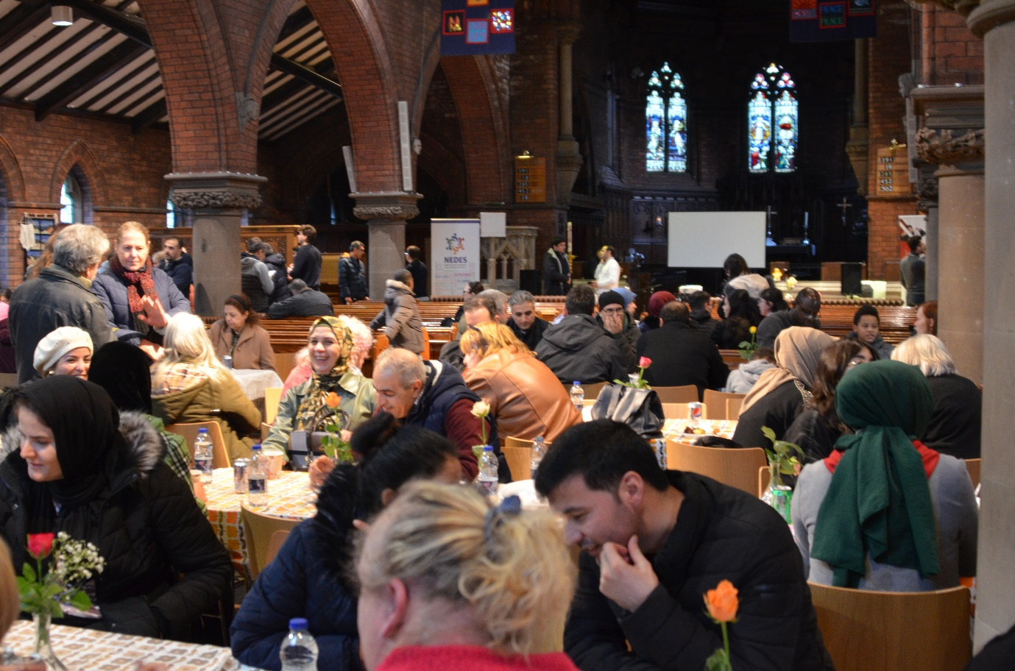

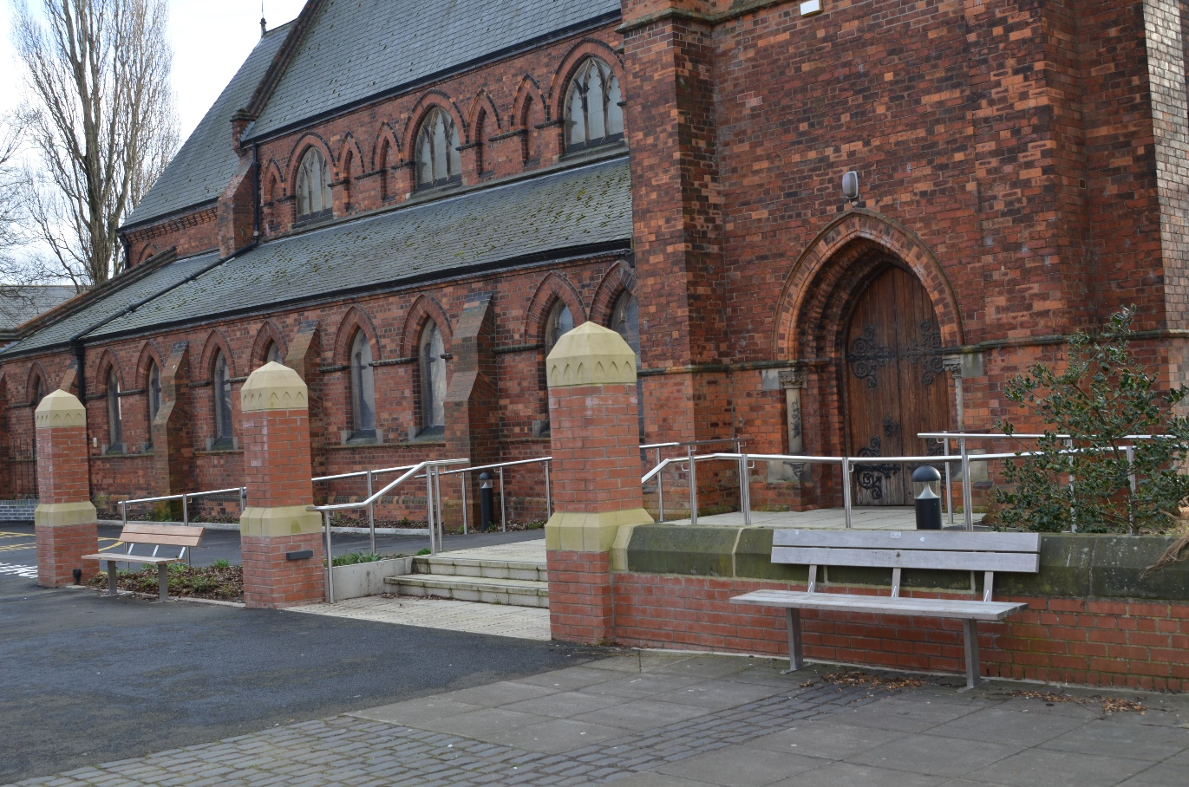

Additional information
Enquiries about this post can be directed to the Archdeacon of Auckland, the Venerable Rick Simpson by emailing Archdeacon.of.Auckland@durham.anglican.org
Information about our Diocese is available at https://durhamdiocese.org
Information about St Peter’s parish is available at https://www.stpetersstockton.org or by visiting our Facebook page at https://www.facebook.com/SPeterYarmRd

St John’s, Elton
St John’s Church is situated in Elton, a parish of about 260 residents. The village is located approximately half a mile from Hartburn Village and 2.5 miles from St. Peter’s Church. The village, surrounded by farms and small holdings, has a residential nursing home, but no school or community centre. A large (900+) housing estate is now being built close to both parishes.
There are 41 people on the Electoral Roll. The usual Sunday attendance is 25 to 30. This increases to 40 plus for special services. Based on the attendance figures for the last 4, 8 and 12 years, attendance has never been better. Monthly Evensong has an attendance of 12 to 15 people.
As well as Elton Hall Residential Care Home we are also linked to Park House Rest Home, situated in Stockton. Monthly communion services are offered in both, led by our Authorised Lay Minister. The ALM also takes home communion for those unable to attend Church and leads the monthly Evensong. In the congregation there are 11 readers, 3 eucharist assistants and an organist. There is also a small team who manage and oversee the general cleaning and maintenance of the Church and Churchyard. Most members of the congregation are involved and willing to help with, cleaning, providing flowers, knitting, and supporting charitable organisations. Over the years we have supported, Christian Aid, Macmillian Nurses, the hostel for the homeless, Harbour Refuge and Mission for Seafarers amongst others.
The majority of the congregation is aged over 60 years, with younger attendees being mostly visiting family members. Most travel to Church by car from Hartburn, Eaglescliffe, Fairfield and outlying parts of the Parish. St. John’s is a friendly and welcoming church. Refreshments are served after Holy Communion which enables people to socialise. We keep in touch with members who are unable to come to church, offering home communion or just a friendly visit or a phone call.
We have a good relationship with St. Peter’s and All Saints' Hartburn Churches, attending special services and supporting events, such as concerts, the Christmas Fair and Parish trips. Specific communications are normally via e-mail and general communications between the Churches is via the weekly ‘News in the Pews’ and the monthly ‘Shout’ leaflet. The Parish Administrator, Sue Mines, is employed as a shared resource by Elton for background office activities eg. Sunday readings and photocopying.

Our Mission
Mission is always included on the PCC agenda at St John’s and is regularly under review. One objective is to increase our profile, both in the immediate locality and the wider area. We would love to have younger people coming into church as we do have an ageing congregation. The new housing estate currently under development may offer an opportunity to progress this. We have previously distributed newsletters in the Parish with positive results. We plan to continue this and have an “Open Church” event with refreshments on offer. We are also planning a memorial service for bereaved families. The village is regularly visited by cycling groups and walkers, who often rest on the village seat situated by the Church wall. Visitors who enter the building comment on the beauty of the interior. We offer a distinctive form of worship (1662 Prayer Book Communion) and we know that this has attracted new worshippers.

Leadership and Governance
Governance at St John’s is overseen by the PCC, which meets regularly to discuss matters in hand and to plan ahead. Active participation in discussions is encouraged. Minutes of meetings are published. There is a tradition of providing support to our clergy.

Finance and generous giving
The congregation at St John’s has a positive and generous attitude to giving, appreciative of the benefits of planned giving and gift aid. As custodians of an old church building, prudently we recognise that we need a level of reserve funds to meet the inevitable cost of building work and other contingencies. We run a Bonus Ball Draw, with profits going towards the maintenance of the Churchyard.
A copy of the 2022 accounts is attached.

Buildings For Mission
St John’s Church is a Grade II listed 19th Century stone building in an open churchyard. The interior has a Comper screen and medieval effigy, stained glass windows and general fine furnishings, which usually impress visitors. It is well maintained by professional help, when required, but mainly by a small group of skilled volunteers. The history of the Church goes back to the 12th Century with a list of incumbents recorded up to the present day. A full history of the Church was compiled about five years ago, by a group of parishioners. The Church can comfortably accommodate 50 to 60 people, suitable for smaller baptisms, weddings, and funerals. It is equipped with a modern, good quality, freestanding organ, a modern mobile font as well as the original stone font and is heated by electric wall heaters. Work is currently being planned to deal with problems of damp, and also some roof work, which is likely to be phased over the next two to three years. The Church has no running water or toilet facilities. The open Churchyard has an area for the internment of ashes, and we have a plan and records of all graves, names, and numbers. There are several pre-booked graves.

Current service patterns
At St John’s every Sunday there is a 9am Holy Communion using the Book of Common Prayer. Hymns are from The English Hymnal. The New Revised Standard Version (NRSV) Bible is used. This has not changed for several years. The use of BCP has attracted several newcomers to St. John’s over the years. The timing allows the sharing of clergy between St. Peter’s and St. John’s. Evensong is held on the fourth Sunday of the month at 6.30pm during the summer (April to September). Recently the service has been continued through the Autumn and Winter, with the time being changed to 4pm. This is led by the ALM.

Occasional Offices
At St John’s there are additional occasional offices, and the summary is as follows:
The occasional offices are led by the retired clergy and the Associate Priest during the Vacancy.

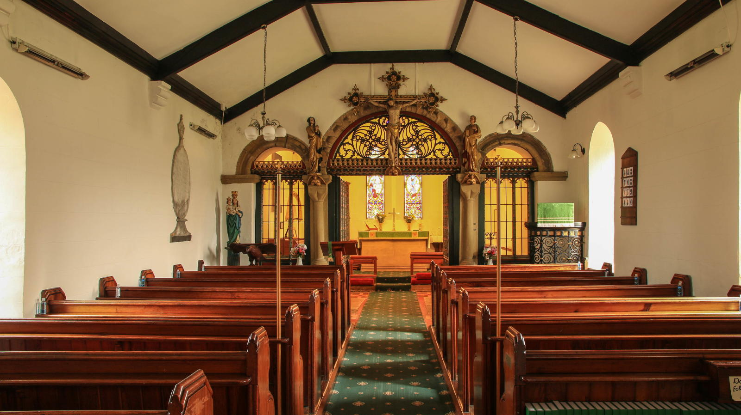

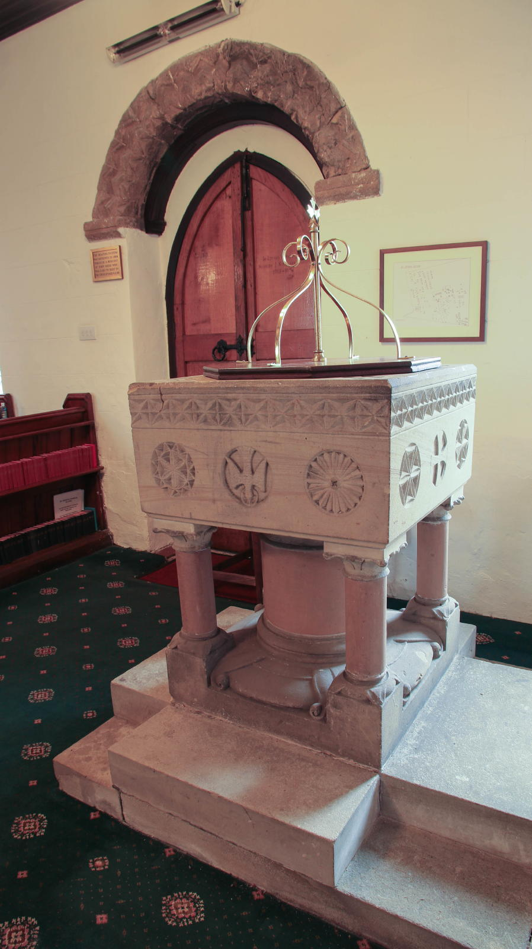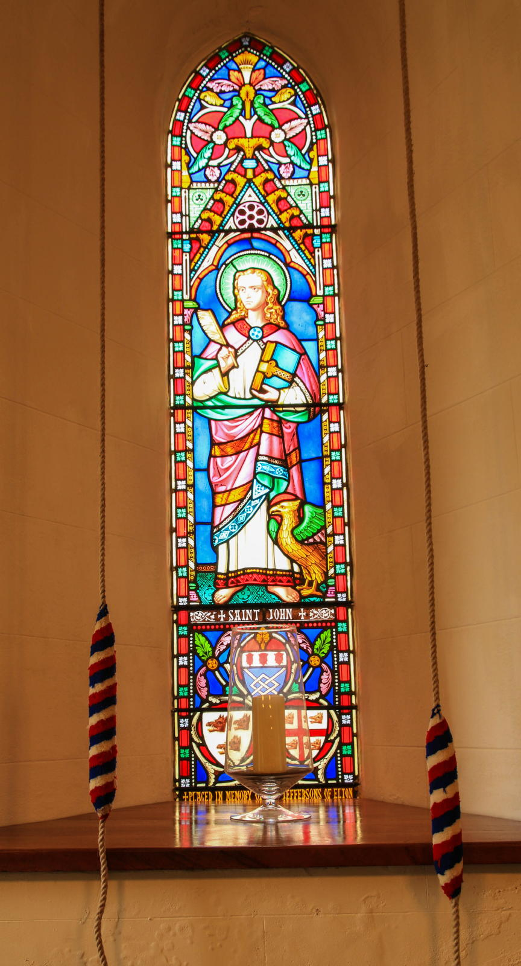

Additional information
Enquiries about this post can be directed to the Archdeacon of Auckland, the Venerable Rick Simpson by emailing Archdeacon.of.Auckland@durham.anglican.org
Information about our Diocese is available at https://durhamdiocese.org
Information about St John’s parish is available at https://www.achurchnearyou.com/church/13629

