PALM SUNDAY
Hosanna to the Son of David, the King of Israel.
Blessed is he who comes in the name of the Lord.
Hosanna in the highest.
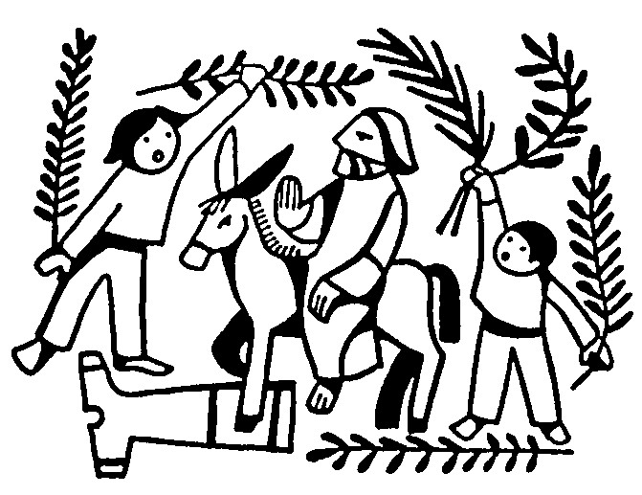

God our Saviour,
whose Son Jesus Christ entered Jerusalem as Messiah to suffer and to die;
let these palms be for us signs of his victory,
and grant that we who bear them in his name
may ever hail him as our King,
and follow him in the way that leads to eternal life;
who is alive and reigns with you,
in the unity of the Holy Spirit,
one God, now and forever.
Amen.

The Palm Gospel Read Matthew 21.1-11

The Collect Let us pray

True and humble king,
hailed by the crowd as Messiah:
grant us the faith to know you and love you,
that we may be found beside you
on the way of the cross,
which is the path of glory.
Amen.

The Passion Reading
Read Matthew 26.14-end of chapter 27
You may like to keep a time of silence afterwards

Prayers Spend some time in prayer perhaps letting people, situations, places come to mind. You don’t have to use words and silence is often best. Alternatively, you may prefer to light a candle as an act of prayer.

The Lord’s Prayer, followed by

Lord Jesus Christ,
when you rode into Jerusalem
the people waved palms
with shouts of acclamation.
Grant that when the shouting dies
we may still walk beside you even to a cross.
Amen.

HOLY WEEK

We can keep Holy Week together as best as we are able from the comfort of our own homes. Our suggestion is this: using the resources we have already sent to you, try to say Compline (Night Prayer) Monday, Tuesday, Wednesday and Friday of Holy Week at 7pm; the Maundy Thursday material at 7pm, and Good Friday Stations at 2pm. Compline is the last Office of the day in religious communities. The name Compline is from the Latin completorium meaning ‘completion’. It is spoken or chanted. It is deliberately simple with no adornments but mere silence for quiet reflection as appropriate.
In place of the readings already given in your resources pack you may instead like to use the following Gospel readings:

Monday John 12.1-11
Tuesday John 12.20-36
Wednesday John 13.21-32
Friday John 19.38-42

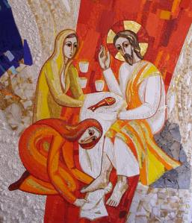

MAUNDY THURSDAY

Let us pray that we may love one another as Christ has loved us.

Reading 1 Corinthians 11.23-26

On this night as we recall the institution of the Eucharist let us hold one another in prayer and look forward to the day when we can meet and partake together once more. So, we still pray with confidence

God our Father,
you have invited us to share in the supper
which your Son gave to his Church
to proclaim his death until he comes:
may he nourish us by his presence,
and unite us in his love;
which is alive and reigns with you,
in the unity of the Holy Spirit,
one God, now and forever.
Amen.
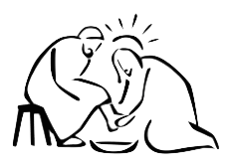

Reading John 13.1-17, 31b-35

Ubi caritas et amor, Deus ibi est.
Where charity and love are, God is there.

Prayers use the ones below and/or add your own before finishing with the Lord’s Prayer

Infinite, intimate God;
this night you kneel before your friends
and wash our feet.
Bound together in your love,
trembling, we drink your cup and watch.
Amen

Lord Jesus Christ,
you have taught us
that what we do for the least of our brothers and sisters
we do also for you:
give us the will to be the servant of others
as you were the servant of all,
and gave up your life and died for us,
but are alive and reign, now and for ever.
Amen

The Watch though we are not in church you still may like to set aside some time for silent prayer as we ‘go out into the night’ and contemplate Christ’s agony in Gethsemane.

Stay with me, remain here with me,
watch and pray, watch and pray.

The Gospel of the Watch Luke 22.31-62

Christ was obedient unto death. Go in his peace.

GOOD FRIDAY – STATIONS OF THE CROSS

The ‘Stations’ or ‘Way of the Cross’ have been prayed for centuries. They allow us to follow in the footsteps of Christ – actively, prayerfully and imaginatively engaging in his journey. Traditionally there were 14 stations: 9 scriptural stations and 5 based on popular devotions. Pope John Paul II developed a fully scriptural set of stations which are commonly used and are included in the Church of England’s seasonal material. Usually there are tableaux or images to aid this devotion, and you will find plenty online, however in this time of self-isolation the titles of the stations coupled with scripture and silence remain a helpful aid for a personal pilgrimage of prayer.
How to do this:
- Begin with the opening prayer
- Then say the name of the first Station, then pray:
We adore you, O Christ, and we bless you,
because by your holy cross you have redeemed the world.
- Read the scripture that accompanies the Station
- Spend some time in quiet reflection or imaginative contemplation – who or what can I see, hear? How does this make me feel? What do I wish to say to God about this?
- Pray the following
Holy God,
holy and strong,
holy and immortal,
have mercy upon us.
- Move onto the next Station and continue as outlined above until you have prayed through all of them.

Gracious and eternal God,
look with mercy on this your family
for which our Lord Jesus Christ was willing
to be betrayed into the hands of his adversaries
and to suffer death upon the cross;
and grant us to rejoice
in the benefits of his passion;
through him who lives and reigns
with you and the Holy Spirit,
one God now and for ever. Amen.

First Station:
Jesus in agony in the garden of Gethsemane
Mark 14.32-36

Second Station:
Jesus betrayed by Judas and arrested
Mark 14.43-46

Third Station:
Jesus condemned by the Sanhedrin
Mark 14.55-64

Fourth Station:
Peter denies Jesus
Mark 14.72

Fifth Station:
Jesus judged by Pilate
Mark 15.14,15

Sixth Station:
Jesus scourged and crowned with thorns
Mark 15.17-19

Seventh Station:
Jesus carries the cross
Mark 15.20

Eighth Station:
Simon of Cyrene helps Jesus to carry the cross
Mark 15.21

Ninth Station:
Jesus meets the women of Jerusalem
Luke 23.27-31

Tenth Station:
Jesus is crucified
Mark 15.24

Eleventh Station:
Jesus promises the kingdom to the penitent thief
Luke 23.39-43

Twelfth Station:
Jesus on the cross; his mother and his friend
John 19.26, 27

Thirteenth Station:
Jesus dies on the cross
Mark 15.34-37

Fourteenth Station:
Jesus laid in the tomb
Mark 15.46

The Lord’s Prayer followed by

Lord Jesus Christ,
as we kneel at the foot of your cross,
help us to see and know your love for us,
so that we may place at your feet
all that we have and are.
Amen

May God bless us,
that in us may be found love and humility,
obedience and thanksgiving,
discipline, gentleness and peace.
Amen

HOLY SATURDAY MORNING

Christ’s body lies in the tomb.
Yet you may recall the unusual phrase in the Creed, ‘he descended into hell’. Orthodox Christians understand this period as the ‘Harrowing of Hell’ whereby Christ descends and enters the darkest of places in order to release the dead, hence the many icons and paintings depicting this scene. Christ is seen standing triumphantly on a cross, representing the defeat of death and holding out his hand to lead out the newly liberated from this place of the dead. This is a joyous moment and a foretaste for the Easter celebration to come.

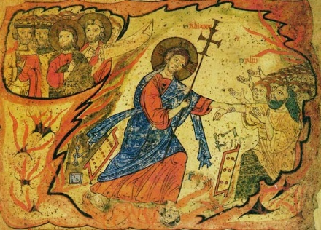

Whatever your view of such theology it can serve as a prompt for reflection on our own ‘hellish’ experiences for indeed many of us will have known or, alas, still know places or times of darkness. How did you get through? Who grasped your hand to pull you out? Who is helping you now?
Above all, this is a day of intense quiet and stillness.
There is a nothingness, an emptiness.
Silence hangs in the air.
And all we can do is wait….

HOLY SATURDAY EVENING: EASTER EVE VIGIL

Begin this when it goes dark outside.
It continues our time of reflecting and waiting and follows a pattern of readings and silence as we begin to contemplate redemption and hope.
You might wish to light a candle before you start.

The Creation Genesis 1.1-2.4a; Psalm 104.1-7
Silence is kept
Crossing the Red Sea Exodus 14.10-end, 15.1a
Silence is kept
The Valley of Dry Bones Ezekiel 37.1-14, Psalm 126
Silence is kept

The Lord’s Prayer

Bless the Lord, my soul, and bless God’s holy name.
Bless the Lord, my soul, who leads me into life.

Lighten our darkness, Lord, we pray,
and in your great mercy
defend us from all perils and dangers of this night,
for the love of your only Son,
our Saviour, Jesus Christ. Amen
EASTER SUNDAY

This is the day when our Lord Jesus Christ passed from death to life. Throughout the world Christians celebrate the mighty power of God as Christ calls us out of darkness to share in his marvellous light. May we, and all Christ’s people, shine as lights in the world to the glory of God the Father.
Light a candle.

The Exsultet (Easter Song of Praise – introduction only)

Rejoice, heavenly powers! Sing, choirs of angels!
O Universe, dance around God’s throne!
Jesus Christ, our King, is risen!
Sound the victorious trumpet of salvation!
Rejoice O earth in glory, revealing the splendour of your creation,
radiant in the brightness of your triumphant King!
Christ has conquered! Now his life and glory fill you!
Darkness vanishes for ever!
Rejoice, O Mother Church! Exult in glory!
The risen Saviour, our Lord of life, shines upon you!
Let all God’s people sing and shout for joy.

Let us pray
God of glory,
by the raising of your Son
you have broken the chains of death and hell:
fill your Church with faith and hope;
for a new day has dawned
and the way to life stands open in our Saviour Jesus Christ. Amen

Readings Acts 10.34-43; Psalm 114; John 20.1-18
Imagine this Gospel scene and hold the resurrection in your heart.

Prayers using your own words or silence let us hold the needs of the world in prayer, so too our worldwide churches, our families and friends and look forward in hope to the day when we can worship together in person. Follow this with the Lord’s prayer, then
Risen Lord Jesus,
as Mary Magdalene met you in the garden
on the morning of your resurrection
so may we meet you today and every day:
speak to us as you spoke to her;
reveal yourself as the living Lord;
renew our hope and kindle our joy;
and send us to share the good news with others. Amen

Alleluia. Christ is risen.
He is risen indeed. Alleluia!

God, who through the resurrection of our Lord Jesus Christ has given us the victory, give us joy and peace in our faith, and the blessing of God almighty, Father, Son, and Holy Spirit, be with us and remain with us for ever. Amen.

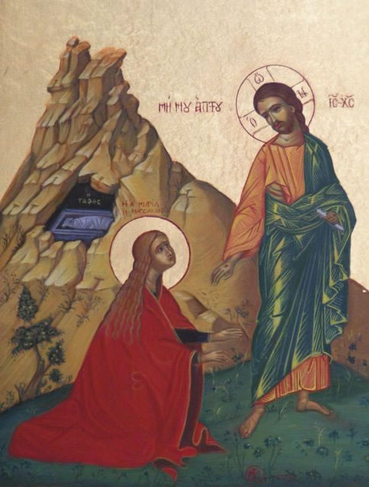

Common Worship: Times and Seasons, material from which is included in this service, is copyright © The Archbishops’ Council 2006. A New Zealand Prayer book, © 1989 The Anglican Church in Aotearoa, New Zealand and Polynesia

