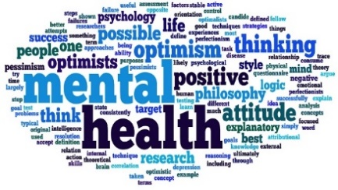

Dioceses of Durham and Newcastle
Boards of Education

Mental Health in Schools Conference
Wednesday 5th July 2017
Marriott Hotel Metro Centre | Gateshead | NE11 9XF

Time | Item | Lead
09.00 | Registration and Coffee
09.30 | Conference Commences | Introduction from Paul Rickeard
09.35 | Introduction to the Day | Gill Hedworth - Education Consultant in Behaviour and Well-being
09.50 | Policy and Practice in Schools | Minds Ahead – Leeds Carnegie Centre for Excellence in Mental Health - Claire Wong Consultant
10.20 | What Works in Schools | Gill Hedworth
10.45 | Coffee Break
11.00 | Local Overview – Emotional Health | CAHMS – Rhian Davies and Angela Miller
11.45 | Emotionally Healthy School Quality Mark – Audit your own School and plan how to gain this Award | Claire Wong and Gill Hedworth
12.25 | Close by Deputy Leader of Newcastle City Council | Joyce McCarty
12.30 | Lunch
13.30 | Workshop Sessions  *Workshops will last approximately 50 minutes and you will get the opportunity to attend all three
 | Workshop 1 - Resilience | Threedom Solutions
 | Workshop 2 - Self-Harm Primary and Secondary | CAHMS
 | Workshop 3 - Anxiety | Minds Ahead
16.30 | Conference Concludes

