**Associate (Interim) Minister**

**in the**

**Great Aycliffe Team**

(to be known locally as “Team Vicar”)

**Parish Profile**

Please find below details of the parish of Great Aycliffe, for which we are seeking a Team Vicar.

This profile needs to be read in conjunction with the Role Description and Person Specification document, which explains the very particular circumstances of – and skills needed for – this post.

This is an Interim Ministry role, for a period of up to three years. It is possible that it may be extended for up to three years, or offered as a Team Vicar role (Common Tenure). However, decisions about this depend upon the progress of development work within the parish under the leadership of the ICM and the needs and opportunities that are discerned as this time of interim leadership concludes. This is expected to be roughly two years.

This is a full-time post, with a full stipend, pension and provision of suitable housing in the parish. (If an applicant wishes to request a housing allowance instead, we would ask you to raise this at the point of application; any decision about this is at the discretion of the Bishop.)

Thank you very much for your interest in this post.

**Our Diocesan Vision -** An introduction from Bishop Sarah

This is an exciting time to be exploring joining the Diocesan family in Durham Diocese. We are on the cusp of a fresh chapter in our mission and ministry together. We are currently discerning with the National Church who will be the next Bishop of Durham, called to lead as we seek to make real our vision for the transformation we so desire across our Diocese. We were deeply encouraged by the award last year of significant national funding, demonstrating real confidence in our vision.

Our strategy for transformation and missional growth (‘Called to Fruitfulness’) is an opportunity and invitation for each of our parishes to step out in faith together, responding practically to our priorities to ***Challenge Poverty, Energise Growth, Care for God’s Creation*** and ***Engage with Children, Youth and Young Adults***. Making this a reality it will look different in every community. In some places it will come about in collaboration with others. Nobody is expected to do everything immediately or alone, but we are all invited and expected to find ways to respond relevantly.

In Great Aycliffe this feels particularly relevant, as the parish is working with an Interim Change Minister, seeking to develop its worship and mission, open to the changes that God is leading them to make to embrace a vibrant future.

In praying for a Team Vicar here we are looking for someone excited by and wanting to be part of this vision and new future, locally and in the Diocese. Together we pray hopefully

***Loving God****, guiding the people of Durham Diocese faithfully through the years:*

*We thank you for saints who have marked our path,  
young and old, known and unknown, from all places and in all walks of life.  
Help us to find your way in our generation:*

*transformed by your truth, sharing your life, blessing our communities.*

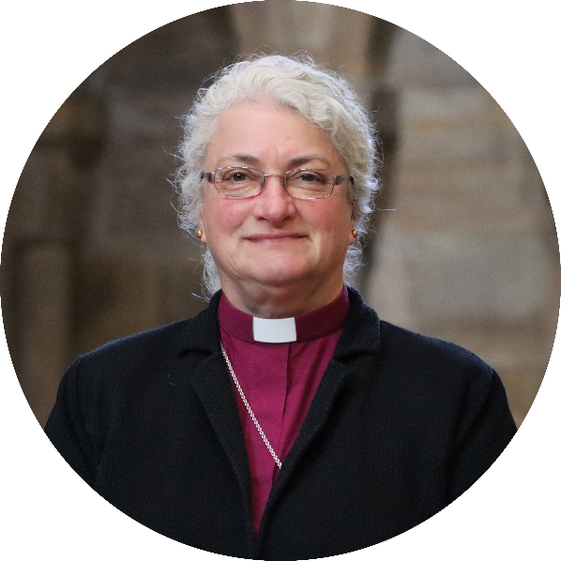*Through Jesus Christ our Lord,*

***Amen***

We look forward to meeting together  
and sharing in this with you.

In Christ,

**+Sarah**

**Bishop of Jarrow**

**Acting Bishop of Durham**

**DESCRIPTION OF THE PARISH**

The Parish of Great Aycliffe currently encompasses the area of Newton Aycliffe, Aycliffe Village, Brafferton, Aycliffe Industrial Estate, parts of School Aycliffe, Coatham Mundeville and Preston-le-Skerne.

The total population of the area approximates to 35,000 and the parish is continuing to grow as new housing developments appear. We are a mixed parish with pockets of deprivation but through the expansion of local industry there are also parts of the parish which are considered to be thriving. The ethnicity of the area is almost exclusively white European.

Facilities in the area include:

· two Academy schools (11-16 years)

· nine infant/junior schools (one Church of England and two Roman Catholic)

· four community centres and one youth centre

· two leisure centres and three golf clubs

· a number of local health centres and two substantial hospitals within a few miles

· seven nursing homes

· a number of smaller shopping centres and a larger unit within the town centre

· additionally there is a Young People Centre and Walworth Special School.

In general the whole area has easy road and rail access, a local airport and a major port within 15 to 20 miles. There is a range of open spaces e.g. wetlands, a 5 mile circular walk through fields and woods and a number of nature reserves.

It is within easy reach of Durham City, York, Newcastle, Sunderland and Teesside. Junction 59 on A1M and the East coast mainline are a short drive away.

The parish has four places of worship, namely:

* St Andrew’s Parish Church in Aycliffe Village
* 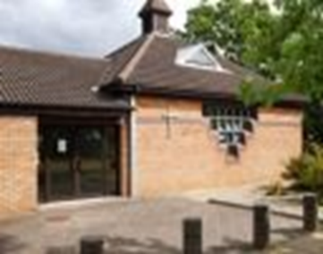St Clare's Parish Church in Newton Aycliffe town centre
* St Elizabeth's licensed worship centre in Woodham (Newton Aycliffe)
* St Francis Chapel within a school in Horndale (Newton Aycliffe).

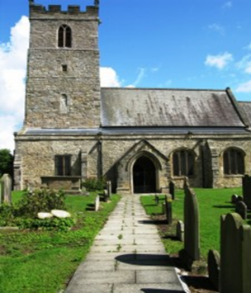

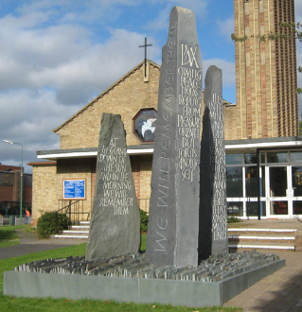

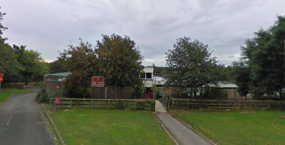

There is a Parish Office which is staffed by a paid Parish Assistant on Thursday mornings and for a couple of hours mid-week.

**MINISTRY**

The clergy team currently comprises an Interim Change Minister, who works across all three churches and the whole parish. There are three wardens with a vacancy for a fourth.

We have a Licensed Lay Minister and a number of people have completed the Wings for Worship training delivered by the Diocese, so are licensed to preach within the parish a few times each year.

**INDIVIDUAL CHURCH DESCRIPTIONS**

**ST ANDREW’S CHURCH, AYCLIFFE VILLAGE**

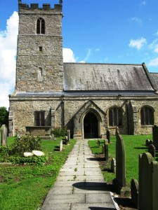

St Andrew’s is a Grade I listed building, one of the oldest in the area. The original church was built in Saxon times and much of the Saxon stonework is still visible. Overall the fabric of the building is judged to be in good repair. The church has an open churchyard which is still used quite regularly. A number of headstones in the ancient churchyard are listed, as is the War Memorial.

**St Andrew’s** is the oldest church, steeped in history and a very traditional worship space in Aycliffe Village. It is very popular for weddings and baptisms. Surrounded by an ancient graveyard, it has a war memorial and a new graveyard. The DCC has registered the church with the Small Pilgrim Places network. Preparatory work is ongoing with the architect to provide facilities to increase the welcome and hospitality available within the church building, to include toilet and servery, and better preserve the ancient stone artefacts.

**Our Congregation**

The congregation is small, but deeply committed to Jesus - a group meets for Morning Prayer on Wednesday mornings using liturgy from the Northumbrian Community. Church members have established good links with the village school, and the school now attend church for Harvest, Christmas and Easter Services.

**Community Links**

The congregation has ready access to Aycliffe Village Hall and it is used for a number of events each year.

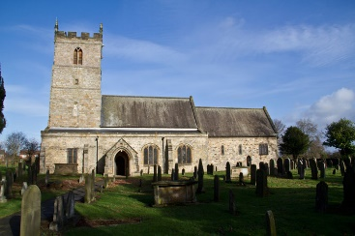

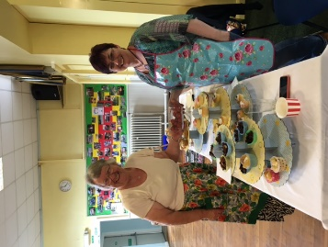

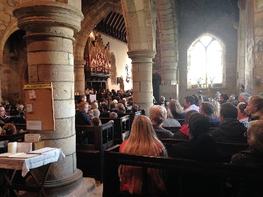

Being a Grade 1 listed building St. Andrew’s has many visitors from history groups, as well as people interested in genealogy and archaeology.

**ST CLARE’S CHURCH, NEWTON AYCLIFFE**

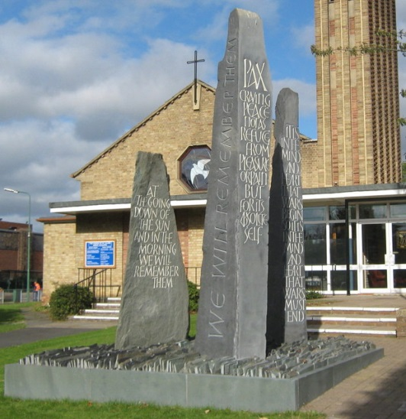

**St Clare’s** is the other Parish Church, at the very heart of the town. It was dedicated in 1955, replacing Clarence Farm, which served as Newton Aycliffe’s first church from 1950. The church stands in the centre of Newton Aycliffe adjacent to the shopping centre. The building includes clergy and choir vestries, Lady Chapel and Parish Office. There are two large halls, one of which has a stage, projector, screen and sound system. WiFi has been installed throughout the building and funding was obtained for a major refurbishment of the stage equipment, which is complete. There is a small, well-stocked library in the memorial room, additional toilets including disabled facilities and baby changing facilities, and a large modern kitchen. To the rear of the kitchen is a garden with soft fruit bushes, fruit trees and vegetables. A sheltered garden between the church and halls was revamped into a beautiful Peace Garden some years ago and provides a peaceful outdoors area in good weather. Both church and halls have a large storage capacity. A congregation of the Redeemed Christian Church of God meets in one of the halls on a Sunday morning.

**Our Congregations; Children and Youth Ministry**

St Clare’s takes greats joy is in its youth ministry and outreach. The growth of Messy Church, which meets monthly, gives us the chance to develop and sustain relationships with people we might never meet in other ways. The wide variety of activities that families engage in whilst ‘being church’ - such as pilgrimage, outdoor fun, messy sports, baptism, visitors – are led by our strong team of volunteers. Our average attendance of 50 speaks for itself. When we held our first Messy Pilgrimage to Seaton Carew, we were joined by the Bishop of Jarrow, who enjoyed walking with us and meeting with the children and members of the team.

Our Sunday morning congregation is older and could be called traditional. The church has a core group of volunteers. We are experimenting with the use of projector and screen for a less traditional style of worship from time to time, especially in all age services, often led by our Licensed Lay Minister. Morning Prayer using liturgy from the Northumbria Community is held on Monday mornings.

Another aspect of youth mission is the popular **KIDZ FLICKS,** monthly film shows, which attract on average 30 youngsters**.**

The very successful **‘Shine’,** our church and community choir, makes full use of the new stage facilities when performing to packed audiences in the hall. Shine has approximately 50 members. It develops caring relationships, a sense of belonging and huge feelings of achievement for all participants, brilliantly supported by families and volunteers at all levels. The choir performs in some of our church services and at other venues in the town

There is joy in seeing young adults flourish in **Parish Youth,** as they engage with one another and enjoy Deanery and Diocesan activities. They are so generous in their service to the parish, organising social, fundraising and festive events such as Parish Christmas Lunch, Greek/Indian/American themed meal-events, and Fathers’ and Mothers’ Day celebrations.

Alongside this monthly gathering, young people can be prepared for confirmation and discipleship within their churches. Two of the youth have completed the Diocesan ‘Growing young leaders’ course in April 2024 and they are exploring how their ministry might develop 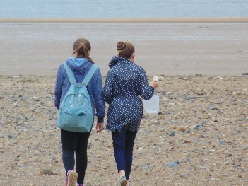in the parish.

Many young children are brought to baptism in the parish and the **Toddlers** **Group** seeks to continue the relationship with these youngsters and parents. This meets weekly in term time and is a relatively new venture, gradually developing in strength and numbers.

Our children and young people occasionally take part in our Sunday morning worship by serving, leading intercessions, and on the reading rota.

**Community Links**

St Clare’s hall is well used by groups within the community:

A group of Syrian refugee families attend a social and English Language classes, week by week in one of the halls where we enjoy meeting and socialising with them.

Each of these activities welcomes different sections of the community into our ‘church’.

There is a weekly Welcome Café on a Tuesday and Café Church on a Thursday, mainly attended by older people, and it is envisaged the Interim Team Vicar, as they oversee pastoral work in the parish, develop an Anna Chaplain style of pastoral care to these groups.

Durham Foodbank have collection and distribution points in the building. These are organised by members of our Parish congregations, helped by volunteers from other churches and members of the wider community. We are supported in this work by the generous food donations from schools, churches and businesses in the area. There is also Fuelbank, a scheme administered by Npower, through the Durham Christian Partnership, like Foodbank.

The charity Lifefline is currently based here, and Godfrey’s Allsorts, a charity shop. All of these are important aspects of our outreach and ecumenical mission, especially as the number of individuals and families seeking help is rising significantly.

Within Foodbank there is additional support for people struggling on low income with regular sessions from e.g. , debt management and homelessness charities.

The hall is a **Place of Welcome,** offering refreshment, warmth, company and advice to the lonely or those in low mood, for whatever reason. All volunteers are welcoming and non-judgemental, showing people that God cares for them, through our hospitality.





St Clare’s Church hosts several civic services each year. The Remembrance Day Service in particular is a major event in the town. In the past junior schools and several charities have held their Carol Services with us and the resumption of this would be welcomed. Parties of schoolchildren visit us regularly as part of their religious studies.

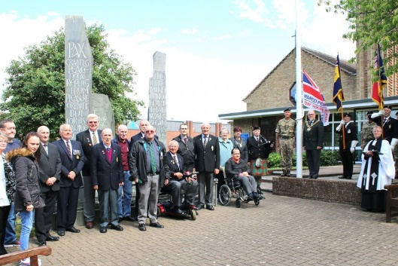

**ST ELIZABETH’S CHURCH, WOODHAM**

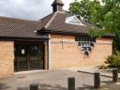

**St Elizabeth’s** church is a more modern building dating from 1986, to serve the Woodham area.It offers an intimate and flexible worship space, within a warm environment.It was built in conjunction with the community centre at Woodham. It was designed by Tony Stringer and the furniture was made from white ash by Northumbrian craftsman. It is a very flexible worship space, seating up to 100 people. Modern stained glass windows enhance the building as a place of worship. The church was dedicated to St Elizabeth of Hungary in the same year and serves as an outreach centre for the people of Woodham. Being a modern building it benefits from gas heating and double glazing in the hall. It incorporates a small kitchen area which is extremely useful for the various functions held within the well-equipped meeting room, with a screen and projector.

**Congregation and Community Links**

The average attendance is currently 15. It is largely an older congregation. Significant support is given to a number of charities. We are fostering ties with the local shop owners.

Several people attend Knit and Natter sessions on Monday afternoons during term time. The items produced go to premature babies, prisoners’ children, Shoe Box Appeal and a local baby charity, Lifeline.   
  
A group of 12 ladies meet each Monday to play board games, for friendship and fun. This social group is open to all in the community. They also organise day trips and away days.

**Rubicon** is the Parish bereavement group, held at St Elizabeth’s Church on Thursday afternoons. This is a support and social group for all who have been recently bereaved. The group also provides signposting to other local services if required e.g. counselling, benefits and medical services.

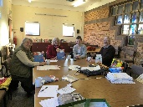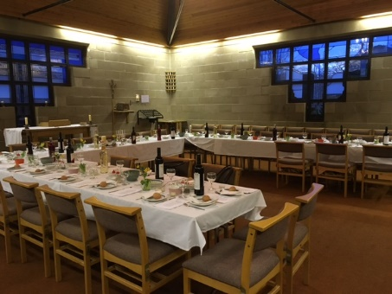

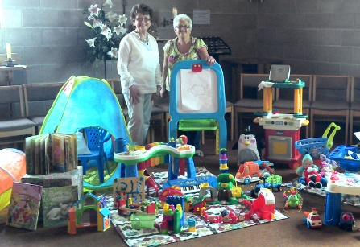

**ST FRANCIS CHURCH, HORNDALE**

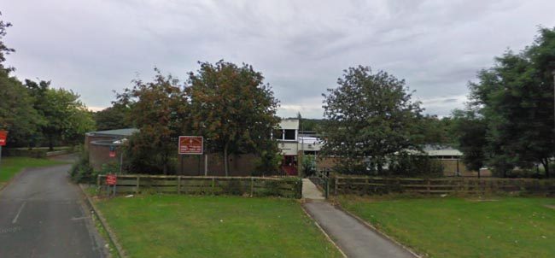

The school was built about 1970 and part of it began to be used as a worship centre in 1971. This continued until 1981 when additional building including a hall, Sanctuary and Lady Chapel were incorporated.

There is presently no Sunday service. A Lay member as well as Rev John lead collective worship in St Francis C of E Junior school twice a week. It is an exciting time for the school as it joins together with Horndale infants to become an all through Church of England school.

There are foundation governors on the Governing Body and it is expected the Interim Team Vicar takes on responsibility as ex-officio governor at the school. The school now has responsibility for the insurance and maintenance of the building. A Siams inspection is due within the next 12 months, and it is expected that the Interim Team Vicar plays an active part in working alongside the excellent and supportive headteacher in supporting her in preparation for this.

The Parish admits children to communion before confirmation, and several children at the school have been admitted in this way in recent years.

The loss of St Francis as a viable worship space has left a void in what is the area of greatest social deprivation in the parish.

It will be an exciting challenge to consider how that might best be addressed, perhaps by setting up a mission and outreach centre in the Horndale area.

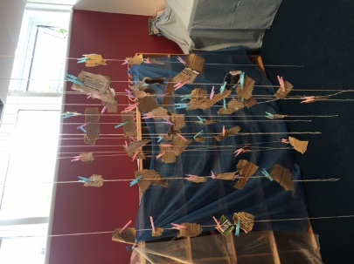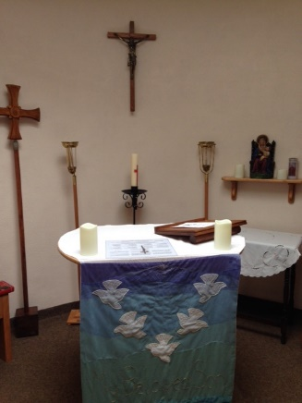

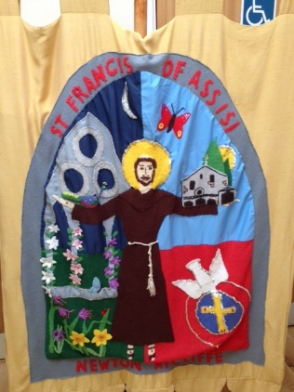

**SERVICE TIMES ACROSS THE PARISH**

**Sunday**

St Andrew 11.00 am Holy Communion/All-Age Worship

St Clare 10.00 am Holy Communion/All-Age Worship

St Elizabeth 9.30 am Holy Communion/All-Age Worship

A Home Group currently meets fortnightly on a Wednesday evening, there is room for this aspect of church life to be developed with a strong team of leaders prepared.

**Average Attendance**

**16+ Under 16**

St Andrew 18

St Elizabeth 15

St Clare 35 5

Café Church 15

Messy Church approx 30 families

**Occasional Offices in the Parish 2024**

Weddings 8

Funerals 50

Baptisms 45

Electoral Roll 131

**FELLOWSHIP, PARISH MISSION AND OUTREACH**

Café Church

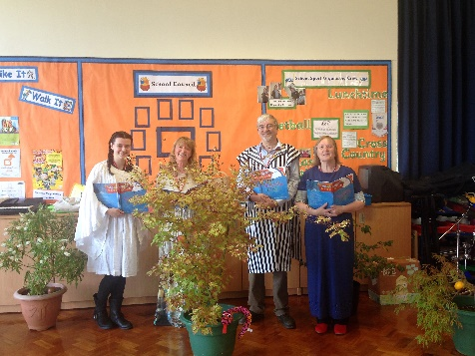Nativity services

Coffee mornings

Kidz Flicks and Feel Good film show

Themed Fairs and Gift Days

Foodbank /Place of Welcome

Shine Choir

Parish Youth

Soup Lunch

Carol Services

Harvest Services

Civic Services

Bible/discipleship groups

Toddler Group

Rubicon Bereavement Group

Village Carols

Knit & Natter and Pop in groups

Social and Fundraising Events: poetry evenings, barbecues, beetle drives, crazy whist, quizzes, Burns Night Supper, Concerts

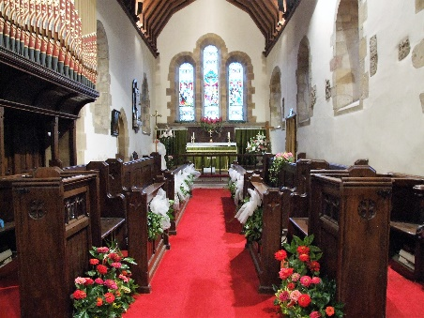

**Communication**

We have a weekly information sheet which is available in all services and we are improving our online presence via our website and social sites such as Facebook. A small group are focusing on developing our social media presence.

**Sustainability**

Following the vacancy left by the retirement in December 2023 of both the Team Rector and Team Vicar, the Vacancy Audit Process identified the need to place an Interim Change Minister in the parish with a brief to stabilise relationships, finances and structures, as well as exercising ministry as a licensed priestly minister in the parish.

**DISCIPLESHIP AND GROWTH**

It is expected that a confirmation preparation group will begin meeting later in the year and that candidates will be confirmed at a Deanery Confirmation service in the Autumn.

**ECUMENICAL LINKS**

Presently Churches Together in Aycliffe does not meet, but there has been a recent initiative which has seen the ministers of churches in the town come together informally for fellowship and prayer. The biggest church in the town by far is Glow church which meets in its own building on the industrial estate.

**FINANCE**

The parish struggles to meet its share, and work is being done by Rev John Musson to enable finances to be better understood by the PCC and parish. The parish is part of the Parish Giving Scheme and each church has a card reader.

**KEY CONTACTS**

Interim Change Minister Rev John Musson 07849023891 John.Musson@durham.anglican.org

Parish Wardens: Mrs Helen McCormick

Mr David Blair

Mrs Miriam Wilson

Licensed Lay Minister Mr Jim Walsh

Youth and Children’s Worker: Mrs Helen McCormick