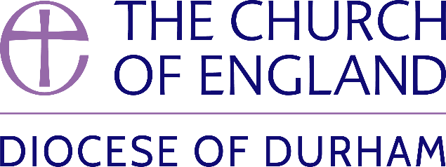 | DIOCESE OF DURHAM  Movement of Clergy: September-October 2024
Name | Current Post | New Post | Effective Date
(1) MOVEMENT TO OR WITHIN THE DIOCESE:
Reeve, The Revd Rebecca Louise Elizabeth | Curate, Ockbrook and Borrowash Parish (Derby) | Priest in Charge, Hartlepool St Aidan and St Columba | 02.09.24
Musson, The Revd William John | Vicar, Cudham (St Peter and St Paul) and Downe (Rochester) | SSM Public Preacher, Diocese of Durham | 03.09.24
Briggs, The Revd Dr Richard Stephen | PTO, Diocese of Durham | Principal, Lindisfarne College of Theology | 07.09.24
Walton, The Revd Teresa Margaret | PTO, Diocese of Durham | Priest in Charge, Washington Holy Trinity | 09.09.24
Avent, The Revd Hilary | PTO, Diocese of Durham | SSM Associate Priest, Hetton-Lyons with Eppleton | 25.09.24
Rushton, The Revd Gavin Michael | Priest in Charge, Oxclose and SSM Priest in Charge, New Seaham Christ Church | Vicar, Oxclose, remaining also SSM Priest in Charge, New Seaham Christ Church | 06.10.24
Strand, The Revd Sarah Elizabeth | Tutor, Cranmer Hall, St John’s College | Dean of Anglican Formation, Cranmer Hall, St John’s College, University of Durham | 08.10.24
Conlon, The Revd Shaun | Priest in Charge, Prestwich St Mary (Manchester) | SSM Public Preacher, Diocese of Durham | 15.10.24
Richardson, The Revd Hannah Marie | Curate, Norton St Mary the Virgin and Norton St Michael and All Angels | Priest in Charge, Bensham and Teams (St Chad) | 15.10.24
Gray, The Revd Elaine | SSM Curate, Hebburn St John with Jarrow Grange Christ Church | SSM Associate Minister, Hebburn St John with Jarrow Grange Christ Church | 20.10.24
(2) MOVEMENT FROM THE DIOCESE:
(3) RESIGNATIONS:
Jones, The Revd Alexander Richard Irving | Curate, Gateshead St George |  | 08.09.24
(4) RETIREMENTS:
Whitley, The Revd Brian | Priest in Charge, Cockfield, Lynesack and Evenwood |  | 30.09.24
Brooker, The Revd Canon Anna Lesley | HfD Priest in Charge, Brancepeth St Brandon |  | 21.10.24

Published 9 September 2024| Bishop of Durham’s Office

