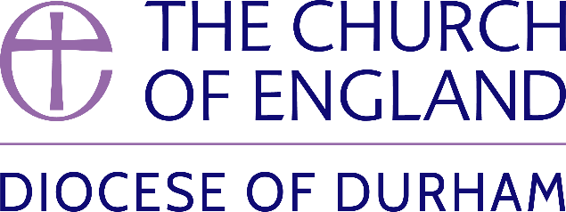 | DIOCESE OF DURHAM  Movement of Clergy: November-December 2024
Name | Current Post | New Post | Effective Date
(1) MOVEMENT TO OR WITHIN THE DIOCESE:
Britcliffe, The Revd Christine Elizabeth | SSM Curate, Lumley, Chilton Moor and East and West Rainton | SSM Associate Priest, Lumley, Chilton Moor and East and West Rainton | 11.11.24
Musson, The Revd William John | SSM Public Preacher in the diocese of Durham | SSM Priest in Charge, Great Aycliffe | 17.11.24
Clark, The Revd Lilian | SSM Curate, Bishopwearmouth St Gabriel | SSM Associate Priest, Bishopwearmouth St Gabriel | 27.11.24
Conlon, The Revd Shaun | SSM Public Preacher in the diocese of Durham | SSM Priest in Charge, Wheatley Hill, Thornley and Wingate with Hutton Henry; Haswell and Shotton | 10.12.24
(2) MOVEMENT FROM THE DIOCESE:
(3) RESIGNATIONS:
Tetley, The Revd Matthew David | SSM Public Preacher in the diocese of Durham and Minor Canon, Durham Cathedral |  | 05.11.24
Hudson, The Revd Sr Dawn Margaret | Curate, Hillside (Lobley Hill and Marley Hill) |  | 17.12.24
(4) RETIREMENTS:
Hill, The Revd Stuart Graeme | Associate Priest, Jarrow and Simonside |  | 11.11.24

Published 25 November 2024| Bishop of Durham’s Office

