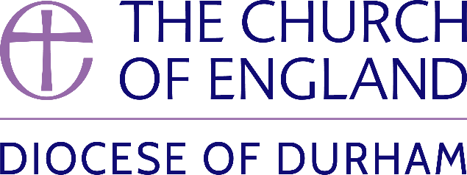 | DIOCESE OF DURHAM  Movement of Clergy: April-May 2025
Name | Current Post | New Post | Effective Date
(1) MOVEMENT TO OR WITHIN THE DIOCESE:
The Revd Marie Edwards | PTO, Diocese of York | Chaplain, Hild-Bede College Durham University | 10.4.25
The Revd Rich Grant | P in C Gateshead St George | Vicar Gateshead St George | 28.4.25
The Revd Dr Tiffany Conlin | PTO, Diocese of Newcastle | Director of Contextual Learning, Lindisfarne College of Theology | 10.5.25
(2) MOVEMENT FROM THE DIOCESE:
The Revd Dave Edmondson | Associate Rector, Chester le Street | Vicar of Shortlands, Diocese of Rochester | 06.5.25
The Revd Steven Martin | Curate, Lanchester and Burnhope | Vicar, Bamber Bridge and Walton le Dale (Blackburn) | 26.04.2025
(3) RESIGNATIONS:
The Revd Adele Phillips | MSE in Gateshead Team Parish |  | 26.3.25
(4) RETIREMENTS:
The Revd Hilary Avent | Self-Supporting Associate Minister, Hetton-Lyons with Eppleton |  | 30.4.25
The Revd Mark Harrison | Vicar, Dalton le Dale, Murton & South Hetton |  | 28.5.25
The Revd Linda Lindsay | P in C Crook |  | 31.5.25

Published May 2025 | Bishop of Durham’s Office

