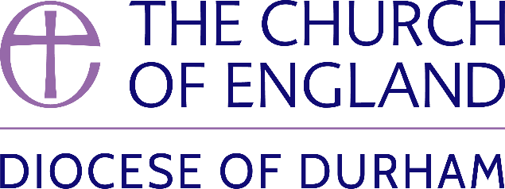 | DIOCESE OF DURHAM  Movement of Clergy: May-June 2024
Name | Current Post | New Post | Effective Date
(1) MOVEMENT TO OR WITHIN THE DIOCESE:
MacLaren, The Revd Clare | Provost, Sunderland Minster | To be also Honorary Non-Residentiary Canon, Durham Cathedral | 12.05.24
Burke, The Revd Anita Kay | Curate, Oxclose | To be also SSM Assistant Curate, New Seaham Christ Church | 26.05.24
Rushton, The Revd Gavin Michael | Priest in Charge, Oxclose | To be also Interim SSM Priest in Charge, New Seaham Christ Church | 26.05.24
Bartlett, The Revd Canon Dr Alan Bennett | Ministry Development Adviser, Diocese of Durham | To be also SSM Assistant Curate, St Edmund Bearpark (Benefice of Durham St Margaret, Neville’s Cross St John and Bearpark St Edmund) to be known as Mission Priest | 09.06.24
Lucas, The Revd David James | Curate, Heighington St Michael & Darlington St Matthew with St Luke | Team Rector, Upper Skerne | 09.06.24
Parker, The Revd Canon Dr Emma Louise | Deputy Warden, Cranmer Hall | Priest in Charge, Bishopwearmouth St Gabriel | 16.06.24
(2) MOVEMENT FROM THE DIOCESE:
Elwood, The Revd Claire Siobhan | Curate, Durham St Nicholas | Interim Associate Minister, York St Michael le Belfrey (York) | 08.05.24
(3) RESIGNATIONS:
Noppen, The Revd Chantal | Team Vicar, North Wearside |  | 31.05.24
(4) RETIREMENTS:
Mackay, The Revd Margaret | Priest in Charge, Gateshead (Team Ministry) |  | 30.06.24

Published 09 May 2024| Bishop of Durham’s Office

