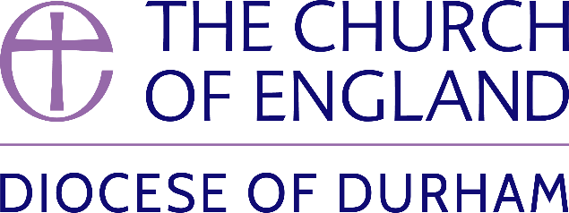 | DIOCESE OF DURHAM  Movement of Clergy: May-July 2025
Name | Current Post | New Post | Effective Date
(1) MOVEMENT TO OR WITHIN THE DIOCESE:
Conlin, The Revd Dr Tiffany Jane Kate | PTO in the diocese of Newcastle | Director of Contextual Learning, Lindisfarne College of Theology | 07.05.2025
Freeman, The Revd Keith Ian | Team Rector, Benefice of Castleford (Leeds) | Incumbent, Harelaw & Annfield Plain and Burnopfield & Dipton | 05.07.2025
Shelton, The Revd James Eoin | Curate, Benefice of Ditchingham, Hedenham, Broome, Earsham, Alburgh and Denton (Norwich) | Director of the Cuthbert Centre for Pilgrimage and Prayer, Durham Cathedral | 15.07.2025
(2) MOVEMENT FROM THE DIOCESE:
Edmondson, The Revd David Philip Thomas | Associate Rector, Chester-le-Street St Mary & St Cuthbert | Vicar, St Mary’s Shortlands (Rochester) | 05.05.2025
Wratten, The Revd Jason Sydney | Curate, Jarrow and Simonside | Minor Canon Youth Chaplain, St Albans Cathedral | 14.06.2025
(3) RESIGNATIONS:
Harward, The Revd Kayla Brooke | Curate, Cleadon Park St Mark and St Cuthbert and Harton St Peter |  | 14.06.2025
(4) RETIREMENTS:
Harrison, The Revd Mark | Vicar, Dalton le Dale and Murton and South Hetton in Plurality |  | 28.05.2025
Lindsay, The Revd Linda | HfD Priest in Charge, Crook St Catherine |  | 31.05.2025
Bullock, The Revd Philip Mark | Priest in Charge, Seaton Carew Holy Trinity and Greatham St John the Baptist |  | 31.07.2025

Published 10 June 2025 | Bishop of Durham’s Office

