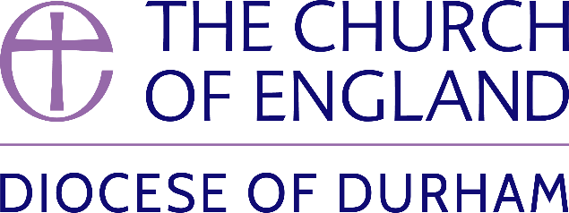 | DIOCESE OF DURHAM  Movement of Clergy: June-July 2024
Name | Current Post | New Post | Effective Date
(1) MOVEMENT TO OR WITHIN THE DIOCESE:
Bartlett, The Revd Canon Dr Alan Bennett | Ministry Development Adviser, Diocese of Durham | To be also SSM Assistant Curate, St Edmund Bearpark (Benefice of Durham St Margaret, Neville’s Cross St John and Bearpark St Edmund) to be known as Mission Priest | 09.06.24
Lucas, The Revd David James | Curate, Heighington St Michael & Darlington St Matthew with St Luke | Team Rector, Upper Skerne | 09.06.24
Parker, The Revd Canon Dr Emma Louise | Deputy Warden, Cranmer Hall | Priest in Charge, Bishopwearmouth St Gabriel | 16.06.24
Ross, The Revd Heather | SSM Curate, Upper Weardale Benefice | SSM Associate Priest, Upper Weardale Benefice | 14.07.24
Sweeting, The Revd Susan | SSM Curate, The Group Ministry of The Annunciation, Sunderland | SSM Associate Priest, The Group Ministry of The Annunciation, Sunderland | 30.07.24
(2) MOVEMENT FROM THE DIOCESE:
Grundy, The Revd Simon | Priest in Charge, Consett | Priest in Charge, Bywell and Mickley (Newcastle) | 14.07.24
May, The Revd Timothy Paul | Curate, Monkwearmouth Team Ministry | Incumbent of Hemingford Abbots and Hemingford Grey in plurality (Ely) | 22.07.24
(3) RESIGNATIONS:
(4) RETIREMENTS:
Mackay, The Revd Margaret | Priest in Charge, Gateshead (Team Ministry) |  | 30.06.24
Jones, The Revd Elaine Edith | Vicar, Peterlee St Cuthbert |  | 31.07.24

Published 20 June 2024| Bishop of Durham’s Office

