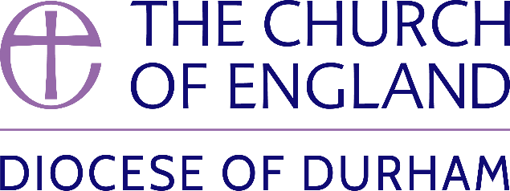 | DIOCESE OF DURHAM  Movement of Clergy: July-September 2025
Name | Current Post | New Post | Effective Date
(1) MOVEMENT TO OR WITHIN THE DIOCESE:
Freeman, The Revd Keith Ian | Team Rector, Benefice of Castleford (Leeds) | Incumbent, Harelaw & Annfield Plain and Burnopfield & Dipton | 05.07.2025
Shelton, The Revd James Eoin | Curate, Benefice of Ditchingham, Hedenham, Broome, Earsham, Alburgh and Denton (Norwich) | Director of the Cuthbert Centre for Pilgrimage and Prayer, Durham Cathedral | 15.07.2025
Briggs, The Revd Dr Richard Stephen | Principal, Lindisfarne College of Theology | To be also SSM Associate Priest, New Brancepeth St Catherine | 14.08.2025
Wall, The Revd Dr Timothy | Priest in Charge, Hetton-Lyons with Eppleton | Director of Foundational Learning at Lindisfarne College of Theology | 06.09.2025
Parkinson, The Revd Daniel James | Minor Canon for Liturgy and Learning, Durham Cathedral | Minor Canon and Succentor, Durham Cathedral | 09.09.2025
Sinclair, The Revd Nigel Craig | Team Rector, Abbeylands (Leeds) | Priest in Charge (0.5 FTE), Egglescliffe St John the Baptist | 14.09.2025
Bagnall, The Revd Canon Katherine Janet | Priest in Charge, Sunderland St Mary & St Peter | Archdeacon of Sunderland | 30.09.2025
(2) MOVEMENT FROM THE DIOCESE:
Everitt, Canon Michael John | Canon Pastor, Durham Cathedral | Interim Dean of Carlisle (Carlisle) | 04.08.2025
Barr-Hamilton, The Revd Nicholas James | Vicar, Fatfield St George | Rector, Chichester St Pancras and St John (Chichester) | 04.09.2025
(3) RESIGNATIONS:
Wall, The Revd Timothy | Priest in Charge, Hetton-Lyons with Eppleton | To be Director of Foundational Learning at Lindisfarne College of Theology | 31.08.2025
Bartlett, The Revd Canon Dr Alan Bennett | Ministry Development Adviser | Remaining SSM Interim Minister, Bearpark St Edmund | 01.09.2025
(4) RETIREMENTS:
Bullock, The Revd Philip Mark | Priest in Charge, Seaton Carew Holy Trinity and Greatham St John the Baptist |  | 31.07.2025
Way, The Revd Michael David | SSM Priest in Charge, Darlington St James the Great |  | 31.08.2025
Brooke, The Revd David Martin | Priest in Charge, Billingham Team Parish |  | 30.09.2025
Published 10 July 2025 | Bishop of Durham’s Office

