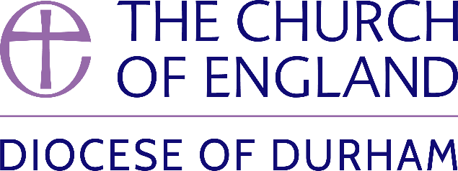 | DIOCESE OF DURHAM  Movement of Clergy: January - February 2025
Name | Current Post | New Post | Effective Date
(1) MOVEMENT TO OR WITHIN THE DIOCESE:
Quinn, The Revd Sarah Elizabeth | Curate, Hetton-Lyons with Eppleton St Michael & St Nicholas | To be ordained Priest by the Bishop of Jarrow | 02.02.25
(2) MOVEMENT FROM THE DIOCESE:
Cooper, The Venerable Robert Gerard | Archdeacon of Sunderland | Dean of Guildford | 25.01.25
(3) RESIGNATIONS:
Hughes, The Revd Abigail Patricia | SSM Assistant Priest, Harelaw and Annfield Plain, Lanchester and Burnhope |  | 05.01.25
(4) RETIREMENTS:
Hall, The Revd Rosalyn | Vicar, Hartlepool Holy Trinity and Priest in Charge, Hartlepool St Hilda |  | 31.01.25
Scott, The Revd Lissa Melanie | Vicar, Heighington St Michael and Darlington St Matthew with St Luke |  | 01.02.25

Published 13 January 2025 | Bishop of Durham’s Office

