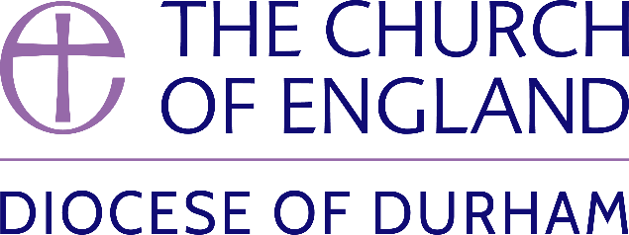 | DIOCESE OF DURHAM  Movement of Clergy: February-March 2024
Name | Current Post | New Post | Effective Date
(1) MOVEMENT TO OR WITHIN THE DIOCESE:
Brown, The Revd Richard Alexander Hamilton | Priest in Charge, Marsh Farm (Holy Cross), (St Albans) | SSM Public Preacher, Diocese of Durham | 07.02.24
Gibbs, The Revd Claire Anne | Priest in Charge, Stockton Country Parish | Priest in Charge of the benefices of Escomb and Witton Park and Etherley in plurality and of the benefice of Hamsterley and Witton-le-Wear. Also Care for Creation Officer (0.33 FTE) for the Diocese of Durham | 10.03.24
(2) MOVEMENT FROM THE DIOCESE:
Atkinson, The Revd David | Vicar, Dunston St Nicholas with Christ Church | Priest in Charge, Benefices of Seghill and Delavel (Newcastle) | 11.02.24
Amoroso, The Revd Rebecca Mary Louise | Chaplain of the Hill Colleges, Durham University | Spiritual & Pastoral Care Team Lead, Broadmoor Hospital (Oxford) | 31.03.24
(3) RESIGNATIONS:
(4) RETIREMENTS:
Butler, The Rt Revd Paul Roger | Bishop of Durham |  | 29.02.24

Published 13 February 2024| Bishop of Durham’s Office

