**Burnopfield and Dipton**

**St James Church**

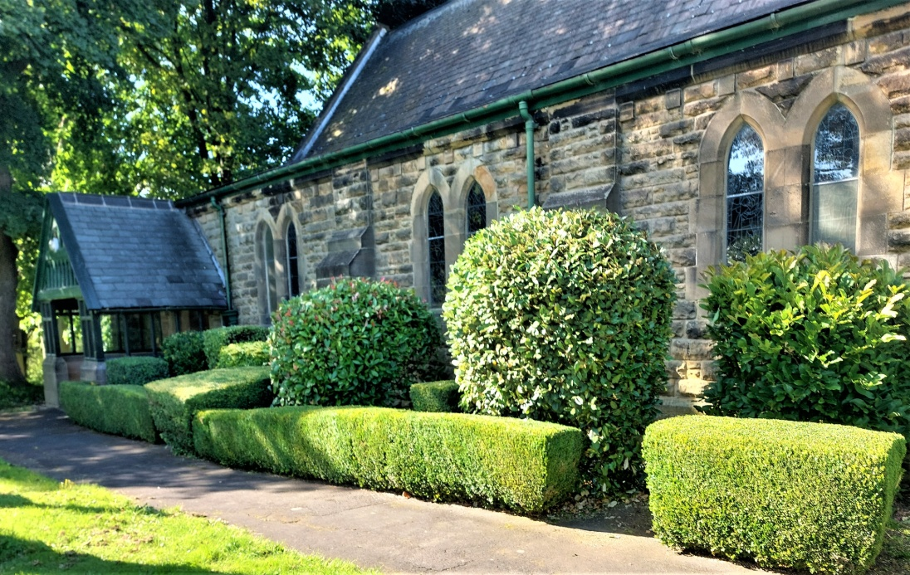

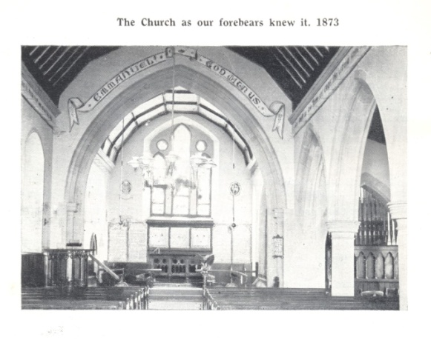 **St James Church**

In 1872 the new Burnopfield Ecclesiastical District had a priest in place, The Revd Thomas Stirrup, all he had to do was build a church, vicarage and possibly a church hall.

The land for the church and churchyard had been given by Mr Richard Hodgson Huntley along with £100 for the building fund. Revd. Stirrup wrote to the Ecclesiastical Commissioners in February 1872 requesting a contribution towards the cost building the church. He received a reply in March 1872 that they would be prepared to contribute £100, this was later increased to £150 due to alterations to the original plans. The parishioners had been putting money aside for the building of the church for over a year. Funds must have been adequate to begin as plans were drawn up and on Whitsun-Tuesday, 21st March 1872, The Right Hon. Lord Ravensworth laid the Foundation Stone of St James’ Church.

This was followed by a public tea and a special service held on Mr Murray’s field at High Friarside.

When the church was completed and the churchyard walled at a cost of £2,500, Revd. Stirrup and twenty six inhabitants of the district petitioned the Bishop to the effect that he; *‘be pleased to consecrate the said newly erected Church by the name of Saint James Church, Burnopfield’* and to dedicate the same to the service of Almighty God and the celebration of Divine Service and Worship according to the rubic rites and ceremonies of the Church of England.

The Right Revd Charles Baring, D.D. Lord Bishop of Durham, consecrated the church on Thursday, 23rd November 1873. The first Sunday services took place on 23rd November 1873 when there were twenty three communicants and also three baptisms on this day; Annie Ramsey, John Morgan and Archibald Batey.

The congregation would be summoned to church by the same bell which calls us today.

**Welcome**

Our parish of St James Burnopfield and Dipton is situated in the Durham Diocese.

This is a 0.5 post with housing provided in Burnopfield.

***Our Vision – to connect people to God and one another.***

**Person Specification**

We look forward to welcoming, into our caring community, an incumbent who can take our parish forward whilst respecting existing traditions.

Our hope is for someone who can nurture us in faith while working collaboratively with the Deanery, PCC and church members to strengthen our congregation by reaching out to our communities particularly younger people and families.

On our part, we will provide an inclusive environment where our priest will have the opportunity to hone existing skills, explore new possibilities and enjoy the support of our worshipping community as we innovate and energise our mission together.

Our priest will be supported in taking time for professional development, including an annual retreat.

And we promise hospitality and good humour!

**Our Parish**

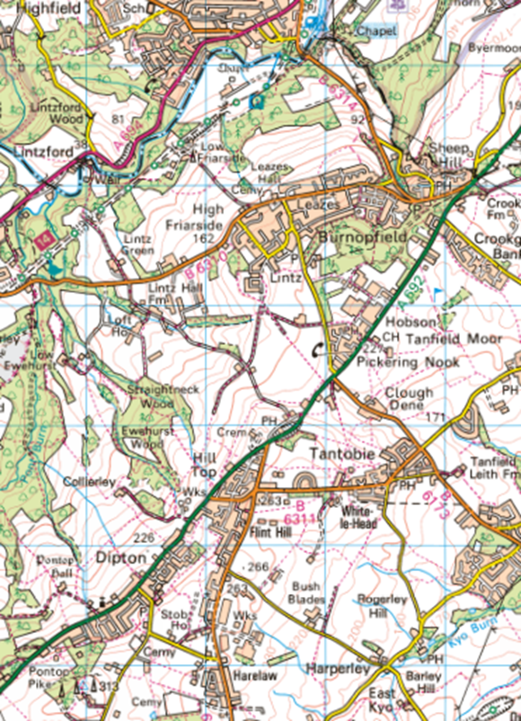The Parish of St James Burnopfield and Dipton is situated in County Durham. It comprises the village of Burnopfield, which is seven miles from Newcastle and 15 miles from Durham, and the village of Dipton which is ten miles from Newcastle and 12 miles from Durham.

Both Burnopfield and Dipton are former colliery villages, which combined as a parish in 2014. The church of St John Dipton closed in 2013 and is now a private residence.

Burnopfield and Dipton have a total population of 7,920 as at 2021.

Burnopfield is primarily residential with one nursery and primary school, a number of small shops (including a Co-op supermarket), a post office, two public houses, two cricket clubs, a golf club, a social club, community centre and a residential care home. The GP surgery has a pharmacy attached. There is also an NHS dental practise.

Dipton is also primarily residential, with one nursery and primary school, a number of local shops, cafes, public house, a GP surgery and one residential care home.

Both villages have a mix of private, rented and local authority owned housing. A new housing estate is being built in Burnopfield. The villages are within easy commuting distance of the Tyneside conurbation and Durham City .

Within Burnopfield there is also a Methodist Church and a Gospel Fellowship. The churches work together in a number of ways, including the Good Friday Walk of Witness, the annual Remembrance Service, a service for Christian Unity and blessing the Christmas Tree. St James hosted the World Day of Prayer in 2022.

There are 67 names on the St James electoral roll. A eucharist is held each Sunday starting at 11am with an average attendance of 25 and a service of Morning Prayer, lay led, on the first Thursday of the month. Pre-covid there was an 8am BCP service (said) and a weekly Thursday morning eucharist (said). Additional services are held at Easter and Christmas and for baptisms, funerals and weddings as required. St James has an active Mothers’ Union. Meetings include an act of worship.

We are fortunate to have a choir, a Reader and an Authorised Pastoral Assistant.

Our regular Sunday eucharist is celebrated using the Book of Common Worship and vestments are worn. Other services can be more informal.

We host the monthly Chapter Meetings when required as well as Diocesan Safeguarding meetings.

St James Church and Community Hall, centrally situated, is used for activities including Café Church, Messy Church, scouts and cubs, exercise classes, craft groups and a social group supporting elderly people. It is also the venue for special village events.

In November 2023 St James celebrated its 150th anniversary, with a service led by the Bishop of Durham.

**Our Mission**

Our mission statement:

“To proclaim the good news of God’s Kingdom, by supporting and fostering established relationships within our church and the local community and baptising and nurturing new believers.”

Our mission work is based on the Diocesan four priorities. Energising Growth. Engaging with Children, Youth and Young adults. Challenging Poverty and Caring for God’s creation.

**Energising Growth**

Our mission is fulfilled in a number of ways, apart from our regular Sunday church services. We hold seasonal Messy Church for young children. During the interregnum we initiated a bi-monthly, lay led, Café Church in the church hall. This alternative form of service is generating new worshippers. Monthly, we also hold a communion service in the Burnopfield Care Home, Morning Prayer (lay led) and home communion as required (lay led). Annual Lent and Advent courses are organised and a member of the congregation leads the area organisation for World Day of Prayer which we support. Further working with the other churches in the village is a future ‘mission’.

When holding baptisms, funerals and social activities we engage sensitively with the people involved and encourage them to join us on other occasions. Our baptism policy encourages a relationship with the family at all stages. Recent baptisms have generated new church members. Three adult members have recently been confirmed. The church website, A Church Near You and other social media sites are updated regularly to publicise the activities available in both the church and the hall which provides an outreach opportunity.

Hall hire includes the WI, a council-supported exercise group and a social group for elderly people, including those with dementia. This is co-ordinated by church members under the auspices of the Methodist at Home Association.

**Engaging with Children**

School groups are encouraged to visit the church, on request. They, along with the scouts, prepare items for the Harvest Festival displays and other events like the Platinum Jubilee and the church’s 150th anniversary.

They are invited to special services, e.g Harvest and Remembrance, Christingle (the Children’s Society is also supported through collection boxes), the Carol Service and the Crib Service. More involvement with local primary schools, active links with uniform organisations in the village and the St John’s Ambulance are areas further development. Our last two incumbents were invited to be school governors.

**Challenging Poverty**

 We engage in other practical activities linked to the community to challenge poverty, including supporting our local Food Bank through donations in church and donations collected in the local Co-op (all donations from the Harvest Festival go to the local Food Bank). Mothers’ Union outreach involves making up toilet bags for hospitals, collecting toiletries for a refugee centre, and books for prisoners to make audio recordings for their children.

Our weekly Coffee Morning in the hall is attended by church and non-church members, as is the monthly bingo session. These are both warm space facilities.

**Caring for God’s creation**

****The church and extension graveyards are closed and managed by Durham County Council. However, there is an open dedicated area within the churchyard for the burial of cremated remains, administered by the church. The church gardening team meets every week to maintain the planted areas and outside structure. All garden waste, and other waste as appropriate, is recycled. We use LED lights and our energy provider uses electricity from renewable sources. Pew blankets offer additional comfort in church during the winter months Other environmental initiatives have included local litter picks.

**Buildings**

The church and church hall are stone buildings. Neither building is listed. The church was consecrated in November 1873 and the church hall (previously a Temperance Hall and given to church) was built in 1872. In 2023

We celebrated our 150th anniversary with a service led by the Bishop of Durham, followed by a reception in the hall. Our church is in use at least two hours each Sunday, an hour every month for Morning Prayer, and as required for funerals and weddings. Baptisms are either held as part of the eucharist service or at a later dedicated service, but always on a Sunday.

In 2023 there was one wedding, two funerals in church, seven at the crematorium and twelve baptisms .

The main church entrance is accessible for prams, wheelchairs and walking aids. There are designated areas for wheelchairs and prams. The vestry, which also includes the toilet, is not accessible for wheelchairs but assistance is always offered for wheelchair users if required. We hope at some time to install a disabled toilet within the body of the church and redecorate. The small kitchen in the vestry enables us to offer tea/coffee after each service. The building currently does not have Wi-Fi but this is being reviewed.

As the church pipe organ is no longer useable, we have installed an electric organ which can be used by visiting organists. We have invested in a hymnal so that music is available for all forms of worship.

The hall is used approx. for 11-12 hours a week on a regular basis. This increases with additional ad hoc bookings.   
The hall has disabled friendly access for all ground floor areas including a toilet. There are excellent kitchen facilities which enable a wide range of catering opportunities.

We hope to install Wi-fi.

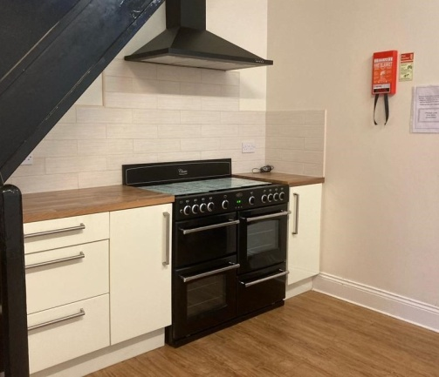  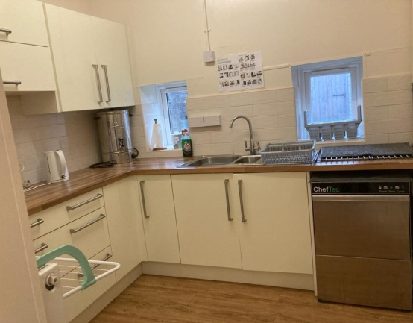

**Governance**

Our PCC meets regularly, and reports are circulated prior to the meeting. The agenda is prepared by the Standing Committee. We have full, frank discussions and any contentious issues go to a vote. The outcome of the vote is binding. Two members regularly attend Deanery Synod Meetings, some of which we have hosted. We support Deanery Services. Members of the Mothers’ Union attend Deanery MU functions. Six church members took part in the Wings for Worship course.

Safeguarding is a permanent agenda item at every PCC meeting and safeguarding officers attend diocesan meetings. The Safeguarding policy is on display in church and the hall. It is prominent on the website, Facebook and A Church Near You. All safeguarding training is kept up to date and we facilitate our own DBS checks. Deanery safeguarding training has taken place in the church hall which is also one of the venues for the Diocesan Safeguarding Officers meeting.

During the interregnum church members have worked closely with visiting clergy. The church is always prepared for the service before clergy arrive. Lay members lead intercessions and take the first reading. They also run Café Church, Messy Church, Morning Prayer and assist in Lent and Advent groups.

Church members are keen to help in a variety of ways, as they are able, e.g. church refreshments and bell ringing.

**Finance**

The treasurer’s report is a standing item on all PCC meetings. Accounts are independently verified. Estimates of work go to the PCC for approval. A two-tier online banking system is in operation. The use of designated and restricted funds enable us to fund specific areas, e.g. buildings and children’s work. There is contingency funding for unplanned repairs and maintenance. We plan by accessing grant funding where possible,

e.g. covid grant for the hall and holding regular fund-raising activities.

Parish Buying is used for our utilities for both the church and the hall and we try to source the most cost-effective option for other services, e.g insurance. Within the last 2/3 years we have been promoting the Parish Giving scheme, which 66% of gift aiders use. The gift aid small donation scheme is used for all qualifying donations. Our QR code enables online donations.

The Legacy Policy is displayed prominently in church.

Currently we are trying to maintain both the church and the hall so both buildings are available for worship and church mission. Income is also generated through hire of rooms in the church hall.

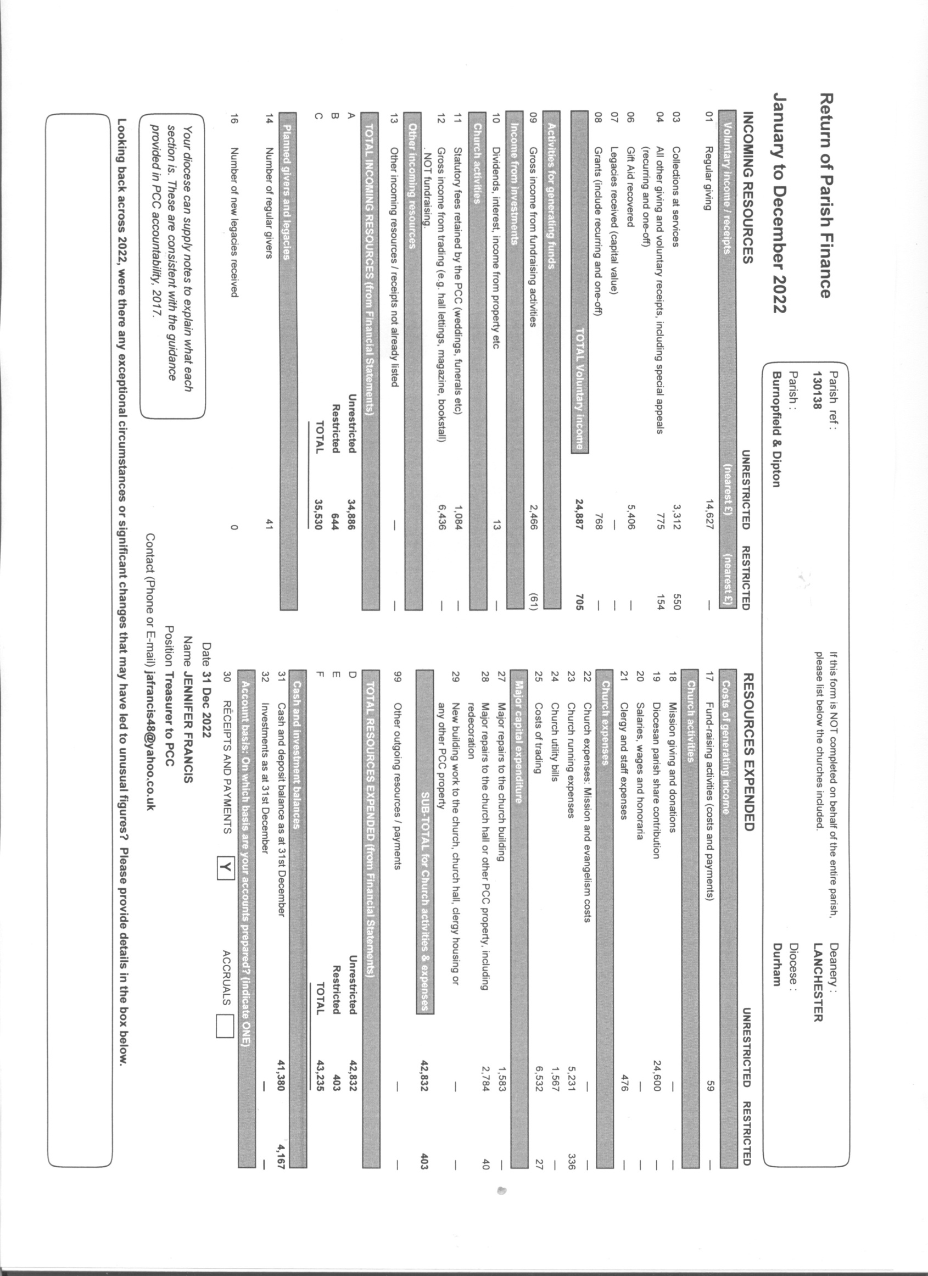

**Issues / Challenges**

Our congregation predominantly comprises older people. We need to be aware of the needs of elderly people and isolated people in the community and develop our pastoral care. Nurturing children and young people through strengthening the links with our two primary schools is a priority.

The uniform groups in Burnopfield and Dipton provide a great opportunity for missional growth. The hall is suitable for a wide range of youth activities and we have a range of baby and toddler equipment.

The regular communion service at Dipton Manor Care Home was suspended during covid and we await the home’s agreement to reinstate it. No alternative suitable premises that would allow religious groups to meet have been identified, we therefore have no venue in Dipton at present. Fortunately, there is a link with Dipton through the members of our congregation who live there. We lead the Remembrance Service at the Dipton Cenotaph and the blessing of the Dipton Christmas Tree.

**Housing**

The vicarage, built in 1954, is a detached property situated on the main road through Burnopfield. It was bought by the diocese in 1983 when a study was added. It has recently been refurbished, decorated and carpeted. It has solar panels, a charging point for an electric vehicle and external lights

The house consists of a kitchen with dining area, two reception rooms, both with bay windows, a study and a downstairs cloakroom. Upstairs there is a refurbished bathroom, three double bedrooms (one with a sink) and one single bedroom. There is a double garage and gardens front and rear.

The church, church hall, GPs’ surgery and Co-op are all within easy walking distance.

There are bus stops nearby for buses to the MetroCentre, Newcastle and Durham. There are several primary and secondary RC faith school schools. There is a primary C of E school in Lanchester.

Hospitals are situated in Gateshead, Newcastle, Durham, Sunderland and Bishop Auckland.

**The Local Area**

The area is predominantly rural in nature although with good road and bus links to major conurbations, the scenic areas of Northumberland and the historic city of Durham.

The local area has excellent opportunities for walking, running, cycling and horse-riding. It is within easy reach of the Derwent Walk Country Park with its miles of user-friendly routes, and National Trust Gibside, with its Regency-style pleasure gardens.

Beamish Museum, one of the country’s largest open air museums, is within easy travelling distance as is the Tanfield Railway, another popular heritage facility

Bishop Auckland, a little further away, hosts the annual Kynren pageant and is also home to the Bishop Auckland Faith Museum.

All shopping needs are catered for via the neighbouring towns and cities, as well as out of town supermarkets and market towns including Hexham and Morpeth.

People who live in the North East are either born and brought up here or are drawn to the area by its welcoming atmosphere and close proximity to both coast and countryside.

**Additional Vicarage Photographs**

Reception room

Study

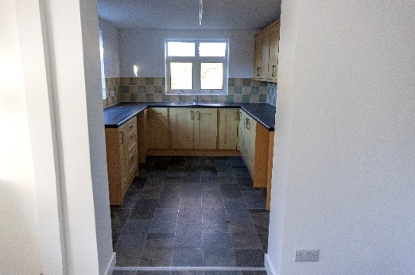

Kitchen

Breakfast room

Bedroom (front)

Bathroom

Breakfast room

Breakfast room

Drive and double garage

Bathroom