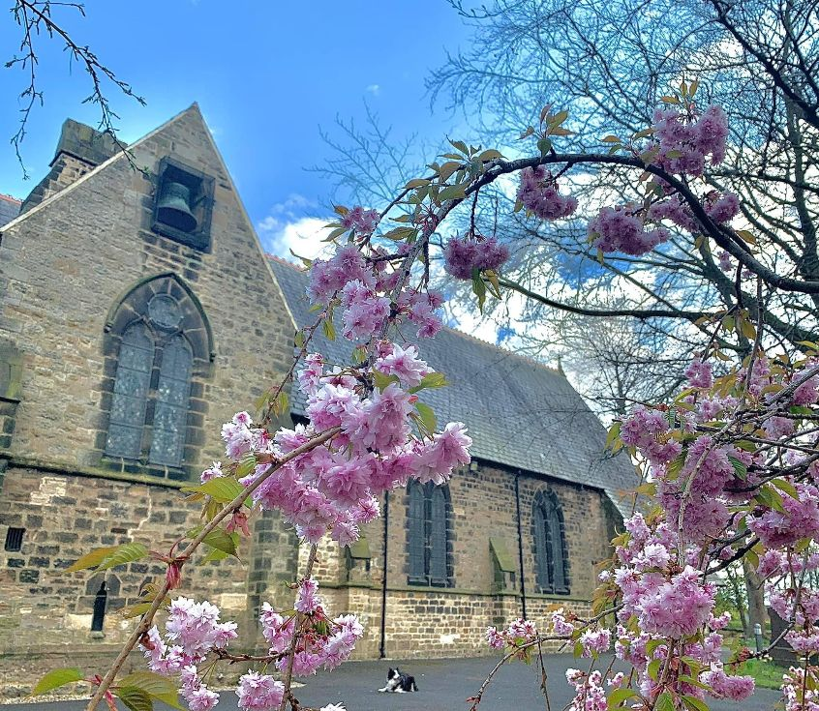

The Benefice of
St Mary Magdalene, Belmont &
St Laurence, Pittington

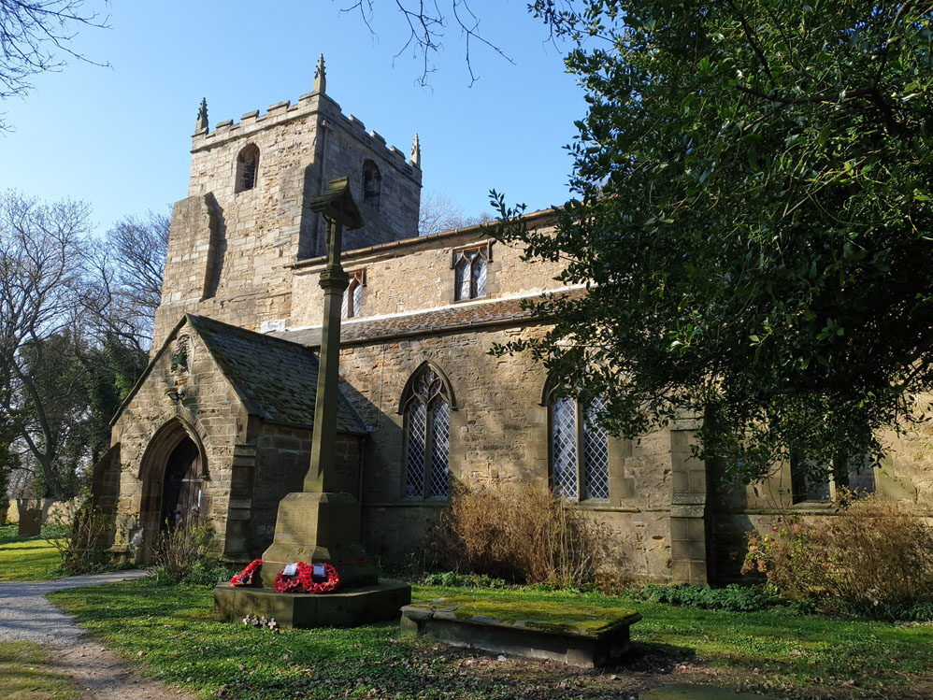

Parish Profile

Contents for both Churches
- Summary

- The broader context

- The vicar we need

- About the parish

- About the Church

  - The church as a worshipping people
  - The church and the community it serves
  - The church building and resources

Overview
The United Benefice was created in 2007 linking the parish of St. Mary Magdalene Belmont with the smaller parish of St. Laurence Pittington. The United Benefice falls in the Diocese and Deanery of Durham. Although the parishes of Pittington and Belmont are different in many ways the Benefice has proved to be successful, and the two churches work well together, each bringing different history, experiences and complementary talents and gifts that strengthen the whole.

In this document the profiles are presented in two sections, the first relating to St Mary Magdalene and the second to St Laurence. Their slightly different presentational styles reflect the character of the individual churches but we share many of the same priorities. and in particular we are in very close harmony in our search for the right person lead us forward.

St Mary Magdalene Churchwardens: Kevin Reynolds and Anne Corbett
St Laurence Churchwardens: | Dave Arnott and Jean Gartland

St Mary Magdalene Profile .
- SUMMARY

The parish of Belmont is situated on the outskirts of the beautiful Cathedral City of Durham and has an estimated population of 8,769. St Mary Magdalene has an IMD Score of 10.7 and is ranked 9496 out of 12443 in terms of most deprived parishes.
We are an open, flexible and inclusive, evangelical community church serving the villages of Belmont and Carrville and some homes in Gilesgate Moor. We see our church as welcoming, friendly, caring and giving of ourselves in service to God and to the members of our community. We are a congregation of active people, including several professional individuals who give of their expertise, those who are now retired and freely give of their time, and many lay people involved in worship, ministry and mission. We are thankful that our worship together is significantly enhanced by having in our congregation retired clergy to support our incumbent and a benefice choir who practise weekly and sing at key services and festivals. We seek to be faithful to God, faithful to each other and faithful to our shared future as a United Benefice.
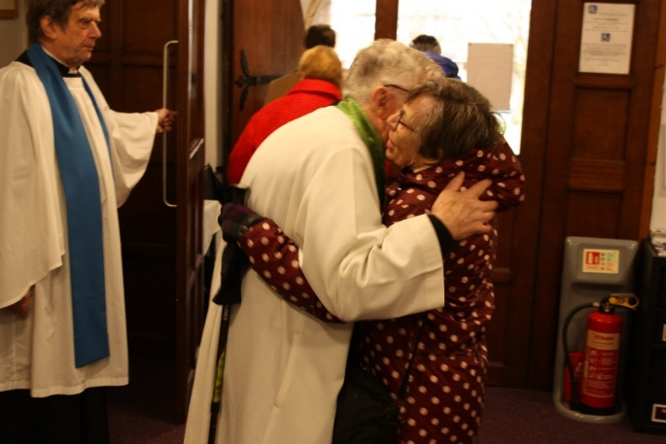
We aspire to be a place and a community through which God’s love shines, and by which our world is transformed.

Inspired by Mary Magdalene, we seek to:
- Respond to the grace we receive from God.
- Travel together where Jesus leads.
- Provide from our resources to grow God’s church and care for all in need.
- Be called by name to share our experiences of the Good News of the Gospel.

This is achieved through the Five Marks of Mission:
- To proclaim the Good News of the Kingdon.
- To teach, baptise and nurture new believers.
- To respond to human need by loving service.
- To seek to transform the unjust structures of society, to challenge violence and pursue peace and reconciliation.
- To strive to safeguard the integrity of creation and sustain and renew the life of the earth.

We offer:
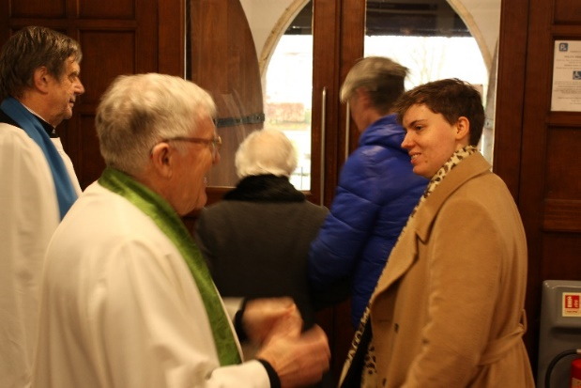
- A loving and supportive congregation who care for each other and the Priest-in-Charge.
- Opportunities for our Priest-in-Charge to grow in Christ and take time for retreat.
- A committed and supportive staff team.
- Paid administrative support.
- A positive and supportive PCC.
- A desirable location to live and work.
- A financially stable parish (inc. significant additional annual income from The Gilligate Church Estate Charity)
- Additional responsibilities (ex-officio governor of local CofE primary school and member of the The Gilligate Church Estate Charity, a trustee and chair of Belmont Parish Hall Association.)

Moving forward, we recognise that we need someone who will help us refresh our mission and grow the church. We are committed to expanding our missional reach. We recognise that our current congregation is aged, and that the church body needs to grow in number to help maintain a Christian presence and mission. We are willing to share in this mission actively but feel the need of ordained leadership.

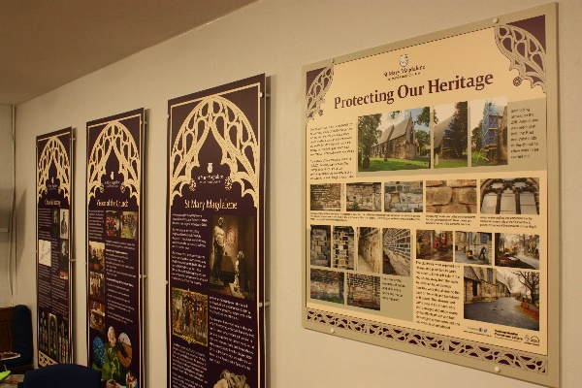
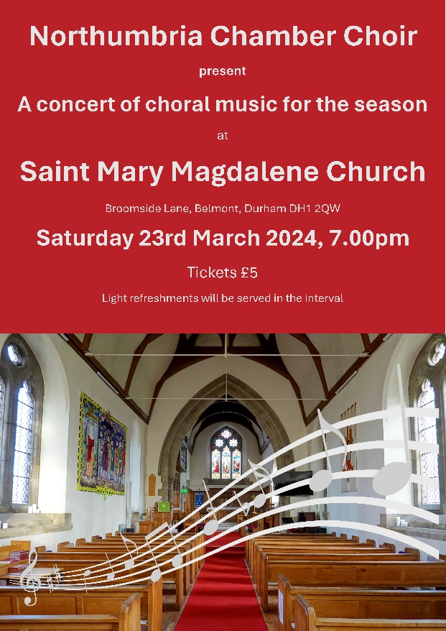

- THE BROADER CONTEXT

The Deanery usually has 4 deanery synod meetings per year and there are 3 reps from SMM. The church supports the ordination of women and has had three previous female incumbents.

Church Administration and Organisation
- Vicar
- One Reader
- One Lay Pastoral Minister
- One Authorised Lay Chaplain
- Some of the congregation are ordained and lead services and preach
- One administrator (P/T) - paid
- Two Churchwardens
- Treasurer
- PCC secretary
- Pastoral Visiting Team
- One cleaner (P/T) – paid

There is good administrative collaboration with the other parishes in our group (St Giles, Sherburn & Shadforth), our treasurers and administrators work well together, and we hope to build on that collaboration with our new incumbent.

More information can be found on our website and social media:
Website: https://www.achurchnearyou.com/church/9980/
Facebook: https://www.facebook.com/groups/SMMBelmont

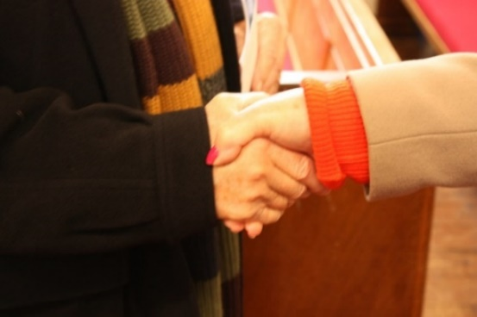
Parochial Church Council - has 16 members including 3 deanery synod reps. Standing Committee has 5 members, the incumbent, two churchwardens, treasurer and secretary. The PCC meets every six weeks with Standing Committee held two weeks prior to allow for minutes to be produced and sent out with the agenda. We also have a Communications group and a Charities group (PCC currently donates 10% of its income to charity). This way of working recognises differing talents within our church family and enables more church members to have a meaningful involvement in church life. The current Health and Safety policy is held up as a model of good practice and has been in operation for 21 years. All DBS checks are up to date.

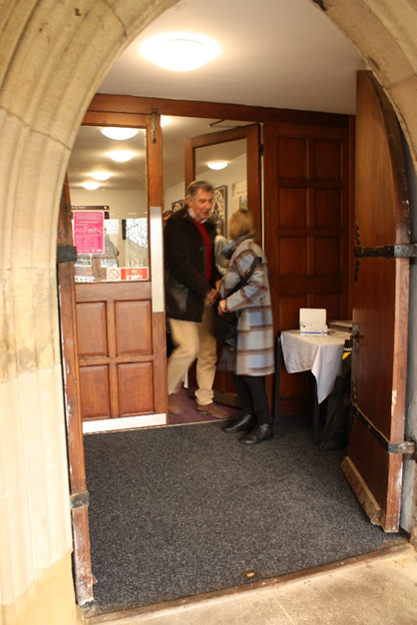
Church Finances – The General Fund balance at 31st December 2023 was £7973 and our tracker savings account with restricted access was £16501, income and expenditure is balanced at around £5000 per month and in order to maintain this we have had to reduce our parish pledge for 2024 from £62,000 to £33,000. Up until recently (due to covid and cost of living crisis) we have met our Parish Share (and overpaid by £10,770 in the last 7 years). We currently employ three people: the administrator; the organist; and the cleaner. These people receive salaries on a monthly basis and an independently appointed auditor calculates PAYE.

The Gilligate Church Estate Charity - is a registered charity that was established under a High Court Order of 1866.The Charity generates income from endowed funds and distributes that income according to prescribed shares to the parish churches of St Giles and Belmont and to the Education Trusts in each parish. The incumbent is an ex-officio member of this Trust. Annual income not required by each parish is invested by the Charity in Extraordinary Repair Funds for each Church for their future use. Approximately £24,000 is claimed per annum from Gilligate to cover the costs for anything related to buildings and administration of the church. Currently the Trust's net assets were just over £2,000,000.

Belmont Education Trust - of which the incumbent is an ex-officio member, exists to fund education and development of people under the age of 25 in each parish. The Belmont Trust receives annually one eighth of the Gilligate Trust's annual income and has discretion as to how to use this money in the interests of younger people in the parish. The account currently stands at £15,000, with a further £10,000 expected in April.
Past recipients from the Trust include Messy Church, Belmont Guides, Students from the congregation now at university, Belmont Primary School (Bibles and support for a PHSE course), a pupil’s mental health project.

- THE VICAR WE NEED

We are looking for an energetic leader who loves people and feels at ease communicating with everyone in our community. Someone who delights in building teams and working through people’s gifts; a compassionate encourager. In short, we want them to help us realise God’s wonder and presence in Belmont whether it is from the pulpit, in the local shop or primary school.

They will be our spiritual leader; have a strong faith, deeply rooted in prayer and also a willingness to engage in self-reflection and personal development. They will need the desire and motivation to lead the parish in addressing our priorities; to act as a catalyst to unleash the energy and enthusiasm for change within the parish.

Our priorities for the future:
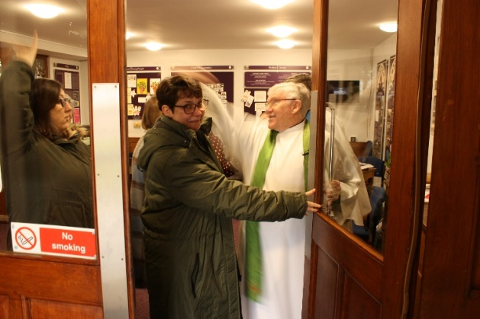
- leading on the collaborative discernment of a realistic but ambitious vision for mission and growth,
- the creation of a strategic approach to mission and growth with clear goals to help achieve this,
- continue in the encouragement, support and equipping of lay people to share in the worship and mission of the church,
- the introduction of new forms of church worship where faith can be explored by beginners/returners, and people can grow in discipleship,
- work with children and youth through avenues where the good news can be shared so that young people might realistically begin a journey of discipleship.

- ABOUT THE PARISH
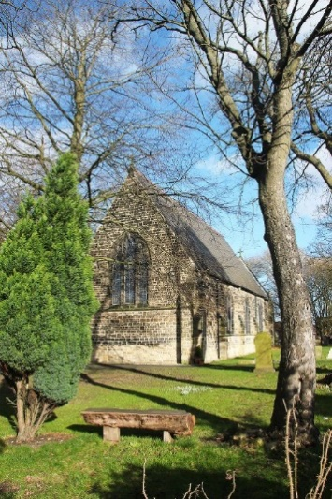
The parish of Belmont is situated on the outskirts of the beautiful Cathedral City of Durham and has an estimated population of 8,769. St Mary Magdalene has an IMD Score of 10.7 and is ranked 9496 out of 12443 in terms of most deprived parishes. The parish is split by the A1M allowing easy access to North and South and is a combination of suburban and commuting populations.

It is principally a residential parish with some industrial and commercial outlets. Number on the Electoral Roll is currently 111. St Mary Magdalene enjoys close links with Carrville Methodist church which is located ten minutes walk from the church.

It is a popular and sought after place to live with many families with children of all ages and a significant number of retired people. The parish has a Care Home and a house that supports people with severe physical and mental disabilities. There are four primary schools - Belmont C of E Primary School, Cheveley Park Primary School, Thomas More RC Primary School, and St Hilds C of E Aided Primary School, constitutionally linked with our neighbouring St. Giles parish. Belmont Community School (11-16) is an up-and-coming secondary school in the parish, which is rated Good by Ofsted.

Belmont Parish Church has special responsibility for Belmont C of E Controlled Primary School. There are three foundation governors including the incumbent who is an ex-officio governor. The parish also has a community centre, a health and fitness club, shops, library, 2 doctors’ surgeries and a large retail park. In 2005 the modern, well-equipped and versatile Belmont Parish Hall was opened in the grounds of the Parish Church and is a facility greatly valued in the community.

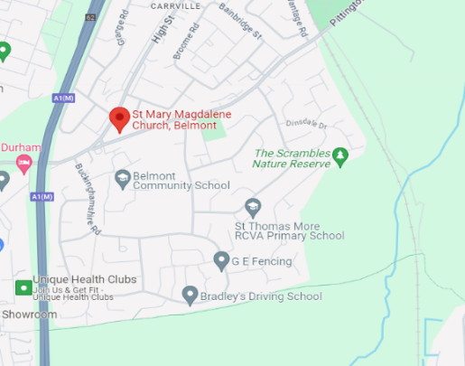
Few places in the world can match the City of Durham, with its dramatic setting on a rocky horseshoe bend in the River Wear. The great Norman Cathedral and nearby Castle - which is part of the University - form a World Heritage site, recognised by UNESCO as one of the most exceptional historic and architectural features of the planet. There is a good selection of shops, including several bookshops and many national names, a range of sporting opportunities and varied options for eating out.

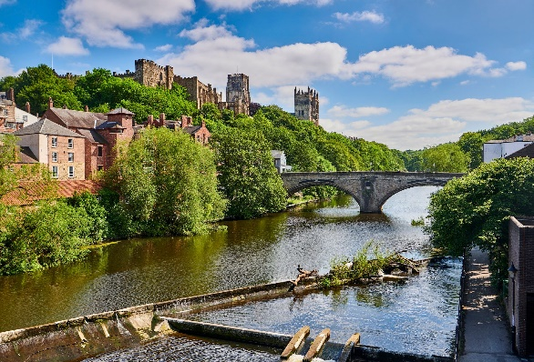
The University of Durham is an integral part of the city and contains one of the finest theological departments in the world. Cranmer Hall is one part of St. John's College, an independent Christian foundation within the University. Anglican ordinands train alongside Baptist student ministers, candidates for ministry in other free churches as well as those who simply wish to study theology, ministry and mission in the Wesley Study Centre. Those thinking of ordination and those in training frequently use our church to worship and explore their calling.

- ABOUT THE CHURCH
- The church as a worshipping people

Regular worship
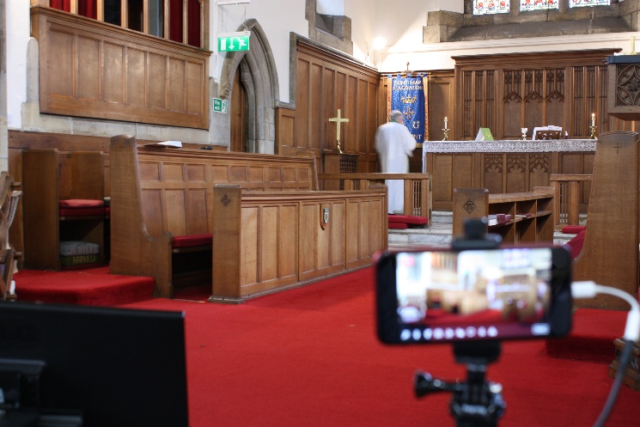
We hold two Sunday services, one at 9.00am, the other at 10.30am. There is also a regular Wednesday service at 10.00 am.
At the heart of our worship at St Mary Magdalene is the communion service. The 10.30 am Eucharist on Sunday attracts the largest congregation with a weekly average of between 40 – 50 adults. This service is normally `live streamed` to allow the housebound or ill to feel part of the worshipping community.
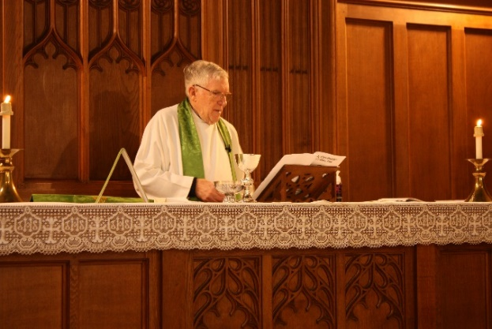
We also celebrate Holy Communion at 9.00 am on Sundays (BCP) and at 10.00 am on Wednesdays (Common Worship) – both services average 15 - 20 adults. We have produced our own Orders of Service for use across the United Benefice. Our Bible is the NIV, and our new hymnbook is “Hymns Old and New” which is supplemented whenever fitting with other worship songs through use of our AV system. We readily mix traditional hymns and modern choruses during services utilising the pipe organ and piano.
We also enjoy Joint Services with our partner church, St. Laurence, usually on the first Sunday of each month - each benefice church alternating the hosting of the service. This is a friendly arrangement that can accommodate any special happenings in the benefice.

There are also occasional joint services with Carrville Methodist Church, services which are held at their Chapel or at St Mary Magdalene.

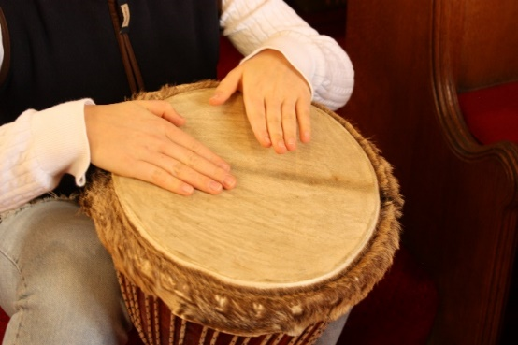
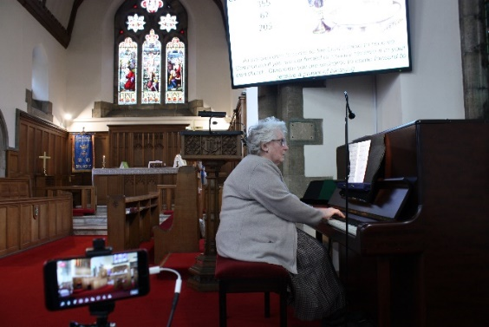
Music is important to us in worship: we have a Director of Music who is supported by other talented pianists. The hymns and songs during communion add considerably to our worship, and we have formed a Benefice choir, which rehearses weekly, and sings (approximately monthly) at joint or special services. The choir has also featured in our in-house concerts – performing both sacred and secular music – and we had requests to sing at funeral services.

In general clergy wear an Alb and stole to conduct services with our Reader wearing cassock, surplice and scarf. Sermons or Homilies are preached at the Sunday services lasting around 10 minutes. There is much Lay involvement in the services – from welcome, leading intercessions, readings and assisting with the chalice administration at the altar. During communion a prayer ministry is offered by the Laity to anyone who feel the need of prayer for themselves or loved-ones. We have been blessed during the Vacancy with the help and support of retired clergy.
Home Communions are offered, on a regular basis, to the housebound and at the local Care home.

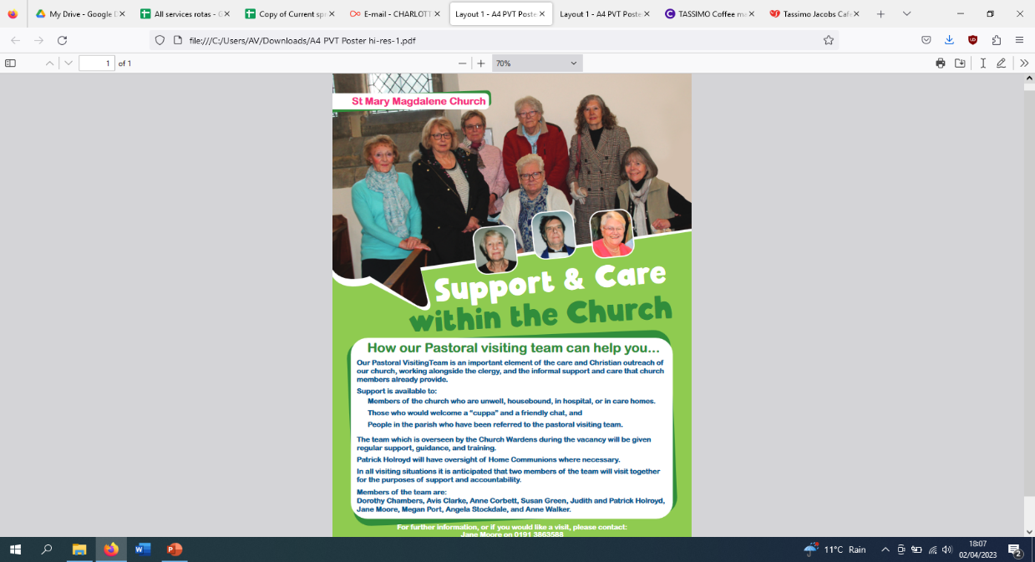
There is a dedicated Pastoral Visiting Team which is an important element of the care and Christian outreach of our Church, working alongside the clergy and the informal support and care that church members already provide. They offer spiritual, social and practical help to members of the church who are unwell, housebound, in hospital or in care homes or who have requested their support.
This work is carried out alongside the role of our Lay Chaplain who works closely with the PVT. Her role is to offer spiritual care and support to all people to the parish and church community. In particular, she has developed a chaplaincy service at Cheveley Park shops and a ministry in following up with bereaved families who have held a funeral at the church.

Occasional Offices

Baptism – infant baptisms include children of active church members and those who are not usual attenders. According to Diocesan and PCC policy, we admit baptised children to communion (if they seek this and with full support of their parents) before confirmation. Last year 12 baptisms of children aged 1-15 took place, including a ten-year old boy from Messy Church – the first for them.
“The church is really welcoming and non-judgemental.” (Occasional attender and mother of a baby recently baptised)

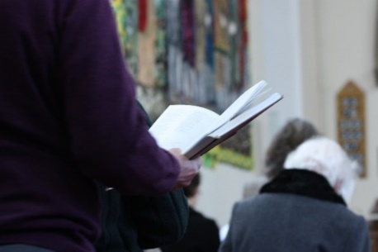
Weddings – We take marriage preparation very seriously and would encourage couples to attend church during the time of preparation (This has lapsed since being in vacancy and is an area that needs to be reintroduced). The PCC supports the Incumbent to explore marriage after divorce with a couple according to the Incumbent’s pastoral discretion and with the blessing of the Bishop. Marriage preparation is always done by the clergy because of the legal and pastoral considerations e.g. re-marriage, ‘qualifying connections’ under the Marriage Measure etc. We had 4 weddings last year.
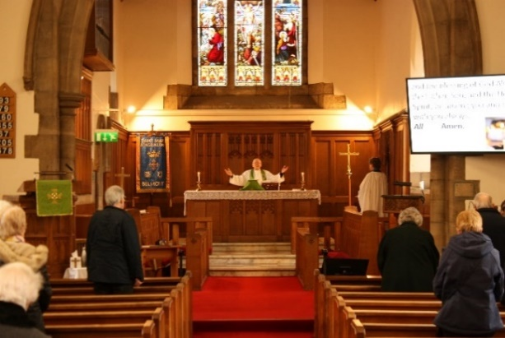
Funerals - This is an important part of our ministry. We offer prayer and support to families who have lost loved ones. Last year we conducted 26 funerals at the church or Crematorium and 2 church services which were followed by burial. Each year it is our custom to invite those families who have lost their loved ones to a service at All Souls, where we regularly remember those of our community who have died.
We have established a Garden of Remembrance within the church grounds where, following a short informal service, the ashes of loved-ones can be interred.

As an aid to Bible Study, currently 13 members of the congregation take Bible Reading Notes which are purchased from the Bible Reading Fellowship. Currently one group of people from the congregation also meets for Bible Study every other week at a member’s home.
Home-based fellowship groups are currently under review as there is only one. They have proved very popular in the past, offering Christian prayer, study and support. Over the years as people move away from the parish, attendance has declined. This is something we would like to build up again.

- The church and the community it serves.

We encourage all in our Christian community to share and develop their leadership and gifts. This ranges from leading worship and taking an active part in the services, preaching and teaching to leading various groups that support mission and outreach, sitting on committees, ensuring our buildings are well looked after, clean and look their best, welcoming people to church both on Sunday and during the week, visiting the housebound and delivering our monthly magazine.

We seek to use the major church festivals of Christmas and Easter as opportunities for witness and serve the wider community. At Christmas, in addition to our normal church services, services for schools and other local organisations, we offer many special events of celebration e.g. a carol service with The Salvation Army, and Durham Fire Service Carol service.

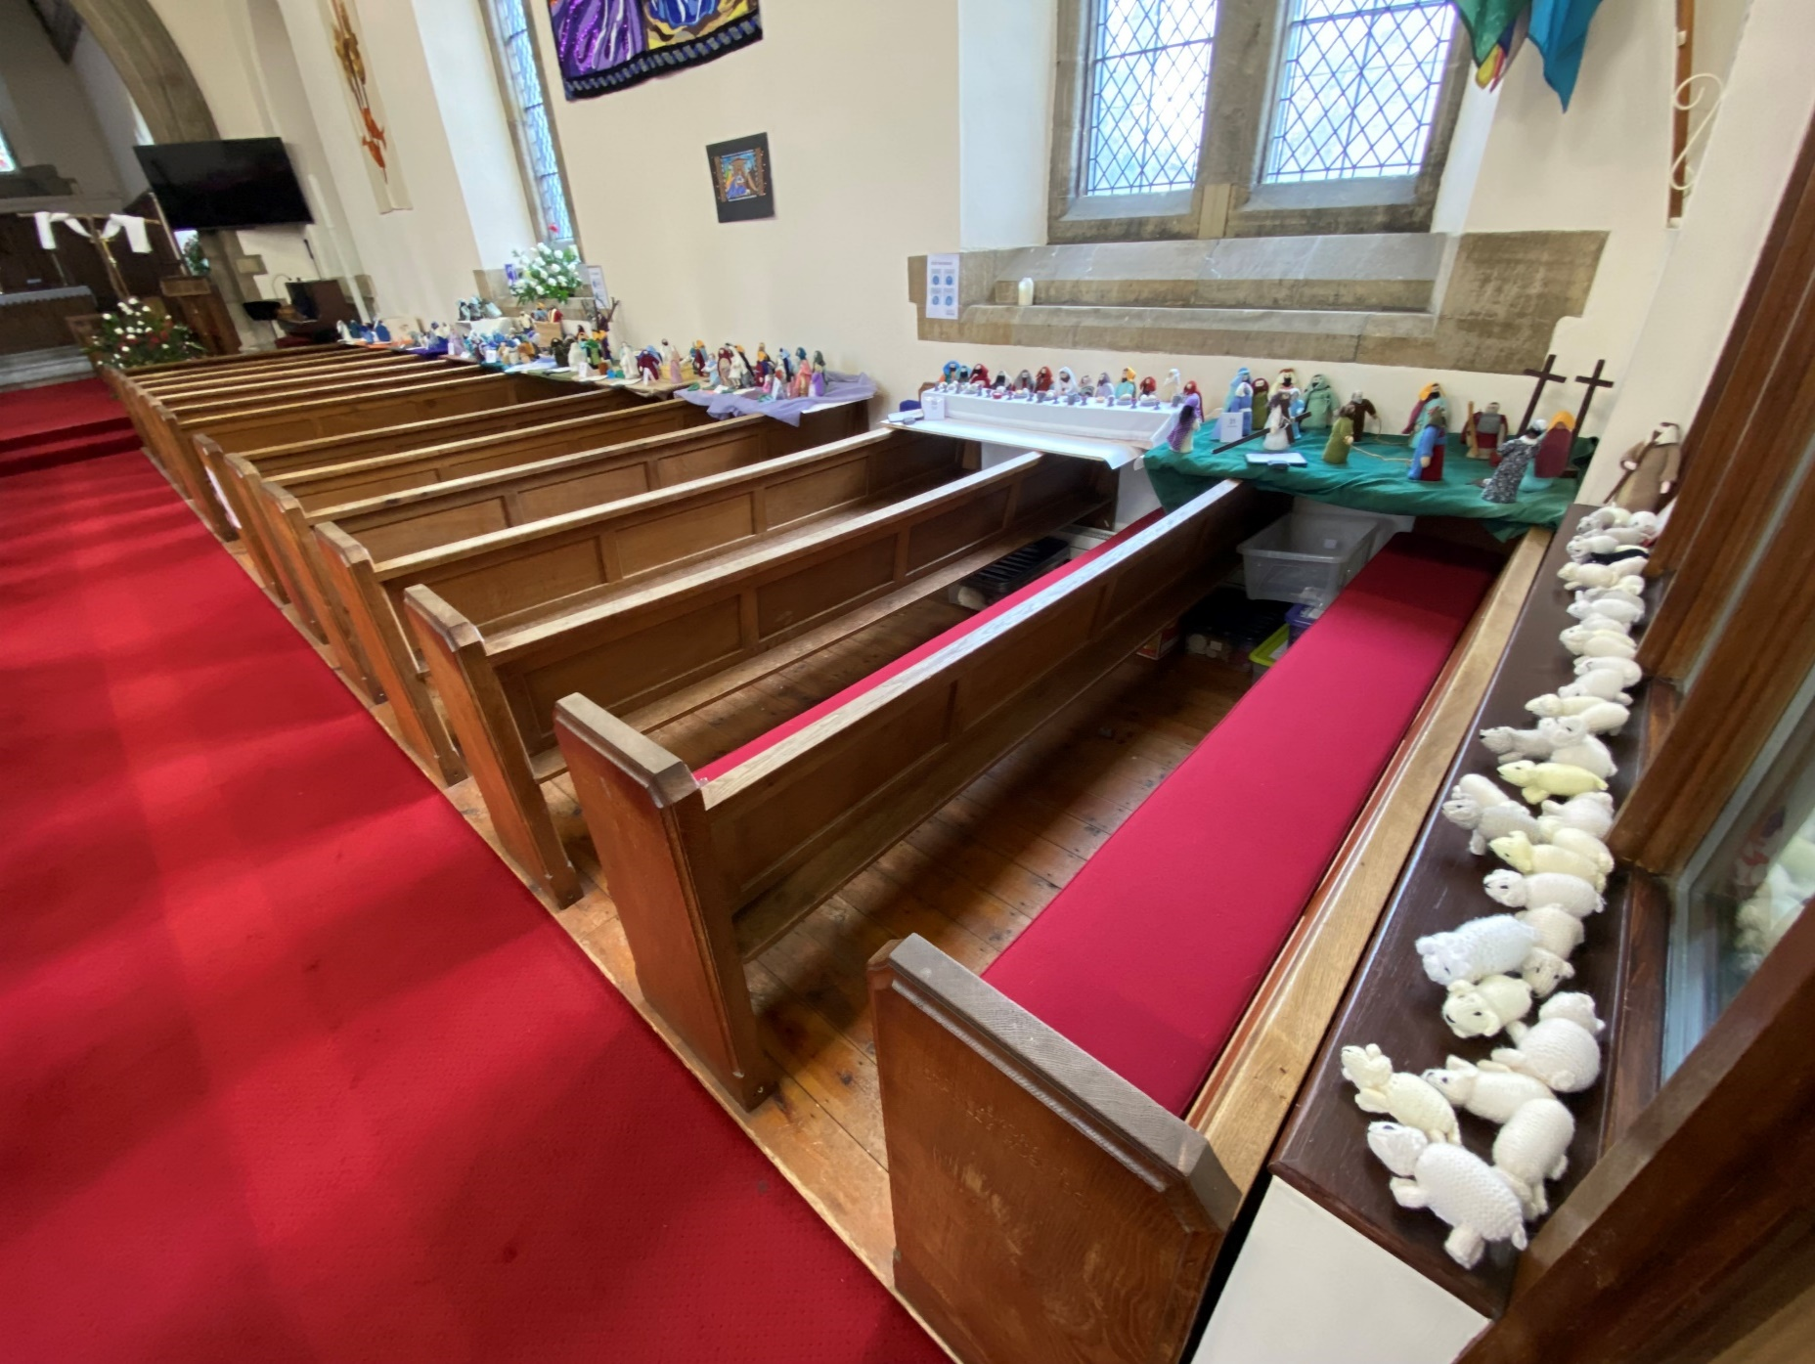
“I like how welcome our son is made to feel, despite his being a pest!” (Mother of an active toddler)

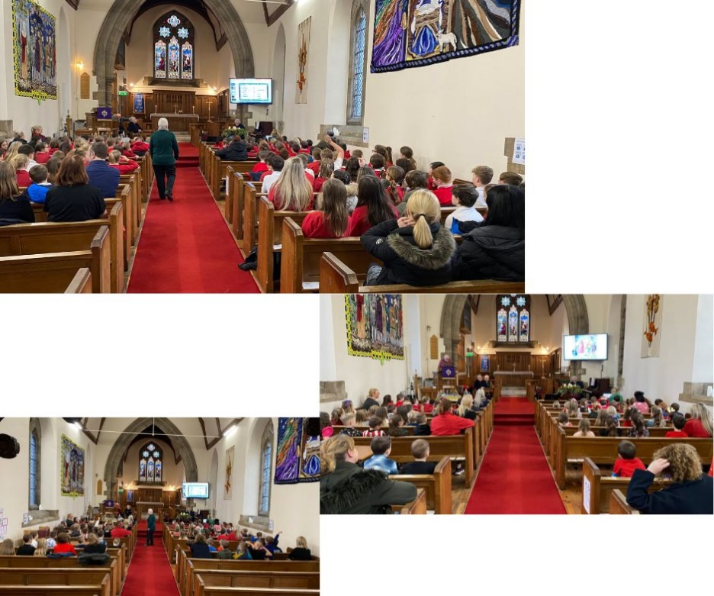
We enjoy excellent links and relationships with Belmont C.E. (Controlled) Primary School that opened on January 1st 2015, following the amalgamation of Belmont Infant and Belmont Church of England Junior School. There is now also bursary school provision. In the past, the incumbents have been actively involved in the life of the school. We currently have two foundation governor vacancies to be filled. Throughout the year pupils from the school visit to complete various projects.
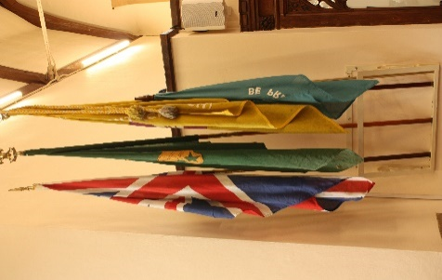
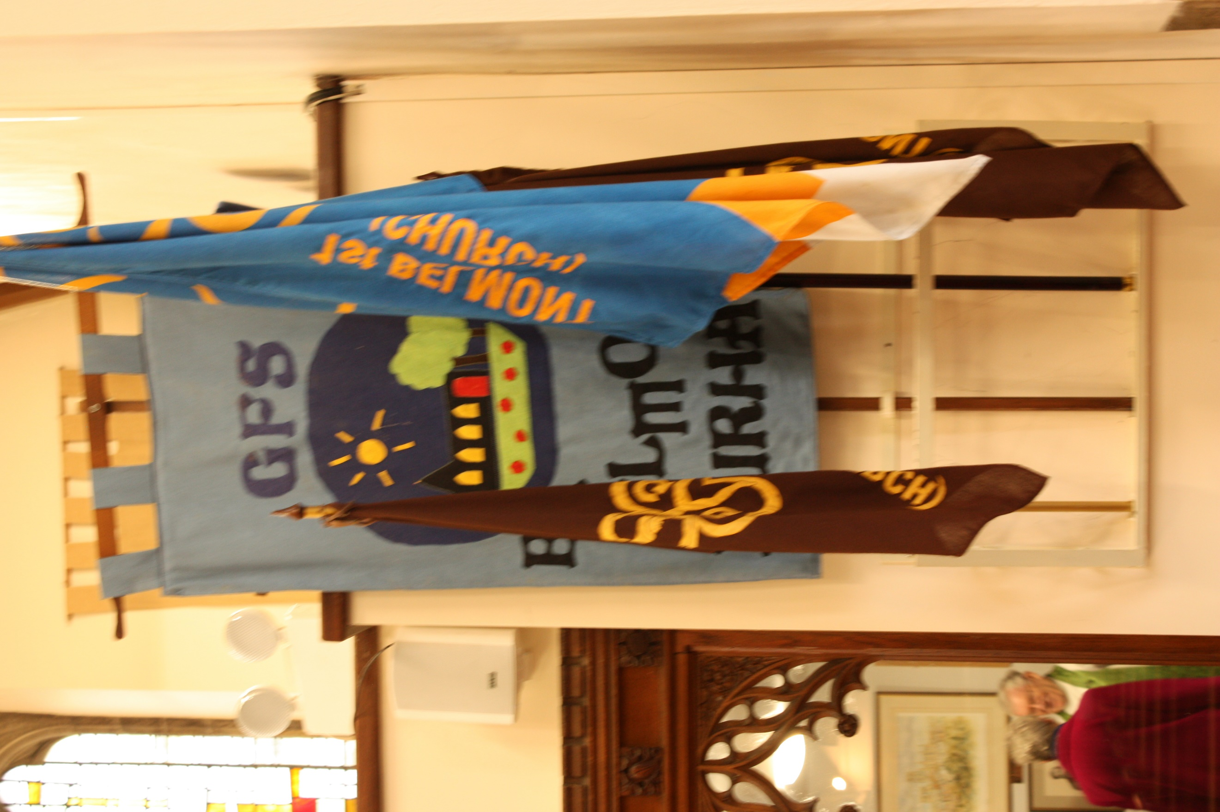
1st Belmont (Church) Scout and Guide Groups
Guiding and Scouting units meet weekly to offer a varied and stimulating programme for their members, whose ages range from 5 – 26! There is an ever-growing number of Rainbows, Beavers, Brownies, Cubs, Guides, Scouts, Senior Section and Explorers.

Their aim is to help young people develop emotionally, mentally, physically and spiritually so they can make a positive contribution to their community and the wider world. There is a good attendance for the Remembrance Day service.

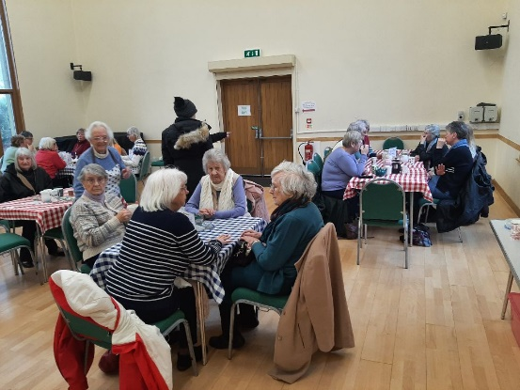
A team of volunteers runs Café Church every Wednesday morning, an opportunity for local residents members of the community to drop in for coffee and cakes, for friendship and fellowship, for support, and for prayer and chat on matters of faith in a calm and peaceful setting. Several residents from the nearby residential homes for the elderly and disabled are regular visitors to Café Church. Average weekly attendance: 45-55 with 11 helpers. From the donations given, the Café has been able to annually give £2000 to charitable causes.

“It is a godsend to me. Whatever the weather I try to come” (Moira)

“ We love the friendship and company; lovely cakes and sausage rolls – all home-made! It’s a meeting place; something to look forward to” (Stella’s table)

“Love it! Can’t wait to get out of bed. Lovely food and coffee” (Margaret)

“A beautiful place. Ladies who look after us” (Marion)

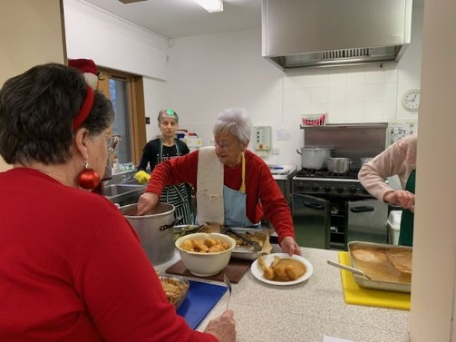
In a similar way, on a Thursday, at The Table, teams of volunteers, comprising church members and members of the community, work a rota to provide a weekly midday meal and friendship opportunities for older single members of the community. Average attendance is 26 diners (with a waiting list); 5 teams of cooks, 9 helpers.
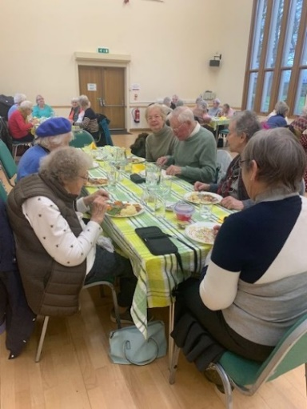
“I’ve been coming from the start! (Rena)

“I come for the company” (Marie)

“It gets me out – the only time I get out in the week” (Joyce)

The Mothers’ Union has 23 members ranging in ages from 60 – 90+ years. They meet once a month in the Parish Hall to enjoy talks and fellowship and also take part in the Women’s World Day of Prayer and other ecumenical events. In addition to holding social events, as part of the church family they are involved in many aspects of church activities including church services, transporting church members, the Table, and being part of the Pastoral Visiting Team. They also provide emergency bags to the local hospital.

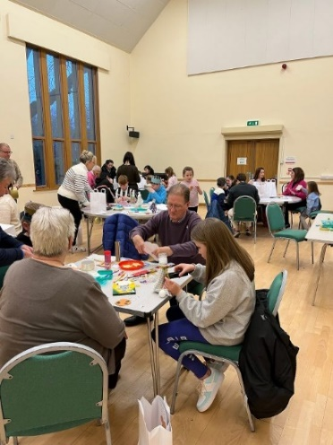
Messy Church is held on the first Sunday of most months in the Parish Hall. It is an opportunity for children and parents/relatives to join in with craft activities, hear a story from the Bible, take part in a short, specially designed service and finish off by having tea together. It has become quite a multi-national group, with families from UK, Italy, Macedonia, USA, Vietnam, France taking part! We regularly have an enthusiastic attendance of 20 children, 11 parents and 12 helpers.
A Bible-related activity takes place in the Parish Hall followed by a short service in church after which tea is served in the Hall.

‘We look forward to every first Sunday in the month to attend Messy Church, run by such welcoming and lovely people that makes me feel I am visiting my own family. MC is like the heart of our community that accepts everyone, no matter of religion, race or belief. We love MC and all the people there. ‘ (Parent of MC child)

‘We love to attend MC. The staff are amazing – we always feel welcomed and loved. We feel part of one big family The themes presented are well thought out, creative and fun. ‘ (Parent)

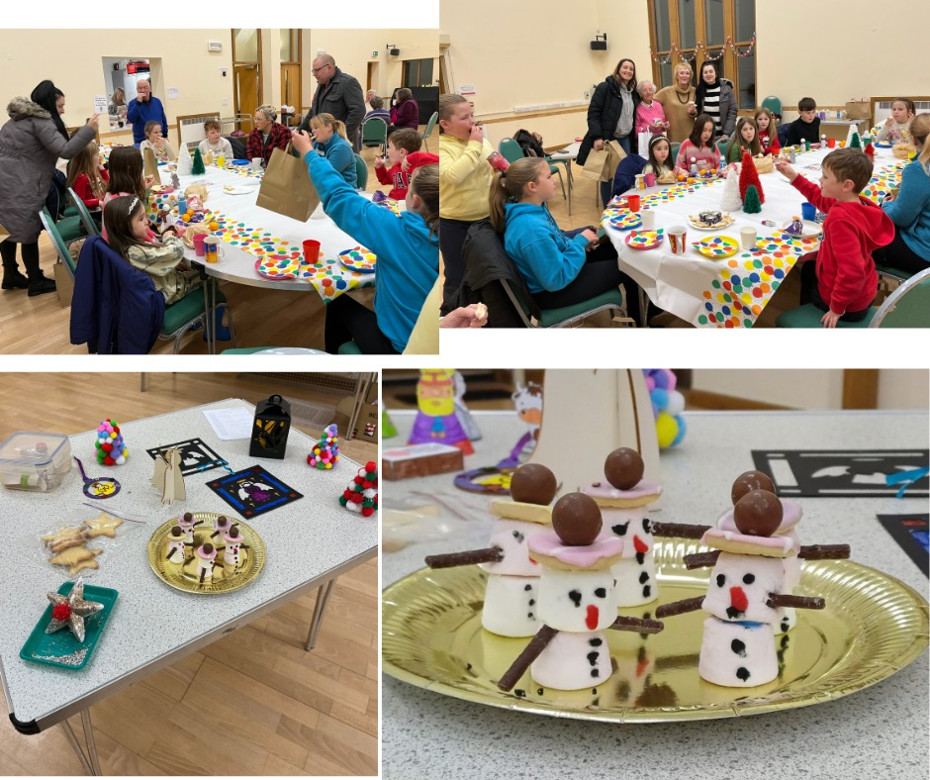
Children’s work on Zaccheus
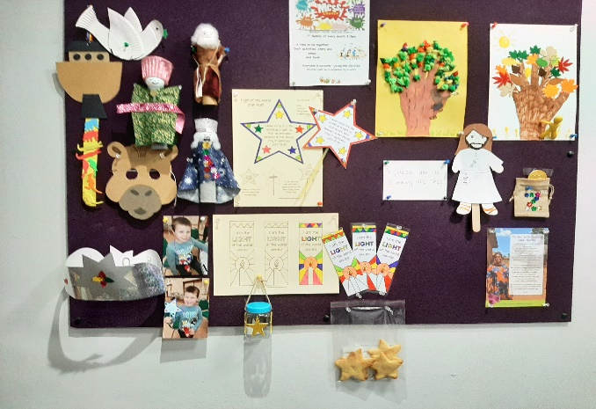

The Grapevine, is a popular United Benefice monthly magazine co-ordinated by SMM, which is well received in the community and has a distribution of 300 copies. It is an important means of bringing the church and its mission into the homes of its subscribers; it is also available in shops and other outlets in our parishes.
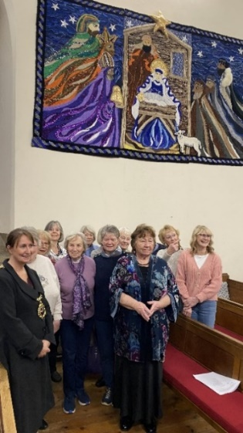
Our Artwork group meets twice weekly and has produced two magnificent pieces of work for the walls of the nave. These often take years to produce and their next project is underway to make hundreds of poppies from bottle bases. It includes people in the community working together with church members.

Fundraising and Social Events were organised by a fundraising committee. This was initially set up to raise funds for major building projects but now church members come together occasionally to organise social events with the focus more on providing enjoyable experiences rather than raising money. Our next event is the Northumbria Chamber Choir performing on 23rd March.

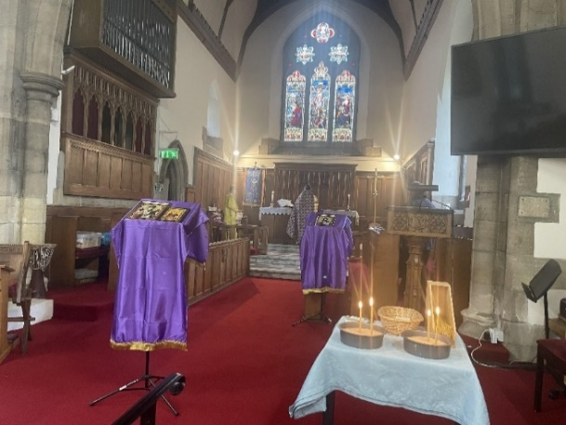
Since March 2023 we have hosted worship for members of the Russian Orthodox Church who live in the Durham and Darlington area. They meet on the last Saturday of the month, with worship in both Russian and English. The location is proving very popular and their numbers for worship are gradually increasing.
“I could immediately feel the warm and welcome of this Christian Community”

“Thank you for your hospitality and warmth”

“We feel very fortunate to be here” ( all from Ekaterina)

While being aware of some of our own ‘neediness’, we are a church which reaches out to those in need, and we are blessed to have a number of people who visit those who are sick, isolated and bereaved, and who take home communion to those who request it. A number of disabled people attend our 10.30am Sunday service and we are greatly enriched by our joyful fellowship with them and their helpers.

- The church building and resources

Our church, a Grade 2 Listed Butterfield building, was built circa 1855.It has some interesting features: Mousey Thompson carvings, 3 fine stained-glass windows, and a 1902 Harrison organ. It is in good condition and well cared for.
It can accommodate about 150 people with an additional 24 in the choir stalls. Two pews have been removed in the nave to accommodate wheelchair, and pram/pushchair users.
In the last decade or so, the following improvements have been made:

- A new gas-fired heating system
- Conversion of the lower vestry into an office for the vicar and the Church Administrator
- The installation of a new audio-visual system with large screen TV and new microphones and speakers and WIFI (with additional smaller supplementary screen and speakers in the Narthex.)
- Most recently, with the help of a LPOW Roofing grant and a Heritage Lottery Fund Grant, we have been able to carry out roof repairs, and a major programme of repairs including the replacement of eroded stonework, repointing of exterior walls with lime mortar, improvements to the drainage system, and resurfacing of footpaths, limited parking areas and driveway entrances.
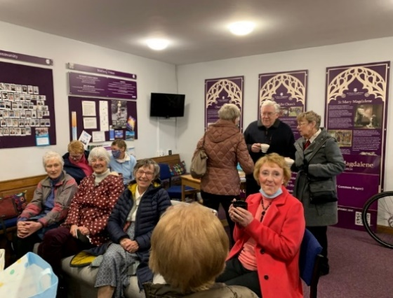
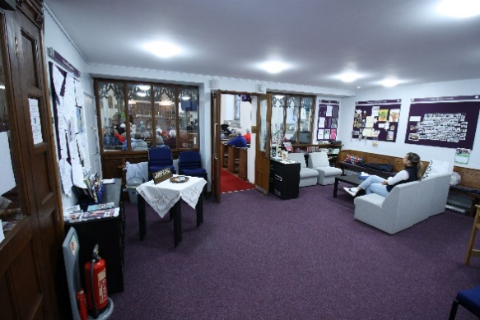

We have carried out improvements to the Narthex which have created a comfortable space for small group meetings in an environment that provides vital information about church events and mission. Toilet and kitchen facilities have been significantly enhanced in the autumn of 2023 by virtue of a generous legacy. Finally, in the last year we have erected new external noticeboards.

Whilst the churchyard is a closed churchyard, with Durham County Council having responsibility for grass cutting, tree care and the repair of all external walls, we are blessed to have a small team of members of the congregation who are committed to looking after: Health and Safety issues, internal
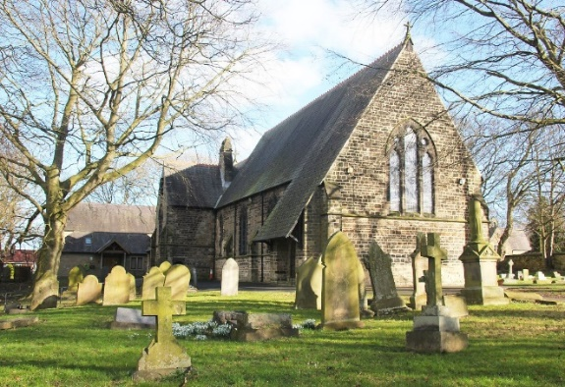
and external repairs and the additional care of the churchyard: bird boxes, small garden areas, keeping the churchyard tidy, ivy removal, close grass cutting around graves etc, and safety issues of access in winter – snow clearing and gritting of walkways.
No major repairs were pinpointed in the last Quinquennial Report of February 2020, but our architect has advised that further roofing repairs may be necessary in the next 15 years.

The Vicarage is a spacious, detached family home, built in 1988, and set in low maintenance gardens with lawns – about two minutes’ walk from the church. It has gas central heating and there is parking space for up to 3 cars.
Upstairs It consists of 4 bedrooms, one bathroom with shower and WC, one shower room with WC; and downstairs a separate WC, 2 living rooms, dining room, kitchen, utility room and a large study.

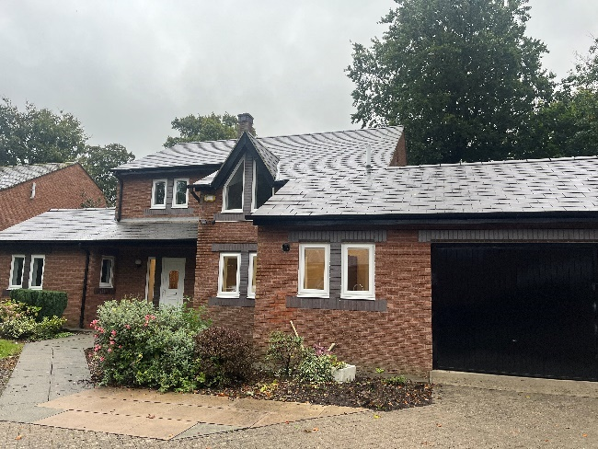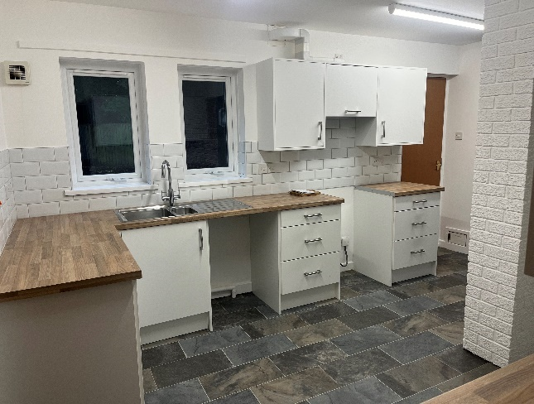

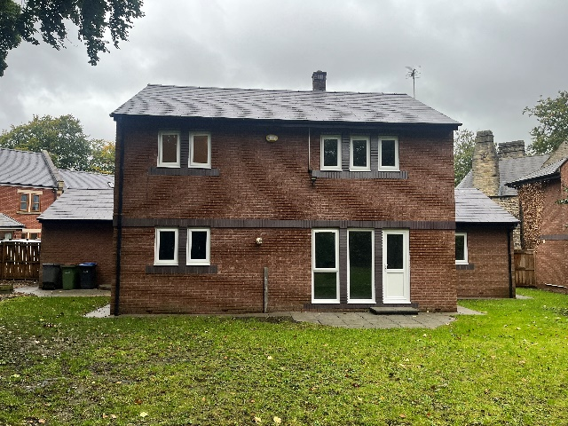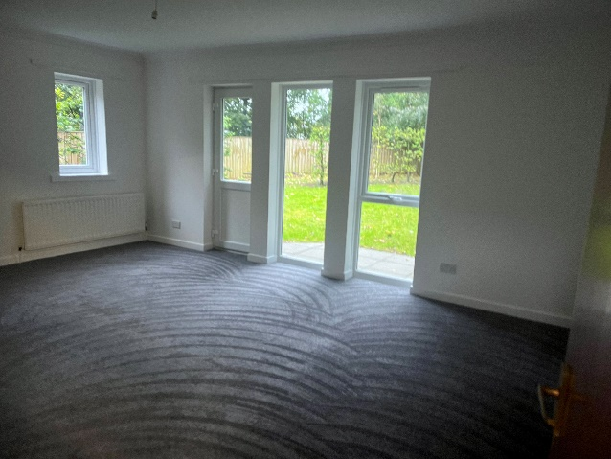

The Parish Hall is built in the churchyard, and adjacent to the church, the hall was the brainchild of our then Vicar, The Rev. Rob Innes, and was built in 2005 with grants and funds raised by church and community. It is a magnificent facility for church and community, suitable for a wide range of activities, and hired for community and family occasions.
The hall is separately managed by Belmont Parish Hall Association (BPHA) and run on a daily basis by a Hall Manager and a team of volunteers. The church has reserved use of the building on Sundays for after service coffee, for Messy Church (2.00- 5.00 on the First Sunday of the month), the monthly Mothers’ Union and for festival events.

The Parish Hall Association mounts a complementary programme of events that include a hugely successful programme of Master-Musician concerts, featuring young internationally recognised musicians from all over Europe and sometimes beyond.

The church also hires the main hall for Café Church on Wednesday mornings and The Table on Thursdays. BPHA also runs its own events in addition to what the church may organise – for example, monthly classical music concerts, quizzes, fitness and Yoga sessions.


We are a God-loving, welcoming church community.
Do you feel called to join us on our journey?

The Parish of
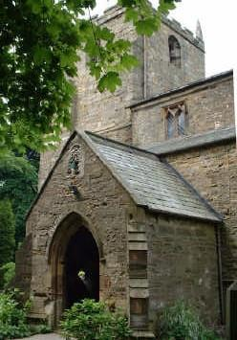

St. Laurence, Pittington

A United Benefice with St Mary Magdalene, Belmont.

IN THE DIOCESE AND DEANERY OF DURHAM

PARISH PROFILE

Faceboook: |  | St.Laurence Church Pittington
Section one: Summary of the profile

We are a village church serving the people of Pittington, Durham and beyond. The church family is gathered from a wide range of people and backgrounds but like many churches we have a predominantly aging congregation, and we recognise the need to develop our ministry amongst children and young people. The congregation has a broadly central but varied and open churchmanship and lay participation in our worship is encouraged. This variety is reflected in the different styles of worship and the many activities we enjoy. The church is a happy place to be with a small but welcoming, inclusive and active congregation and it is very much a part of the village community which provides a firm foundation for outreach.

We expect a new minister to help us to explore and develop existing and new areas of our ministry, to encourage the further development and application of the gifts and talents of our congregations in both churches in our United Benefice and to strengthen our ministry within our communities. (Please see Section 3).
The historic Grade 1 listed building provides a remarkable focus for our worship and an attractive setting for other activities that bring opportunities to develop relationships with members of the community who would not normally enter a church,

Section two: The broader context

The church is based in the Diocese and Deanery of Durham. The church is connected with the Deanery by having two representatives to attend Deanery Synod meetings. The Synod tackles matters like poverty, mission, children and young people. The new priest would have support from the Archdeacon and from retired clergy. The priest would reside in the Vicarage at Belmont opposite St Mary Magdalene. The journey from there to St Laurence is a few minutes by car. The church’s activities are well supported by the people of Pittington and although the church is hidden away, we suffer very little from vandalism.
We totally support the ordination of women and have had a mix of male and female priests in the past.

Finance:

The Church has always met its pledged Parish Share despite our many other financial demands such as increased insurance premiums and the general running costs of a Grade I listed building. We have also managed to maintain our annual charity giving and recently confirmed our target of giving 5% of our regular income. The day to day operation of the church is funded mostly from regular giving but well supported events such as cream teas generate essential additional funds to maintain and improve this historic church building whilst providing valuable opportunities for outreach to allow us to be the body of Christ more effectively in this community. We have always been keen to get away from the popular image that churches only reach out to the community when they need to raise funds for maintenance. With that motivation, events such as occasional summer open days, linked to the annual Heritage Weekend draw people into our church and provide an opportunity to meet with visitors who might not normally set foot through the door. It is an opportunity to 'give' to the village and everything from the refreshments to church tours are free to all.

Recent History:

Since 2007 the parish has been a partner in a United Benefice with the much larger, nearby parish of St. Mary Magdalene, Belmont. In the previous decade the parish of St. Laurence had at different times experienced being part of a United Benefice with the parish of Sherburn, a plurality with the parish of Shadforth and a single, united parish with both Sherburn and Shadforth. The current period of stability is very welcome.
Although the two parishes of Pittington and Belmont are very different in many ways the united benefice has proved to be remarkably successful and the two churches work well together, each bringing different history, experiences, strengths and gifts that strengthen the whole.

Section three: The vicar we need
Based on these ideas and thoughts, we are looking for a faithful priest who will enjoy the vision that has evolved within our two congregations since becoming a United Benefice.

We are looking forward to a new minister who will continue to help us to explore and develop existing and new areas of our ministry, to encourage the further development and application of the gifts and talents of our congregations and to strengthen our ministry within our communities.

We pray that any priest who would want to come and work in our two parishes would be committed to build upon the distinctive, but complementary, styles and strengths of our two congregations. We would also hope for a desire to build upon existing bonds within the wider locality, and that he/she would enjoy the challenge and fellowship that has been described in our parish profile.

We are looking and praying for someone who will lead us, bringing his/her own gifts, vision and experience to help us to move forward in God’s grace, and, especially, someone:

- whose life is rooted in prayer and the Eucharist;

- who, through the worship of both churches, will move people to experience God’s love;
- who will be able to connect the Bible to everyday life in a modern, imaginative and creative way;

- who is a prayerful, and calculated, risk-taker, prepared to step out in faith;

- who will encourage people to serve God and one another;

- who will develop the spiritual life of both churches;

- who will lead us to explore different forms and styles of worship;

- who will be warm, compassionate and ready to listen to those whom he or she meets, both inside and outside the church congregations;

- who will encourage all to use their skills and talents in the service of God;
- who will be able to communicate effectively, be at ease in our two churches and enable them to fulfil their mission and outreach;
- who will maintain and develop existing working relationships with other local churches; and
- who will build on the excellent relationships in place with the headteachers and teachers in our local primary schools.

Section four: About the parish
The parish of Pittington lies to the east of Durham City and has its roots in the former mining communities of High Pittington and Littletown and the smaller agricultural centres of Low Pittington and Hallgarth. It is now a growing and exciting village, with many new inhabitants, some new housing and it is a residential base for people who work in and around the university city of Durham. The village has a highly regarded restaurant, a shop, a hotel and a pub.
The location of the church is behind the Hallgarth Manor Hotel (recently renamed ‘Sixty One’) in High Pittington, at the end of a lane, opposite the Old Vicarage which is now privately owned.
The total population is around 2500, with a mixed housing pattern of local authority houses and bungalows, private houses and newer housing estates. With very good access to road and motorway links, the main east-coast rail route and two airports this is now a very convenient residential area not only for Durham City but also for Teesside, Tyneside and Wearside.
Community and Church Involvement

The present generation is likely to be the last with living memories of the long mining history of the area. As this generation naturally reduces in number, younger families are arriving. The working population in the villages has changed from a workforce in the local vicinity to a much more mobile / commuter workforce. In many households both parents work and children are often supported by local grandparents, which reflects the traditional, stable family structures of the region. Pittington has an excellent and popular primary school which includes a nursery unit. The church enjoys a good relationship with the school. The two organisations promote and join-in each other’s activities. We host many educational visits from the school and also their carol service. School leavers progress mostly to the secondary school in the neighbouring community of Belmont although some travel further afield.
Social interests in the Village focus around various activities based in the village hall (which is used by the church each week for our GFS activities), the school (which has an active and well supported PTA), the Sixty One Hotel and the church. The village is also home to the Methodist church of St. John which has a diminishing and mostly elderly congregation.
The church building provides a beautiful venue for occasional concerts and for photographic groups.

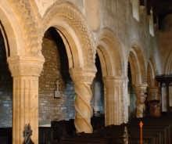
Section five: About the church

The Church Building
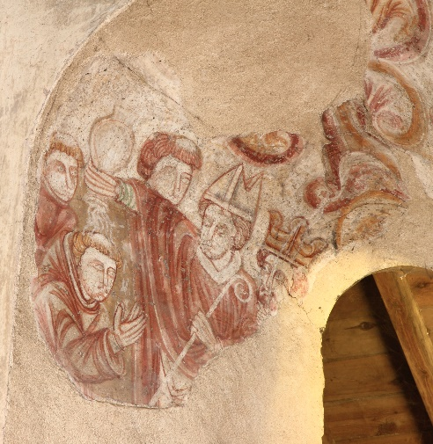
St. Laurence’s Church in Pittington is one of the most historical churches in the area, with an 11th century architectural base, and additions of Norman and Medieval interest, including beautiful arches which could well have been prototypes for those in Durham Cathedral’s Galilee chapel. The church is Grade I Listed.

St Laurence’s has been well maintained and although the maintenance of such a significant building is costly in terms of time, effort and money the resources have always been found and the effort has never distracted us from the true purpose of the church.
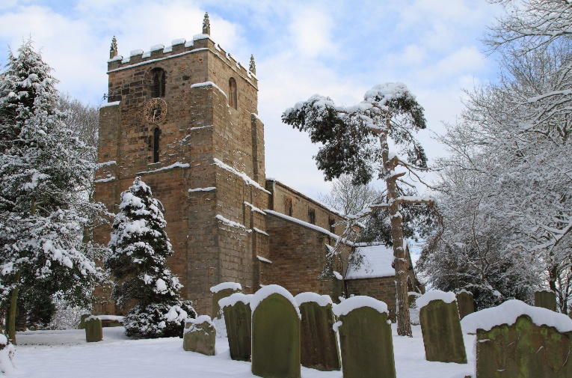

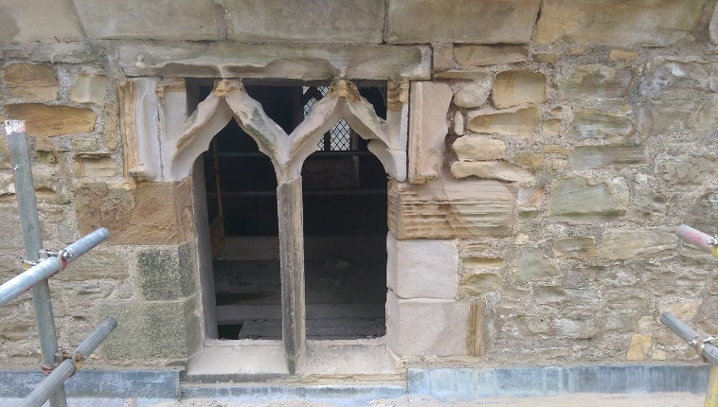
Our most recent major building repair was to have a clerestory window completely refurbished and glazed at a cost of £11,000. The raising of the money was achieved in twelve months through open day events such as ‘Snowdrop Saturday’ and via ‘posh nosh’ dining evenings at Belmont Parish Hall. We received a £2,000 grant towards this from Northumbria Historic Churches Trust. Crumbling stonework behind the organ is our current maintenance concern.

Worship and Outreach:
Both parishes in the United Benefice have followed a pattern of worship with the traditional Eucharist at its heart but each has retained its own character. The two churches use a common form of liturgy although we may treat it slightly differently. In the case of St. Laurence’s this has been one of flexibility and development making use of the variety offered by Common Worship and through lay participation. St. Laurence’s is very much a village church and has therefore always sought to be inclusive and not to develop a style that alienates those of differing churchmanship. This is reflected by a congregation from a broad range of traditions from catholic to evangelical and a corresponding acceptance of worship styles from the very traditional to the modern. Projection facilities are available, and music is provided mostly by a high-quality music system. We have vestments and value Holy Communion, while caring deeply for a preached ministry of the Gospel of Jesus. Lay ministry is encouraged and valued.
The Sunday congregation includes members of most age groups with the noticeable exception of children of school age. We have a highly successful Girls Friendly Society group with a long waiting list to join, which also reaches out to girls and their families who are not necessarily regular worshippers at our church. The group meets in the village hall, but we struggle to attract young people to worship with us in church. We recognise that the Eucharist may not be the best option to attract young people and would value the experience of our new minister to develop our ministry to children.
As with many churches we have a relatively large proportion of elderly members. We no longer have a Messy Church in Pittington, although some families do attend Belmont Messy Church.
At present regular Sunday services are: 9.30 am Parish Communion with a joint service for the two churches once every month, alternating on the first Sunday of the month. The Benefice Choir supports these services. The Choir is really well established with approximately 16 members.
Private Prayer is held on Thursdays 10 to 11am, except during the winter and this has been regularly attended by six people, who cannot always get to the Sunday service.
Special services such as our ‘Family Carols and Nativity’ regularly fill the church (200+) and they provide a valuable opportunity to welcome and include those who would not usually attend a regular Sunday service. We had developed our special services including a Harvest, where the Pittington School children submit their art work to hang between the arches. This requires re-establishing following the COVID pandemic, particularly as there has been a change in headteacher.
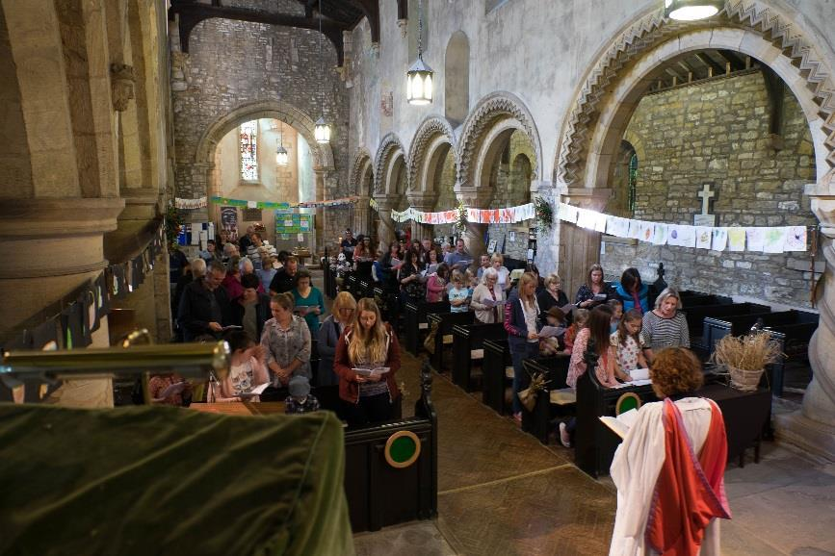

Harvest service with participation from Pittington Primary School. Their artwork is displayed between the arches

Activities beyond formal worship include ecumenical Lent groups.
Weddings, baptisms and funerals vary in number each year. During 2023 we had 7 weddings, 5 baptisms and 5 funerals. Our historic church is a popular wedding venue and we have had more than a dozen weddings in some years. 2024/5 bookings are arriving already. We see weddings as part of our ministry and many couples who had no previous connection with our church continue to worship with us after their wedding.
The variety within the united benefice has a great deal to offer, particularly as a rich training ground, with plenty of occasional offices and scope for lay growth. In recent years the parishes have supported, each year, a student on placement from St. John’s Theological College and the United Benefice provides an excellent training for Curates, because of the contrasts in practice and traditions in our two churches.
We have the church open on Saturday afternoons from May to September and we have been trialling unmanned open weeks when the church remains open to visitors to reflect, pray or just appreciate the architecture. These have proved to be very successful with no security problems to date. Throughout the year we provide very popular Cream Teas, which is another activity aimed to draw the community into the church and which is also a valuable fund-raiser. This is a major contributor to mission and outreach. We often have more than one hundred visitors to each tea.
Outreach is also achieved via live streaming and typically 6 people tune in to receive the service when we have joint service at St Laurence. Information about the church is provided primarily through ‘A Church Near You’ and our Facebook page which, with over 100 members allows us to ensure that the most up to date information about the church and our activities is easily accessible. The Facebook medium is by far our most successful means of communication and outreach.
We are also a ‘Small Pilgrim Places’ site and mapped walks have been developed between us, Durham Cathedral and Witton Gilbert Church. Meditation leaflets have been published to guide the visitor on a reflective journey.
Our music is an improving area with the ongoing development of the joint choir with St. Mary Magdalene. Music for worship is provided mostly using a high-quality sound system using professionally recorded music and backing tracks which provide us with a selection of over 600 hymns and worship songs with organ or music group accompaniment as appropriate. Most visitors are unaware that the organ music is not live while others think that we have a particularly good organist!
St. Mary Magdalene and St. Laurence do much together including regular joint services, a joint choir, a shared magazine and some fundraising and social events.

