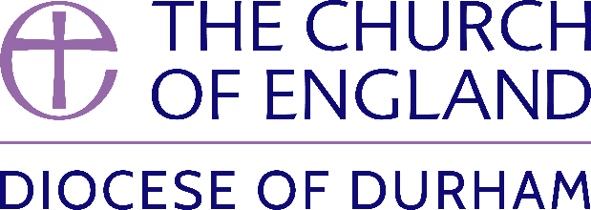
Please complete in black ink

ARCHDEACONS’ VISITATION 2024

CERTIFICATE OF ELECTION OF CHURCHWARDENS

To Incumbents, Priests-in-Charge, or Churchwardens (2023) of parishes
in the Archdeaconries of Sunderland, Durham and Auckland.

As soon as the Annual Parochial Meeting for 2024 has taken place, the Chair of that meeting should complete this Certificate, and return it to the relevant Archdeacon’s Office NO LATER THAN 31st MAY 2024

The Archdeacon of Auckland, c/o Mrs Dawn Robinson, Holy Trinity Vicarage, 45 Milbank Road, DARLINGTON DL3 9NL. Dawn.Robinson@durham.anglican.org
OR
The Archdeacon of Durham, c/o Mrs Kate Martin, Cuthbert House, Stonebridge,, Durham DH1 3RY. Kate.Martin@durham.anglican.org
OR
The Archdeacon of Sunderland, c/o Mrs Linda Richardson, St Nicholas Vicarage, Hedworth Lane, BOLDON COLLIERY, NE35 9JA Linda.Richardson@durham.anglican.org

Archdeaconry of……………………………………………. Parish of …………………………………………………………………….

I, the undersigned, hereby certify that the under mentioned persons were duly elected to serve the office of Churchwardens in the above parish for the year then ensuing:

Please state in BLOCK CAPITALS the full names, addresses (including post code), telephone numbers and email addresses of the newly elected Churchwardens :

1. 2.
…………………………………………………………………………………….. …………………………………………………………………………………
…………………………………………………………………………………….. ………………………………………………………………………………….

…………………………………………………………………………………….. …………………………………………………………………………………

…………………………………………………………………………………….. ………………………………………………………………………………….

……………………………………………………………………………………. ………………………………………………………………………………….

……………………………………………………………………………………. ………………………………………………………………………………….

……………………………………………………………………………………. ………………………………………………………………………………….

Name of Chair …………….……………………………………… Chair’s Signature ……………………………………………………………………………………

Signed this………………………………………………………………………………. day of………………………………………………2024

