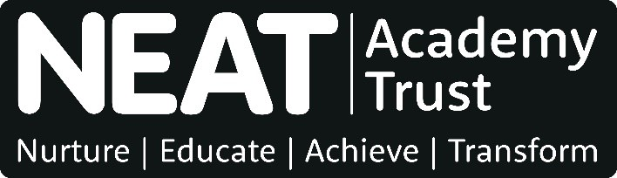

Equalities Monitoring Form

We aim to have a workforce that reflects the communities we serve. To measure our performance in meeting this aim, we collect information from people applying for jobs. We separate this form from the rest of your application. The information you give is confidential and will not be seen by anyone involved in the recruitment process. It will not affect our decision on your application.
We publish a Privacy Notice for job applicants that explains the personal data we collect and how and why we process it. This can be viewed on the NEAT website at: https://www.neat.org.uk/policies-documents/

Name:
Job you are applying for: | Date:
School(s)/NEAT Central Team:

Please provide details about yourself by ticking the relevant boxes.

Gender
Are you: male? female?

Disability
The Equalities Act 2010 defines a disability as ‘a physical or mental impairment which has a substantial and long-term adverse effect on the person’s ability to carry out normal day-to-day activities’.

Do you consider you have a disability under this definition? Yes No

As part of our Guaranteed Interview Scheme, we interview all applicants who declare they have a disability who meet the essential criteria for a job vacancy.

Are you responsible for caring for anyone?

I am not responsible for caring for anyone.
I care for children or a child.
I care for another relative.
I care for someone else (please say who)

Your date of birth

How would you describe your ethnic background?
White: Black or black British:
British African Gypsy or Irish Traveller Caribbean
Irish Any other Black background
Roma
Any other White background

Asian or Asian British: Mixed or Multiple:
Bangladeshi White and Asian
Chinese White and Black African
Indian White and Black Caribbean
Pakistani Any other mixed background
Any other Asian background
Other ethnic group
Arab
Other (please say which)

Relationship status
Divorced/dissolved civil partnership Single
Married/in a civil partnership Cohabiting
Widow/widower Prefer not so say

How would you describe your sexual orientation?
Heterosexual/straight Bi-sexual
A gay man A gay woman/lesbian
Prefer not to say Other (please say which)

How would you describe your religion or belief?
Buddhist Christian
Hindu Jewish
Muslim Sikh
No religion Prefer not to say
Other (please say which)

Where did you find out about this vacancy?
North East Jobs website Schools North East website
Times Educational Supplement website School website
NEAT website Word of mouth
Other (please say where)

