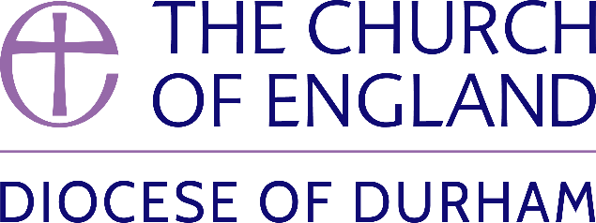 | DIOCESE OF DURHAM  Movement of Clergy: April-May 2024
Name | Current Post | New Post | Effective Date
(1) MOVEMENT TO OR WITHIN THE DIOCESE:
Southern, The Revd Lindsay Margaret | Vicar, Parish of Catterick with Tunstall (Leeds) | SSM Priest in Charge of Chilton St Aidan, Cornforth and Ferryhill | 08.04.24
MacLaren, The Revd Clare | Canon Residentiary, Newcastle Cathedral (Newcastle) | Provost, Sunderland Minster | 14.04.24
Hole, The Revd Dr Samuel Richard | Associate Vicar, Chelsea St Luke (London) | Chaplain and Solway Fellow, University College, Durham University | 25.04.24
Fisher, The Revd John | Priest in Charge, Durham St Giles, Shadforth and Sherburn | Vicar, Durham St Giles, Shadforth and Sherburn | 28.04.24
Feeney, The Revd Rebecca Anne Mary | Curate in Charge, Chorley St Peter (Blackburn) | Chaplain, HMP Low Newton | 29.04.24
MacLaren, The Revd Clare | Provost, Sunderland Minster | To be also Honorary Non-Residentiary Canon, Durham Cathedral | 12.05.24
(2) MOVEMENT FROM THE DIOCESE:
Ferguson, The Revd Timothy Michael | Chaplain, St Hild & St Bede College, Durham University and Bridging the Gap Officer | Vicar, Byker & Walkergate (Newcastle) | 28.04.24
Elwood, The Revd Claire Siobhan | Curate, Durham St Nicholas | Interim Associate Minister, York St Michael le Belfrey (York) | 08.05.24
(3) RESIGNATIONS:
(4) RETIREMENTS:
Abbott, The Revd Barry Joseph | Rector, Swalwell and Whickham St Mary in Plurality |  | 15.04.24
McTeer, The Revd Canon Robert Ian | Vicar, Auckland St Helen |  | 30.04.24

Published 15 April 2024| Bishop of Durham’s Office

